**PROJECT MANAGEMENT PLAN**

**<Barangay South Signal Village Web App>**

BARANGAY SOUTH SIGNAL VILLAGE

128 COL. BALLECER ST COR. GEN. ESPINO ST. ZONE 6

SOUTH SIGNAL VILLAGE, TAGUIG CITY

By

|  |  |
| --- | --- |
| Rark Mowen L. Alcantara | Mikedale B. Dellera |
| Jakerson B. Bermudo | Carl James A. Garcia |
| Wilkins V. Caducio | Princess Joy H. Ferrer |
|  |  |

**June 2023**

**Table of Contents**

List of Tables i

List of Figures ii

1. Company Profile 1

1.1 Company Background 1

1.2 Mission 2

1.3 Vision 2

2. Business Case 3

2.1 Executive Summary 3

2.1.1 Issue 3

2.1.2 Anticipated Outcomes 4

2.1.3 Recommendations 4

2.1.4 Justification 5

2.2 Business Case Analysis Team 5

2.3 Problem Definition 7

2.3.1 Problem Statement 7

2.3.2 Organizational Impact 7

2.3.3 Technology Migration 7

2.4 Project Overview 8

2.4.1 Project Description 8

2.4.2 Goals and Objectives 8

2.4.3 Project Performance 9

2.4.4 Project Assumptions 10

2.4.5 Project Constraints 11

2.4.6 Major Project Milestones 11

2.5 Strategic Alignment 13

2.6 Cost Benefit Analysis 13

2.7 Alternative Analysis 17

3. Project Charter 18

3.1 Executive Summary 18

3.2 Project Purpose/Justification 18

3.2.1 Business Need/Case 18

3.2.2 Business Objectives 19

3.3 Project Description 19

3.3.1 Project Objectives and Success Criteria 20

3.3.2 Requirements 21

3.3.3 Constraints 21

3.3.4 Assumptions 21

3.3.5 Preliminary Scope Statement 21

3.4 Risks 22

3.5 Project Deliverables 22

3.6 Summary Milestone Schedule 2

3.7 Summary Budget 3

3.8 Project Approval Requirements 4

3.9 Project Manager 4

4. Stakeholder Strategy Management Plan 4

4.1 Introduction 4

4.2 Identify Stakeholders 5

4.3 Key Stakeholders 6

4.4 Stakeholder Analysis 7

5. Scope Management Plan 9

5.1 Introduction 9

5.2 Scope Management Approach 10

5.3 Roles and Responsibilities 11

5.4 Scope Definition 12

5.5 Project Scope Statement 13

5.5.1 Product Scope Description 13

5.5.2 Product Acceptance Criteria 13

5.5.3 Project Deliverables 14

5.5.4 Project Exclusions 14

5.5.5 Project Constraints 14

5.5.6 Project Assumptions 15

5.6 Work Breakdown Structure 15

5.7 Scope Verification 19

5.8 Scope Control 19

6. Cost Management Plan 19

6.1 Introduction 19

6.2 Cost Management Approach 21

6.3 Measuring Project Costs 22

6.4 Reporting Format 24

6.5 Cost Variance Response Process 24

6.6 Cost Change Control Process 25

6.7 Project Budget 26

7. Schedule Management Plan 27

7.1 Introduction 27

7.2 Schedule Management Approach 28

7.2.1 Schedule Tool 28

7.2.2 Schedule Milestones 29

7.3 Schedule Control 30

7.4 Schedule Changes and Thresholds 31

7.5 Scope Change 31

8. Work Breakdown Structure 31

8.1 Introduction 31

8.2 Outline View 32

8.3 Hierarchical Structure 36

8.4 Tabular View 41

8.5 Tree Structure View 45

8.6 WBS Dictionary 46

9. Human Resources Management Plan 73

9.1 Introduction 73

9.2 Roles and Responsibilities 73

9.3 Project Organizational Charts 74

9.4 Staffing Management 75

10. Quality Management Plan 75

10.1 Introduction 75

10.2 Quality Management Approach 76

10.3 Quality Requirements/Standards 77

10.4 Quality Assurance 78

10.5 Quality Control 78

10.6 Quality Control Management 79

11. Risk Management Plan 81

11.1 Introduction 81

11.2 Top Three Risks 81

11.3 Risk Management Approach 82

11.4 Risk Identification 83

11.5 Risk Qualification and Prioritization 83

11.6 Risk Monitoring 86

11.7 Risk Mitigation and Avoidance 86

12. Communication Management Plan 88

12.1 Introduction 88

12.2 Communications Management Approach 90

12.3 Communications Management Constraints 90

12.4 Stakeholder Communication Requirements 91

12.5 Roles 93

12.6 Project Team Directory 94

12.7 Communication Methods and Technologies 94

12.8 Communications Matrix 96

12.9 Communication Flowchart 97

12.10 Guidelines for Meetings 97

12.11 Communication Standards 98

12.12 Communication Escalation Process 100

13. Procurement Plan 101

13.1 Introduction 101

13.2 Procurement Risks 101

13.3 Procurement Risk Management 101

13.4 Cost Determination 102

13.5 Procurement Constraints 103

13.6 Contract Approval Process 105

13.7 Decision Criteria 106

13.8 Performance Metrics for Procurement Activities 107

14. Implementation Plan 108

14.1 Executive Summary 108

14.2 Transition Approach 108

14.3 Transition Team Organization 109

14.4 Workforce Transition 110

14.5 Workforce Exec During Transition 111

14.6 Property Transition 112

14.6.1 Intellectual Property 112

14.6.2 User Accounts and Passwords 112

14.7 Knowledge Transfer 113

14.8 Schedule 115

14.9 Handover And Acceptance 115

14.9.1 Handover Process 116

14.9.2 Acceptance Process 116

15. Change Management Plan 117

15.1 Introduction 117

15.2 Change Management Approach 117

15.3 Definitions of Change 118

15.4 Change Control Board 118

15.5 Roles and Responsibilities 119

15.6 Change Control Process 120

16. Sponsor Acceptance 121

Appendices 122

Appendix A: Methodology 122

Appendix B: Release Plan 123

Appendix C: Consolidated Gantt Chart 124

Appendix D: Budget and Project Costs 125

Appendix E: Budget and Cost View Work Packages 125

Appendix F: Prototype 125

A. Resident Prototype: 125

B. Barangay Employee Prototype 133

Appendix G: Links 136

# List of Tables

Table 1 Business Case Analysis Team 5

Table 2 Major Project Milestones 11

Table 3 Projected Cost 15

Table 4 Benefit Analysis 15

Table 5 Cost-Benefit Analysis 16

Table 6 Summary Milestone Schedule 2

Table 7 Summary Budget 3

Table 8 Stakeholder Analysis 7

Table 9 Work Breakdown Structure 15

Table 10 Schedule Variance 22

Table 11 Cost Variance (CV) 23

Table 12 Schedule Performance Index (SPI) 23

Table 13 Cost Performance Index (CPI) 24

Table 14 Project Budget 27

Table 15 Schedule Milestones 29

Table 16 WBS - Outline View 32

Table 17 WBS - Hierarchical Structure 36

Table 18 WBS - Tabular View 41

Table 19 WBS - WBS Dictionary 46

Table 20 Risk register 88

Table 21 Project Team Directory 94

Table 22 Communications Matrix 96

Table 23 Communication Flowchart 97

Table 24 Change Control Board 118

Table 25 List of Links 136

# List of Figures

Figure 1 Estimated Cost Benefit Analysis 16

Figure 2 WBS - Tree Structure View 45

Figure 3 Project Organizational Charts 74

Figure 4 Schedule 115

Figure 5 Methodology 122

Figure 6 Home Page 125

Figure 7 About Us Page 126

Figure 8 Safety Section 127

Figure 9 Contacts 127

Figure 10 Requirements 128

Figure 11 Track Request 128

Figure 12 Data Privacy Notice 129

Figure 13 Registration Page 130

Figure 14 Log in page 130

Figure 15 Resident Dashboard 131

Figure 16 Resident Dashboard Side Bar 131

Figure 17 Resident Dashboard - My Profile 132

Figure 18 Transaction History 132

Figure 19 Admin portal login 133

Figure 20 Administrator Dashboard 133

Figure 21 Barangay Captain Dashboard 134

Figure 22 Barangay Secretary Dashboard 134

Figure 23 Request Manager Dashboard 135

Figure 24 Concern Manager Dashboard 135

# Company Profile

## Company Background



Barangay Signal Village was divided into four (4) barangays namely, **BARANGAY SOUTH SIGNAL VILLAGE**, Barangay Central Signal Village, Barangay Katuparan and Barangay North Signal Village, pursuant to Section 385 and 386 of RA 7160 otherwise known as The Local Gov’t Code of the Philippines. The Sangguniang Panlungsod enacted Ordinance No. 60 Series of 2008 subject to the compliance of various requirements, the creation of SOUTH SIGNAL VILLAGE composed of areas segregated from other Barangay Signal Village voted in favor of the creation of Barangay South Signal Village which was duly confirmed by the COMELEC Board of Canvassers on December 19, 2008.

Upon the division of Signal Village, Mr. Pedro “Pete” Sedan was appointed by Mayor Sigfrido “Freddie” R. Tinga as the first Punong Barangay of South Signal Village. But due to health reason Mr. Pedro Sedan was replaced by Mrs. Patria M. Dueñas. And on May 2011 the first barangay election was held at South Signal Village and Atty. Henry I. Dueñas Sr. was elected as the Punong Barangay.

And on November 18 2013, the second barangay Election was held and the new set of elected Punong Barangay and Kagawad took their oath on November 27, 2013 at SM Aura, Global City Taguig.

Hon. Michelle Ann M. Odevilas was elected as the second Punong Barangay together with the seven (7) Council Members namely: Kgd. Clarissa Anne L. Solis, Committee on Appropriation, Health and Sanitation; Kgd. Jerome P. Sedan, Committee on Youth and Sports Development; Kgd. Kenneth Ian V. Nadela, Committee on Livelihood, Cooperatives and Entrepreneurship; Kgd. Francisco P. Galudo, Committee on Senior Citizens Affairs, Transportation and Traffic Management; Kgd. Cerilo B. Pasicolan, Committee on Peace and Order; Kgd. Ariel M. Viray, Committee on Community Development, Ways and Means; and Kgd. Rosario R. Mendoza, Committee on Education and Culture, and Women’s Organization and Family Welfare.

On May 14, 2018, Hon. Michelle Ann M. Odevilas was re-elected for the second time together with the new set of Barangay Council Members namely: Kgd. Kenneth Ian V. Nadela, Committee on Livelihood, Cooperatives and Entrepreneurship, Kgd. Norman H. Hortilano, Committee on Health and Sanitation, Women’s Organization and Family Welfare and Committee on Education and Culture; Kgd. Glenn V. Daiz, Committee on Ways and Means; Kgd. Francisco P. Galudo, Committee on Appropriation and Committee on Community Development, Kgd. Cesar C. Tiglao, Committee on Transportation and Traffic Management, Kgd. Glenn Robert N. Roa, Committee on Peace and Order; and Kgd. Geoffrey S. Dubria, Committee on Senior Citizens Affairs and Kgd. Kenneth D. Cañeda SK Chairman Committee on Youth and Sports Development.

## Mission

To become a role model of all barangays in the aspect of Peace and Order, Health and Sanitation and Education through community participation.

*Upang maging isang natatanging halimbawa ng lahat ng mga barangay sa larangan ng kapayapaan at kaayusan, kalusugan at kalinisan at edukasyon sa pamamagitan ng sama-samang pagkilos ng sambayanan.*

## Vision

South Signal Village is an environment-friendly barangay where people are God-fearing, healthy and disciplined who are united together for a common purpose of attaining a progressive economy, resilient and peaceful environment for the welfare of the future generation, under the strong and inclusive governance.

*Ang Barangay South Signal Village ay isang maka-kalikasang pamayanan ng mga taong Maka-Diyos, malusog, may kapanutuhan at nagkaka-isa sa tanging layunin na makamit ang isang maunlad na pamumuhay, matatag at tahimik na kapaligiran para sa ikabubuti ng mga susunod na salin-lahi sa ilalim ng isang matibay, at pantay-pantay na pamunuan*

# Business Case

## Executive Summary

Barangay South Signal Village is facing challenges in providing efficient, transparent, and accessible services and information to its residents. The system involves manual processes, limited access to crucial data, and potential service delays. This situation negatively affects residents' overall satisfaction and trust in their Barangay.

To address these issues, the proposed Barangay South Signal Village Web Application project aims to create a digital platform that improves access to information and service provisions. This platform will improve residents' access to vital services, facilitate community and local government communication, and promote transparency.

The web application will provide a range of benefits, including reduced processing time and effort for residents, support for vulnerable community members, error elimination through online forms, real-time insights for barangay staff, secure cloud-based data storage, and reliable information dissemination.

Aligned with the organization's strategic goals, the project supports the continuous improvement of residents' quality of life, adaptation, and innovation to meet evolving needs, and increased satisfaction and trust in local government through exceptional service and support.

Upon successful implementation, the Barangay South Signal Village Web Application project will contribute to the long-term success of the community, creating a more connected, efficient, and transparent environment for residents to thrive in.

### Issue

The proposed project aims to address several problems with the current system of Barangay South Signal Village. These problems include long processing time, which can take up to an hour; the risk of acquiring disease/s due to in-person requests; common errors in manual input; the need for manual search of records; and the lack of secure data storage. These issues impact the efficiency, accuracy, and safety of the barangay's processes.

### Anticipated Outcomes

The project anticipates a functional centralized and live web application that can manage, and process request barangay, as well as submit concerns from the residents of Barangay South Signal Village to the Barangay South Signal Officials by the end of year 2023. This web app will be implemented and deployed in the cloud server managed by the Barangay Administrator who will maintain the overall system. The proposed system should include all necessary functionalities, such as the general web pages of the web application, resident and barangay employee dashboards, and processing requested barangay documents and concerns.

If the proposed project is implemented, the Barangay South Signal Village Officials will primarily benefit from its ability to digitize their transactions and share valuable information about their barangay. It will also provide a new and easier way to process and record paperless barangay documents and concerns online, streamlining their operations and improving efficiency. The project will provide barangay staff with real-time insights on the number of requests per day, the number of pending requests, the number of online requests, and the number of registered accounts via their dashboards, which will help with their statistics. Additionally, the project will help officials to securely store data in the cloud, which saves data over the internet and can only be accessed by the administrator or the barangay employee by logging in to their account. This makes data more secure and easier to access than using filing cabinets.

Barangay South Signal Village Residents will also benefit from this project when implemented because they will have a new and effortless way to access public information about their barangay. It will also help them to have a new and easier way to request barangay documents ahead of time without having to wait in line and spend time requesting at the barangay.

### Recommendations

After careful analysis of the needs and requirements of Barangay South Signal Village, the project team strongly recommend the development of a web app to enhance the communication and service delivery of the barangay to its constituents. The proposed web app will serve as a one-stop-shop platform that will allow the residents of Barangay South Signal Village to access information, request services, and interact with the barangay officials and employees through a user-friendly and secure interface. The web app will be accessible through desktop and mobile devices, making it convenient for all residents to use.

The project team believe that the web app is necessary and beneficial for Barangay South Signal Village for several reasons. For starters, the web app will facilitate efficient communication between the barangay officials and the residents, thereby improving transparency, and accountability, and fostering a closer relationship between the barangay and its constituents. Second, the web app will streamline the delivery of services and reduce the need for physical visits to the barangay hall, increasing the efficiency of the barangay's operations and reducing waiting times for residents. Third, the web app will be a cost-effective solution compared to the traditional methods of communication and service delivery, resulting in cost savings for the barangay and improving the utilization of resources. Fourth, the web app will provide a centralized platform for data management, allowing the barangay officials to easily access and analyze data on the residents' requests, complaints, and feedback. Finally, the web app will give Barangay South Signal Village a competitive advantage in terms of service delivery and communication compared to other barangays that do not have a similar platform, thereby enhancing its reputation and attracting more residents and businesses to the area.

### Justification

Digitalizing the manual and paper processes of Barangay South Signal Village will increase productivity and decrease the errors brought upon by manual processes. Having a web application also increases the range of the services that the barangay can give, from on-site to remote services, which results in a projected increase in sales.

If the Barangay South Signal Web App is not implemented, the barangay stays with manual transactions that (according to the barangay secretary) has an estimated amount of 5-6 documents per 10 requests which contain errors. The barangay will also be putting the residents and the employees at risk through physical transactions which have been proven by the recent pandemic.

## Business Case Analysis Team

Table 1 Business Case Analysis Team

|  |  |  |
| --- | --- | --- |
| Role | Description | Name |
| Product Manager | He is responsible for overseeing the project and ensuring that it is completed on time. | Mikedale B. Dellera |
| Product Owner | He is responsible for defining and prioritizing the project requirements and ensuring that the final product meets the needs of the barangay. | Wilkins V. Caducio |
| Scrum Master | He is responsible for facilitating the agile development process and ensuring that the team is following the Scrum framework. | Jakerson B. Bermudo |
| Documentation Manager | She is responsible for managing the project documentation and ensuring that it is complete and accurate. | Princess Joy H. Ferrer |
| Scrum Team | He is responsible for developing the project deliverables and working together with the rest of the team to ensure the success of the project. | Rark Mowen L. Alcantara  Carl James Garcia |
| Stakeholder  (Project Sponsor) | She is responsible for providing input on the project's scope, including requirements and expectations. She is also responsible for accepting the project deliverables as defined by the project's scope. | Hon. Michelle Odevilas |
| Project Adviser | He is responsible for providing guidance and support to the Project Manager and team. He should ensure that the project aligns with the overall goals and objectives of the organization and provide advice on best practices for managing project scope. | Alvin C. Limpin |

## Problem Definition

### Problem Statement

Barangay South Signal Village is a local community in the Philippines where residents often face difficulties accessing vital information and services the local government provides. Currently, there needs to be a centralized platform for residents to access the necessary resources and services, leading to inefficiencies in communication and service delivery.

The absence of a user-friendly and accessible web application has resulted in delays and dissatisfaction for residents who require information on local policies, programs, and services. Furthermore, the manual processes for availing various services, such as securing permits and filing complaints, contribute to longer waiting times and potential errors.

The Barangay South Signal Village Web Application project aims to address these challenges by developing an integrated and accessible platform that streamlines residents' access to information and services. This will help improve communication between the local government and its constituents, enhance service delivery, and ultimately raise the overall quality of life for the residents.

### Organizational Impact

The barangay south signal village web application is to build a centralized and live web application for barangay south signal village residents. Wherein they can post their barangay profile, history, demography, and organizational chart. They can also list their contacts and requirements guidelines here. The proposed project will also implement a new role for their barangay employees to manage and work the app, these are the barangay secretary, web-app administrator, and the barangay captain. This will help them to manage and sort out everything easier and more quickly compared to their current system.

### Technology Migration

The development of the Barangay South Signal Village Web App will involve the use of different web development technologies. For the back end of the web application, the team will use LARAVEL, an open-source PHP web framework known for its ease of use and powerful features. In front-end development, BLADE.PHP, a templating engine used in the Laravel PHP framework that offers a simple and effective way to create reusable front-end designs using HTML, CSS, JavaScript, and PHP syntax, will be utilized by the team. For managing the data in the web app, the team will use MYSQL, a popular and reliable database management system that enables data storage and retrieval. By utilizing these technologies, the Barangay South Signal Village Web App will be developed to deliver an optimal user experience and meet the needs of the stakeholders.

In terms of data migration, all raw data can be accessed and modified either in the Barangay Employee portal of the web app or in GoDaddy’s cPanel where it will be deployed. The data can be exported into Excel, CSV, or pdf files from the database.

## Project Overview

### Project Description

In order to address the issue of manual transactions having long processing times and leading to typographical errors as well as potential harm to the health of both the residents and the employees, the project aims to develop a web application that digitalizes processes through online forms which help reduce typographical errors by up to 90% that also lessens the processing time for the residents by automating the information to be filled out in the forms. Through the digitalization of the processes, physical transactions and interactions will be lessened since the resident will have a schedule of when they can receive the document they requested and not fall in line just to create a single request.

The project projected an increase to about 2x the number of processes that can be processed per day through manual transactions. This will provide efficiency and effectiveness and transparency for the residents of the barangay.

### Goals and Objectives

This project aims to improve the experience faced by Barangay South Signal Village residents. The web application aims to provide online services to the barangay community. The project aims to provide a better user experience for the residents and prevent unnecessary delays, confusion, and inefficiencies in accessing information and availing services.

To achieve these goals, the specific objectives of the project are:

1. Develop a web application to handle online document requests, reducing the processing time and effort for barangay residents by up to 80%.
2. Assist vulnerable residents, such as PWDs and seniors, by allowing them to request documents through the web app, reducing direct contact and the risk of contagious diseases like COVID-19.
3. Implement online forms to eliminate errors from illegible handwriting and decrease manual input mistakes by up to 90% through guided form filling.
4. Through a statistics dashboard, provide barangay staff with real-time insights on request metrics, pending requests, online submissions, and registered accounts.
5. Build a secure, cloud-based storage solution for data, accessible only to authorized personnel, offering 90% greater security than traditional filing cabinets.

### Project Performance

The success of the web app project for Barangay South Signal Village will be measured based on the following performance indicators:

1. **User Adoption:** The web app will be successful if it is widely adopted and used by the residents of Barangay South Signal Village. The adoption rate will be monitored through analytics and feedback mechanisms on the web app.
2. **Service Delivery:** The web app will be successful if it improves the efficiency and effectiveness of the barangay's service delivery. The time it takes to process requests, the number of complaints resolved, and the resident satisfaction levels will be monitored and measured through the web app.
3. **Cost Savings:** The web app will be successful if it results in cost savings for the barangay. The cost of development, maintenance, and marketing of the web app will be compared to the cost savings achieved through the reduction of physical infrastructure and manual processing.
4. **Data Management:** The web app will be successful if it provides a centralized platform for data management and analysis. The accuracy and completeness of data on the web app, as well as the insights and decisions derived from the data, will be monitored and measured.
5. **Competitive Advantage:** The web app will be successful if it gives Barangay South Signal Village a competitive advantage in terms of service delivery and communication. The reputation of the barangay, as well as the number of new residents and businesses attracted to the area, will be monitored and measured.

Based on these performance indicators, we believe that the web app project for Barangay South Signal Village has a high potential for success. The web app will be monitored and evaluated regularly to ensure that it meets the performance targets and achieves the desired outcomes for the barangay and its constituents.

### Project Assumptions

1. It is assumed that key stakeholders, including community leaders, government officials, and residents of Barangay South Signal Village, will be engaged throughout the project to ensure their needs and concerns are considered in the planning and implementation phases.
2. The project budget has been estimated based on current market prices and industry standards. However, it is assumed that unforeseen cost overruns may occur due to changes in market conditions or unforeseen circumstances.
3. The availability of necessary resources, including personnel, equipment, and materials, has been assumed to be sufficient to complete the project within the proposed timeline. However, potential resource constraints or unforeseen delays may impact project completion.
4. The project assumes that the necessary technology and infrastructure required for the project will be available and functional. However, unforeseen technical issues may arise that could impact project timelines and success.
5. It is assumed that all necessary permits and regulations required for the project will be obtained and adhered to. However, delays or complications in the permitting process may occur that could impact project timelines.
6. The success of the project relies heavily on the acceptance and support of the community in Barangay South Signal Village. It is assumed that the community will be receptive to the project and actively participate in its implementation. However, community opposition or resistance may impact project success.
7. The project assumes that weather conditions will be favorable for project implementation. However, unforeseen weather events, such as typhoons or flooding, may impact project timelines and success.
8. The number of requests per year will increase by 10% after the implementation of the project.

### Project Constraints

Below are the project constraints the team needs to identify and address that may impact on the project’s timeline.

1. **Time:** The project has a deadline, the team needs to construct the project, launch the project, and meet the regulatory requirements. The team needs to plan to plot their project and finish the project within the given time frame.
2. **Scope:** The team needs to address their available resources such as their equipment and technology limitations. The team needs to make sure that they can work and finish the task to meet their project objectives.
3. **Resources:** This will include their skills in how to make and create the project by using the full potential of their available materials and equipment to finish the project. The team should have the necessary resources to complete the project successfully.
4. **Stakeholder expectations:** The team needs to plan, address, and ensure that they can meet the stakeholder expectations but still consider their project constraints.

The project manager's role is important here because they need to identify and manage the constraints the team will face to ensure their project is finished and completed successfully.

### Major Project Milestones

Table 2 Major Project Milestones

|  |  |
| --- | --- |
| **Summary Milestone Schedule – List key project milestones relative to project start.** | |
| **Project Milestone** | **Target Date (mm/dd/yyyy)** |
| **Project Start** | 03/30/2022 |
| **Planning**   * Midterm Presentation (Sprint 1) * Final Presentation (Sprint 2) | 03/05/2022  04/06/2022 |
| **Analysis and Design**   * Pre-midterm presentation (Sprint 3) * Midterm Presentation (Sprint 4) * Final Requirement (Sprint 5) * Pre-final Presentation (Sprint 5) * Final Presentation (Sprint 6) | 09/23/2022  09/28/2022  10/03/2022  10/28/2022  11/02/2022 |
| **Development**   * Initial Release 1 Prototype * Release 2 * Release 3 * Pre-midterm Presentation (Sprint 7) * Midterm Presentation (Sprint 8) * Final Presentation (Sprint 9) | 08/22/2022  08/28/2022  01/12/2023  01/09/2023  01/13/2023  03/03/2023 |
| **Testing**   * Verified use cases with the client (Sprint 10) | 6/12/2023 |
| **Implementation**   * Midterm Presentation (Sprint 11) * Final Presentation (Sprint 12) | 05/04/2023  06/26/2023 |
| **Close-out**   * Project close out meeting (Sprint 13) | 06/05/2023 |

The summary milestone schedule outlines the key milestones for the project in relation to its start date. The project starts on March 30th, 2022, and the planning phase begins on March 5th, 2022. The planning phase includes a midterm presentation during Sprint 1 and a final presentation during Sprint 2. The analysis and design phase starts on September 23rd, 2022, and includes several milestones, such as a midterm presentation during Sprint 4 and a final presentation during Sprint 6. The development phase, which starts on August 22nd, 2022, includes three release milestones and presentations during Sprints 7 to 9. The implementation phase includes a midterm presentation during Sprint 10 and a final presentation during Sprint 11, with target dates of May 4th, 2023, and June 26th, 2023, respectively. Finally, the close-out phase includes milestones for system and documentation handover, gaining formal acceptance, and holding a project close-out meeting, with target dates of June 5th, 2023, June 13th, 2023, and June 25th, 2023.

## Strategic Alignment

The Barangay South Signal Village Web Application project, aligned with the organization's strategic goals and objectives, aims to maximize value, and contribute to the community's long-term success.

**The South Signal Village Web App seeks to enhance the quality of life for Barangay South Signal Village residents.**

This project supports this goal by simplifying access to information and services, improving communication, and promoting transparency within the local government. These enhancements will lead to a better living experience and foster a more connected and engaged community.

**The organization aims to adapt and innovate to address residents' evolving needs continuously.**

The web application project supports this goal by modernizing and consolidating access to local government services and information. The project will help the community stay up-to-date and competitive in an ever-changing world by embracing digital technologies and processes.

**The project aims to improve service delivery efficiency and accuracy, reduce delays, and ensure easy access to reliable information.**

By providing a higher level of service and support, the project will lead to increased satisfaction and trust among residents in their local government.

**The web app's goals and objectives are aligned with the barangay's priorities.**

The web app is aimed at achieving the priorities of the barangay, which are to enhance public safety, promote economic development, and improve access to healthcare and education, by offering information and services related to these areas to help the barangay achieve its objectives.

## Cost Benefit Analysis

**COSTS**

* 1. **Manpower Estimated Cost**

This includes the cost of the team members who will work on the project for 12 months. The team consists of:

1. **Project Manager**: The average salary per month is ₱50,605.00, and the total salary for 12 months is ₱607,260.00.
2. **Product Owner**: The average salary per month is ₱58,500.00, and the total salary for 12 months is ₱702,000.00.
3. **Scrum Master/Developer**: The average salary per month is ₱79,500.00, and the total salary for 12 months is ₱954,000.00.
4. **Scrum Member/Laravel Junior Developer**: The average salary per month is ₱40,000.00, and the total salary for 12 months is ₱960,000.00 (2 team members).
5. **Documentation Manager**: The average salary per month is ₱41,059.00, and the total salary for 12 months is ₱492,708.00.

The total manpower cost estimate is **₱3,715,968.00.**

* 1. **Maintenance Estimated Cost**

This includes the cost of maintaining the website after it has been developed. The cost elements are:

1. **Managed SSL Services**: The cost is ₱4,999.00 per year.
2. **Website Security (Premium)**: The cost is ₱799.00 per month, which amounts to ₱9,588.00 per year.
3. **Website Backup**: The cost is ₱99.00 per month, which amounts to ₱1,188.00 per year.
4. **System Administrator**: The cost is ₱30,000.00 per month, which amounts to ₱360,000.00 per year.

Maintenance (yearly): The total cost for maintenance per year is **₱375,775.00.**

* 1. **Hosting and DNS Cost**: This includes the cost of hosting and domain name system (DNS) protection for the website. The cost element is:

1. **Hosting w/ DNS protection (36 months)**: The cost is **₱12,992.72** every 3 years.
   1. **Indirect Cost**: This includes the cost of utilities, which is covered by the barangay.
2. **Equipment**: No cost element is included for equipment.
3. **Administrative Roles**: No cost element is included for administrative roles.

Table 3 Projected Cost



This table displays the estimated cost of the project, which includes the allocated budget and its duration. The budget of this project is estimated around **₱4,104,735.72** which intended to cover the 12-month duration of the project. In the table, the team shows four types of costs in this project which are the Manpower Estimated Cost, Maintenance Estimated Cost, Hosting and DNS Cost, and the Indirect cost. The total maintenance cost per year is **₱375,775.00.**

**BENEFITS**

Table 4 Benefit Analysis



This table presents the estimated revenue of the barangay for each year. The number of estimated requests was provided by the barangay secretary, and the project team estimates that there will be 70,000 requests per year at a cost of ₱50.00 each. This will result in a total revenue of **₱3,500,000.00** per year.

**COST BENEFIT ANALYSIS**

Table 5 Cost-Benefit Analysis



Figure 1 Estimated Cost Benefit Analysis

Diagrams display the estimated yearly savings, with negative savings expected in the first year due to the cost of developing the project. However, in the following years, the project is expected to yield positive savings. The team expected that the number of requests would increase per year by 10%.

In the year 2, the cost will be amounted to the maintenance of the web app and the salary of the System Administrator which has the total sum of **₱375,775.00.** Additionally, every three years, the cost of renewing the hosting and DNS services, amounting to **₱12,992.72**, will be added to the cost.

## Alternative Analysis

1. **Do nothing (status quo)** the organization would continue to use the current system and maintain the current system process.

**Pros:** It can avoid unintended consequences because change can often lead to unintended consequences. It can also conserve resources such as money, time, and effort by making changes to the project.

**Cons:** One of the downsides of status quo is it can miss out opportunities, it can lead to missing out potential opportunities for the organization and company. Also, failing to adapt to changing environments and continuously evolving markets may lead to stagnation and irrelevance.

1. **Jira Service Management** because it is used for software development to plant, track, and manage the work and projects. It is a flexible and powerful project management tool that can help the team increase their productivity to finish and complete the project.

**Pros:** One advantage of Jira is its customizability; the Jira is highly customizable that allows organizations and companies to edit to their specific needs for their project. It can improve efficiency and productivity. It is also scalable that makes it more suitable for small companies with complex IT (Information Technology) operations.

**Cons:** Main disadvantage of Jira is its Complexity because it can be overwhelming for inexperienced users for its advanced features that makes it complex. It required effort and time to configure it properly. Lastly is its cost, Jira is a paid software tool, and it can be an obstacle to some company or team that has not enough funds for their project.

**Request Tracker** the team chose this because it is an open-source system that can be configured to handle document requests for the barangay south signal village web app.

**Pros:** It is an Open-source software that makes it free to use and can be edited to fit the specific needs of a company and organization. Also, it is scalable because it can handle large volumes of tickets and is suitable for small organizations with complex ticketing requirements.

**Cons:** One disadvantage is its complexity; it can be complex because of its high degree of customization making it hard to configure. It will require technical expertise to use properly.

# Project Charter

## Executive Summary

The product is a Web Application for Barangay South Signal Village that aims to provide an online service that takes on document requests and a ticketing system for inquiries to the community of the barangay. The Web Application will contain substantial information about the barangay such as organizational chart, history, demography, mission, vision and the hazard map.

The Barangay South Signal Village Web Application customers will only be limited to the Barangay South Signal Village residents.

The Barangay South Signal Village heavily relies on papers and most of their records and documents are stored in physical file cabinets, making their client wait for minutes that delay client service as well as their data being unsecured.

Integrate its current system into the digital setting by making a web application that provides information about the barangay and online service/s for their community in a more efficient, effective, and transparent way.

The team consists of 6 members who are currently studying and taking the Bachelor of Science course in Information Technology. All members of the team are students at Asia Pacific College.

## Project Purpose/Justification

This project's purpose is to provide online services to the barangay community. Which also contains information about the barangay, including its current officials and location. The reason is there are multiple problems identified in the current system of the Barangay South Signal Village, such as long processing time, common errors using manual input, manual search records of database and more. The result of this project may be beneficial to the officials and residents of Barangay South Signal Village.

### Business Need/Case

The business need for the Barangay South Signal Village Web App project is to address the long processing times and inefficiencies in the current manual processes used by the barangay administration. Residents experience delays and need more transparency when accessing community services and information.

By developing a user-friendly web app that centralizes essential barangay information and services, the project will streamline communication and service delivery for both the administration and community members. This unified platform will eliminate confusion, reduce processing times, and improve accuracy in service requests and other interactions.

The intended effect of this business case is to enhance efficiency and effectiveness in the barangay operations, allowing the administration to focus on other crucial tasks like addressing community concerns and managing resources. The web app will also improve transparency, enabling residents to monitor the progress of requests and access important information about the barangay. Ultimately, the Barangay South Signal Village Web App project will help the local administration better serve Its community, promote transparency, and improve overall satisfaction among residents.

### Business Objectives

This objectives statement states the goal of the barangay and the plans to achieve it. This project is in direct support the corporate strategic plan to improve the web-application of the Barangay South Signal Village.

* For the barangay to deploy the web app to the residents of Barangay South Signal Village within the timeline and track the number of residents using it to determine its success.
* For the Barangay to see an improvement in the paperwork system by 90% that can reduce the risk of errors or discrepancies. It gives the officials time for other tasks, such as providing direct services to citizens or addressing pressing issues within the community.
* For the Barangay see the increase of residents using the web app by at least 30% in the next few months with the given the resources and opportunities for optimization.
* To achieve a 10% yearly increase in the number of requests after the deployment of the Barangay South Signal Village Web Application by the end of each calendar year.

By setting up SMART objectives, barangay may determine their objectives and create a plan to achieve them. It enables tracking of development along the path and guarantees that objectives are reasonable and reachable.

## Project Description

The Barangay South Signal Village Web App is a centralized and live web application for the residents of the Barangay South Signal Village that provides information about the barangay and caters to online services such as requesting documents online and submitting concerns to the barangay officials.

On the barangay web app homepage, users (resident or non-residents of the barangay) can visit barangay information such as the announcements on the Homepage, barangay information on the About Us page, safety guidelines and map book of the barangay in the Safety Section page, list of contact information in Contact page, and the guidelines for requesting documents in Requirements Guidelines page.

The barangay residents can register in the web application wherein they will have their resident dashboard that will utilize the functions of the web app, such as requesting documents online, submitting concerns, tracking their requests, and viewing the transaction history.

On the client side, the web app will implement different roles, namely as the Barangay Secretary, Web-App administrator, and the Barangay Captain, wherein they will have their dashboard with different tasks and functions such as processing the online requests and concerns of the residents, manage the barangay employee accounts and resident's account in the web application, generating reports, and managing web applications.

### Project Objectives and Success Criteria

The proposed web-application would be successful when the following standards have been upheld:

1. To create a web application that can handle online document requests that will reduce the processing time and time consumption for the constituents of the barangay to up to 80%.
2. To help the community, especially the vulnerable residents such as PWDs and senior residents, to lessen the risk of acquiring contagious diseases such as COVID-19 in requesting barangay documents by applying through the web app that lessens their direct contact with other people.
3. To create online forms to totally remove errors regarding illegible handwriting as well as reduce manual input errors by up to 90% through proper guidance in each part of information to be filled up in the form.
4. To provide barangay staff with real-time insights regarding the number of requests per day, number of pending requests/s, number of online requests, and number of registered accounts by going through a statistics dashboard/page.
5. To build a secure and safe storage location for data by the use of cloud, which saves data over the internet, and this can only be access by the administrator or the barangay staff itself by logging in the account making it 90% more secure than using file cabinet/s.
6. To provide the community with credible information through an official web application.

### Requirements

To be successful, this project, Barangay South Signal Village Web App, must comply with the following requirements:

1. The project should pass functional testing process, in which the team, along with any client representatives and some IT professionals, will evaluate the functionality of the program, determining whether the function is performing according to the required specification.
2. The project must be accomplished without disturbance to the client’s operations.
3. The barangay employees involved in the web app should understand how it operates on the client side and how to maintain it.

As the project progresses, more criteria may be added as needed, with the project client’s permission.

### Constraints

The following constraints pertain to the Barangay South Signal Village Web Application

1. Limited budget for the project
2. The availability of some hardware and software that will be necessary in this project.
3. Legal requirements and procedures due to being under the Local Government Unit (LGU) must be followed.

### Assumptions

The following is a list of assumptions. Upon agreement and signature of this document, all parties acknowledge that these assumptions are true and correct:

1. This project has the full support of the project sponsor, stakeholders, and all departments.
2. The purpose of this project will be communicated throughout the Barangay South Signal Village prior to deployment.
3. The IT personnel will provide additional resources if necessary.

### Preliminary Scope Statement

The Barangay South Signal Village Web App project will include the design, testing, and delivery of an improved current system of the Barangay South Signal Village in requesting barangay documents and reporting for any problem within the vicinity of the barangay. It also includes the main web app that will display the information of the barangay, including the safety guidelines, contact information, history of the barangay, mission, vision, demography, and the organizational chart of the barangay officials. The project team, along with their project adviser and consultants, will oversee the whole project development process, from paperwork through analysis and design and up to software resources. The project team will organize the manual and training for the barangay employees who will be part of the web app. The team will also conduct a session with the Administrator, who will handle the maintenance of programming codes for the web app.

## Risks

The following are the risks for the Barangay South Signal Village Web-Application that the team have identified. To reduce the likelihood of these hazards, the project manager will choose and use the proper risk reduction and avoidance measures.

1. External threats that may breach the web-app's security.
2. Potential disruption of work due to internet outage or power outage.
3. Potential data theft or data loss due to potential security breaches.

## Project Deliverables

The following deliverables must be met upon the successful completion of the Barangay South Signal Web-Application.

* + - 1. Fully functional web-application and the source code.
      2. Recommendation lists for hardware and software that will be used.
      3. Project documentation for the web-application solution
* User’s Manual
* Business Case
* Stakeholders Management Strategy Plan
* Scope Management Plan
* Cost Management Plan
* Time Management Plan
* Human Resource Management Plan
* Communication Management Plan
* Procurement Management Plan
* Project Status Reports Distribution plan
* Implementation Plan
* Change Management Plan

## Summary Milestone Schedule

Table 6 Summary Milestone Schedule

|  |  |
| --- | --- |
| **Summary Milestone Schedule – List key project milestones relative to project start.** | |
| **Project Milestone** | **Target Date (mm/dd/yyyy)** |
| **Project Start** | 03/30/2022 |
| **Planning**   * Midterm Presentation (Sprint 1) * Final Presentation (Sprint 2) | 03/05/2022  04/06/2022 |
| **Analysis and Design**   * Pre-midterm presentation (Sprint 3) * Midterm Presentation (Sprint 4) * Final Requirement (Sprint 5) * Pre-final Presentation (Sprint 5) * Final Presentation (Sprint 6) | 09/23/2022  09/28/2022  10/03/2022  10/28/2022  11/02/2022 |
| **Development**   * Initial Release 1 Prototype * Release 2 * Release 3 * Pre-midterm Presentation (Sprint 7) * Midterm Presentation (Sprint 8) * Final Presentation (Sprint 9) | 08/22/2022  08/28/2022  01/12/2023  01/09/2023  01/13/2023  03/03/2023 |
| **Implementation**   * Midterm Presentation (Sprint 10) * Final Presentation (Sprint 11) | 05/04/2023  06/26/2023 |
| **Testing**   * Verified use cases with the client (Sprint 12) | 6/12/2023 |
| **Close-out**   * Project close out meeting (Sprint 13) | 06/05/2023 |

The summary milestone schedule outlines the key milestones for the project in relation to its start date. The project starts on March 30th, 2022, and the planning phase begins on March 5th, 2022. The planning phase includes a midterm presentation during Sprint 1 and a final presentation during Sprint 2. The analysis and design phase starts on September 23rd, 2022, and includes several milestones, such as a midterm presentation during Sprint 4 and a final presentation during Sprint 6. The development phase, which starts on August 22nd, 2022, includes three release milestones and presentations during Sprints 7 to 9. The implementation phase includes a midterm presentation during Sprint 10 and a final presentation during Sprint 11, with target dates of May 4th, 2023, and June 26th, 2023, respectively. Finally, the close-out phase includes milestones for system and documentation handover, gaining formal acceptance, and holding a project close-out meeting, with target dates of June 5th, 2023, June 13th, 2023, and June 25th, 2023.

## Summary Budget

The estimated budget allocated for the proposed project, assuming that the project will meet the necessary deadlines, and is according to the milestone schedule, is as follows:

Table 7 Summary Budget



This table displays the estimated cost of the project, which includes the allocated budget and its duration. The estimated budget ofthis project is at least **₱4,104,735.72** which intended to cover the 12-month duration of the project. In the table, the team shows four types of costs in this project which are the Manpower Estimated Cost, Maintenance Estimated Cost, Hosting and DNS Cost, and the Indirect cost.

## Project Approval Requirements

The Barangay South Signal Village Web-Application will only be deemed successful if it has undergone thorough testing and all project material has been thoroughly distributed across the whole barangay within the constraints set forth in this charter. A recommendation for the ideal hardware and software specifications will also be included to fully measure the web- app's success. Success will be determined by the Project Client, Hon. Michelle Odevilas, who will also authorize the project's completion.

## Project Manager

Mikedale B. Dellera is named Project Manager for the duration of the Barangay South Signal Web-Application. Mr. Dellera’s responsibility is to manage all project tasks, scheduling, consultation, and communication regarding the Barangay South Signal Village Web-Application. His team, consisting of a scrum master and four scrum members, will support the project. Mr. Dellera will coordinate all resource requirements through the course adviser, Prof. Jose Eugenio L. Quesada. Mr. Dellera is authorized to approve all changes regarding the documentation and the prototype. Any clarification and major changes must be requested through the Project Client, Hon. Michelle Odevilas. Mr. Dellera will provide timely updates to the Project Client.

# Stakeholder Strategy Management Plan

## Introduction

Stakeholder management is a critical aspect of any project, and it is especially important in the development and implementation of a web app for Barangay South Signal Village. The success of the project depends on the support and involvement of key stakeholders, including community leaders, government officials, residents, and other interested parties. A comprehensive stakeholder management strategy is essential to ensure that these stakeholders are engaged, informed, and their needs and concerns are addressed throughout the project. This section outlines the stakeholder management strategy for the development and implementation of the web app in Barangay South Signal Village. It includes an overview of the key stakeholders, their roles and responsibilities, and the communication and engagement activities that will be used to manage their involvement in the project. The stakeholder management strategy is designed to ensure that the web app aligns with the needs and priorities of the community and that it is well-received and utilized by all stakeholders.

There are a number of strategies that could be employed to improve stakeholder management for the Barangay South Signal Village Web-App, such as:

1. **Improved Access to Information:** The web-app will provide stakeholders with easy access to relevant and up-to-date information about public safety, economic development, healthcare, and education.
2. **Enhanced Communication:** The web-app will facilitate communication between stakeholders, including community leaders, government officials, residents, and other interested parties, to help address concerns, share information, and collaborate on initiatives.
3. **Increased Efficiency:** The web-app will streamline access to services and information, reducing the need for time-consuming and often confusing manual processes.
4. **Empowering Community Members:** The web-app will provide community members with the tools and resources to take a more active role in their community's development and decision-making processes.
5. **Cost Savings:** The web-app will help stakeholders save time and money by providing access to information and services online, reducing the need for in-person visits and paperwork.
6. **Greater Transparency:** The web-app will promote greater transparency in local governance by providing stakeholders with access to information about government initiatives, policies, and decisions.

## Identify Stakeholders

The team has brainstormed the following steps to identify project stakeholders:

1. Using a stakeholder analysis to locate all prospective stakeholders. This entails identifying internal and external stakeholders such as Barangay residents. Internal stakeholders include the employees within the barangay.
2. Creating a list of stakeholders based on how they will influence the web app, the power that they will have within the web app and lastly how they will be impacting the project.

These steps will ensure proper engagement and communication between the team and the stakeholders within the project. Communications include the needs and the concerns of the stakeholders that need to be addressed. Completing these steps will guarantee that the project is on the right track.

## Key Stakeholders

Key stakeholders in the development and implementation of the web app for Barangay South Signal Village include:

1. Barangay Captain: These are influential people in the Barangay community, such as captains, councilors, and other community organization leaders. They will play a key role in promoting the web app and ensuring that it meets the needs of their community.
2. Barangay Secretary: They are responsible for maintaining the administrative and record-keeping functions of a Barangay. They play a key role in keeping accurate records of all meetings, ordinances, and transactions of the barangay. They ensure smooth and efficient operation in the Barangay.
3. Barangay Council: Barangay officials and other municipal officials will be the key stakeholders in the project. They will be responsible for providing the funds, resources, and support for the project and ensuring that it aligns with the local government's priorities.
4. Barangay South Signal Residents: The web app is designed to serve the needs of the residents of Barangay South Signal Village, so they are considered also essential stakeholders. They will be the primary users of the web app and will be able to provide valuable feedback on its functionality and effectiveness.

These stakeholders have been identified as key stakeholders due to their potential influence over the project, their potential impact on the project's success, and their potential resistance to the change represented by the project. It is important to engage them early and often in the project's lifecycle and seek their feedback on their desired level of participation and communication.

## Stakeholder Analysis

Table 8 Stakeholder Analysis

|  |  |  |  |  |  |  |  |
| --- | --- | --- | --- | --- | --- | --- | --- |
| Name | Department/  Company | Position | Adviser | Objectives, Requirements, Interests | Influence | Project Contribution | Resistance |
| Hon. Michelle Odevilas | Barangay South Signal Village Official | Barangay Captain |  | Enhance Communication, Promote Transparency, Secure Data Management, and Community Development. | High | Supervised the team on what function should the system have and approve the overall project. | Cost Concerns, Privacy and Security, Illiteracy, and Limited Technical Knowledge |
| Nerisa Caducio | Barangay South Signal Village Official | Barangay Secretary | Barangay Captain | Enhance Communication, Promote Transparency, Secure Data Management, and Community Development. | Medium | Support the team with required documents and address inquiries. | Increase Workload, Limited Technical Knowledge, and Concerns about Data Accuracy. |
| Kgd. Norman H. Hortilano | Barangay South Signal Village Official | Barangay Council (Representative) | Barangay Captain | Enhance Communication, Promote Transparency, Secure Data Management, and Community Development. | Medium | Give supporting ideas, possible risk, and deep analysis. | Security Concerns, Transparency Concerns. |
| Etelinda Villaret | Barangay South Signal Village Resident | Barangay South Signal Village Resident |  | Access to Reliable and up-to-date Information, Accessibility to Different Request Documents and Submit Concerns Online. | High | Providing Input and Feedback and Active Engagement. | Privacy Concerns, Technological Barriers, Resistance to Change, and Mistrust in the Local Government |

# Scope Management Plan

## Introduction

The scope of a project defines what work the team will do, and what deliverables they will produce. It is essential to manage a project's scope carefully to ensure it remains on track and within budget. This Scope Management Plan outlines the processes and procedures used to define, document, verify, and control the team's project scope.

The team follows a five-step process for Project Scope Management.

1. **Collect Requirements**

Schedule one-on-one or group meetings with stakeholders to discuss their needs, wants, and expectations for the project. Use open-ended questions to encourage stakeholders to share as much detail as possible about their requirements. Take notes and document their responses.

1. **Define Scope**

Review all project documentation, including contracts, agreements, and statements of work, to ensure that they align with the project's goals, objectives, and constraints. Use this information to help define the project's scope.

1. **Create WBS**

Involve the project team in its creation to ensure it is comprehensive and accurate. Use brainstorming sessions to gather input from team members and identify all the work packages required to complete the project.

1. **Verify Scope**

Perform a walkthrough of the project deliverables with stakeholders to ensure that they meet their needs and expectations. Allow stakeholders to provide feedback and make suggestions for improvement.

1. **Control Scope**

Update the project scope statement as needed to reflect any changes in the project's goals, objectives, or constraints. Communicate any changes to stakeholders to ensure that they are aware of the project's scope.

## Scope Management Approach

The scope of the Barangay South Signal Village Web App is defined in Scope Definition, Project Scope Statement, Work Breakdown Structure (WBS) and WBS dictionary. The primary objective of the project is to develop a web application for the Barangay South Signal Village community. The web app will provide a platform for residents to access essential information, services, and resources provided by the barangay. The scope of the project includes the planning of the web app's functionalities, analyzing and designing the web app, developing the web app's functionalities, testing the web app for functionality, usability, and performance, and providing user manuals, training, and support.

**Scope Change Management:**

To manage any changes to the project scope, the project team will follow the following procedures:

* + - 1. All project scope changes will be documented and communicated to all relevant stakeholders. This ensures that all project participants are informed of any changes and understand how they may affect the project.
      2. The project team will examine the scope change's impact on the project's timeframe, budget, and resources. This study will help establish whether the change is possible and what changes to the project plan may be required.
      3. The project sponsor or steering committee will approve or reject changes to the project scope. This ensures that any adjustments are consistent with the overall project goals and priorities, and that all stakeholders support the proposed changes.

If the change is approved, the project team will make the necessary changes to the scope, timeline, budget, and resources. This will aid in keeping the project on schedule and ensuring that all modifications are correctly accounted for in the project plan.

By adhering to these rules, the project team will be able to efficiently manage any modifications to the project scope and ensure that the project is finished on time, on budget, and to the satisfaction of all stakeholders.

## Roles and Responsibilities

The following roles and responsibilities have been assigned in relation to scope management:

1. **Project Manager**

The Project Manager is responsible for managing the project's scope and ensuring that it remains within the defined boundaries. This includes identifying and managing any changes to the scope, communicating scope changes to the team and stakeholders, and ensuring that the project's deliverables align with the scope. The Project Manager is also responsible for ensuring that the project is completed on time and meets the specified quality standards.

1. **Product Owner**

The Product Owner is responsible for defining and prioritizing the project requirements and ensuring that the final product meets the needs of the stakeholders. They work closely with the Project Manager and Scrum Team to ensure that the project deliverables align with the scope.

1. **Scrum Master**

The Scrum Master is responsible for facilitating the agile development process and ensuring that the team is following the Scrum framework. They work closely with the Project Manager and Product Owner to ensure that the project is progressing according to the defined scope. The Scrum Master is also responsible for identifying and managing any scope-related risks or issues.

1. **Scrum Team**

The Scrum Team is responsible for developing the project deliverables and working together with the rest of the team to ensure the success of the project. This includes understanding and adhering to the project's scope, identifying any scope-related risks or issues, and communicating these to the Project Manager and Scrum Master.

1. **Documentation Manager**

The Documentation Manager is responsible for managing the project documentation and ensuring that it is complete and accurate. They work closely with the Project Manager and team to ensure that all project documentation aligns with the scope.

1. **Stakeholders**

Stakeholders are responsible for providing input on the project's scope, including requirements and expectations. They are also responsible for accepting the project deliverables as defined by the project's scope. It is important for the Project Manager to communicate regularly with stakeholders to ensure that the project remains aligned with their needs and expectations.

1. **Class Adviser**

The Class Adviser is responsible for providing guidance and support to the Project Manager and team. They should ensure that the project aligns with any relevant academic requirements and provide advice on best practices for managing project scope.

1. **Project Adviser**

The Project Adviser is responsible for providing guidance and support to the Project Manager and team. They should ensure that the project aligns with the overall goals and objectives of the organization and provide advice on best practices for managing project scope.

## Scope Definition

The Barangay South Signal Village Web Application Online Service is a comprehensive digital platform designed to provide essential information and services for residents of South Signal Village Barangay. The project scope involves developing a user-friendly dashboard for barangay announcements, news, and updates, a repository for essential documents such as resolutions, ordinances, and certificates, and various online services like barangay clearance, ID issuance, and permit processing. Additionally, a reporting module will allow residents to communicate concerns and complaints to barangay officials. The platform will ensure user data security and privacy through a secure account creation and management system requiring identity verification through government-issued IDs and robust security measures. Overall, this initiative aims to enhance the efficiency and effectiveness of community engagement and service delivery in the barangay.

## Project Scope Statement

The project scope statement for the Barangay South Signal Village Web App will detail the project’s deliverables and the work necessary to create these deliverables.

### Product Scope Description

The Barangay South Signal Village Web App is a centralized and live web application for the residents of the Barangay South Signal Village that provides information about the barangay and caters to online services such as requesting documents online and submitting concerns to the barangay officials.

On the barangay web app homepage, users (resident or non-residents of the barangay) can visit barangay information such as the announcements on the Homepage, barangay information on the About Us page, safety guidelines and map book of the barangay in the Safety Section page, list of contact information in Contact page, and the guidelines for requesting documents in Requirements Guidelines page.

The barangay residents can register in the web application wherein they will have their resident dashboard that will utilize the functions of the web app, such as requesting documents online, submitting concerns, tracking their requests, and viewing the transaction history.

On the client side, the web app will implement different roles, namely as the Barangay Secretary, Web-App administrator, and the Barangay Captain, wherein they will have their dashboard with different tasks and functions such as processing the online requests and concerns of the residents, manage the barangay employee accounts and resident's account in the web application, generating reports, and managing web applications.

### Product Acceptance Criteria

The Barangay South Signal Village Web App will be deemed successful once the following criteria are met:

* 1. All features, modules, and functionalities outlined in the project scope statement have been developed and tested using the team's and the client's representative's approved test cases.
  2. The web app must be user-friendly and easy to navigate, with a clear and intuitive user interface (UI) and user experience (UX) design.
  3. The web app must be secure and protected from unauthorized access or data breaches.
  4. The web app has been successfully deployed by the barangay.
  5. The team has created all necessary project deliverables, including the user manual for the barangay.

### Project Deliverables

The following list of deliverables will be provided upon successful completion of the project:

* Fully functional web-application and the source code.
* Recommendation lists for hardware and software that will be used.
* Project documentation for the web-application solution:
* User’s Manual
* Business Case
* Stakeholders Management Strategy Plan
* Scope Management Plan
* Cost Management Plan
* Time Management Plan
* Human Resource Management Plan
* Communication Management Plan
* Procurement Management Plan
* Change Request Documentation
* Implementation Plan
* Change Management Plan
* Transition-Out Plan

### Project Exclusions

The following work is outside the scope of this project and will not be included:

* + Online Payment for requesting barangay documents.
  + Integration of other systems or software that are not specifically mentioned in the project scope statement.
  + Full deployment process of this project.

### Project Constraints

The following constraints pertain to the Barangay South Signal Village Web Application

* + Limited budget for the project
  + The availability of some hardware and software that will be necessary in this project.
  + Legal requirements and procedures due to being under the Local Government Unit (LGU) must be followed.

### Project Assumptions

The following is a list of assumptions. Upon agreement and signature of this document, all parties acknowledge that these assumptions are true and correct:

* + This project has the full support of the project sponsor, stakeholders, and all departments.
  + The purpose of this project will be communicated throughout the Barangay South Signal Village prior to deployment.
  + The IT personnel will provide additional resources if necessary.

## Work Breakdown Structure

Table 9 Work Breakdown Structure

|  |
| --- |
| 1. Barangay South Signal Village Web App    1. **PLANNING**       1. Project Preparation          1. Creation of Project Groups          2. Choose Project/Client          3. Choose Adviser/Consultant          4. Design Thinking 1       2. MNTSDEV Team consultation          1. Team meeting with Project adviser          2. Team meeting with Project Sponsor       3. MNTSDEV Creation of Midterm Paper          1. Chapter 1 (Introduction)          2. Chapter 2 (RRL/RRS)          3. Chapter 3 (Methodology)          4. Chapter 4 (Results and Discussions)          5. Chapter 5 (Conclusion)          6. Proofreading          7. Creation of presentation deck       4. MNTSDEV Midterm Evaluation          1. Midterm (Sprint1)          2. Comment Matrix       5. Initial Design          1. Initial wireframe          2. Initial low-fidelity prototype       6. MNTSDEV Progression of Paper/Final Paper          1. Chapter 1 (Introduction)          2. Chapter 2 (RRL/RRS)          3. Chapter 3 (Current System)          4. Chapter 4 (Proposed System)          5. Chapter 5 (Requirement Analysis)          6. Chapter 6 (Conclusion)          7. Proofreading          8. Creation of presentation deck          9. Submission of final Requirements for Final Presentation       7. MNSTDEV Finals Evaluation          1. Final Presentation (Sprint 2)          2. Revision for Comment Matrix and Final Paper          3. Submission of MNSTDEV FINAL Documents    2. **ANALYSIS AND DESIGN**       1. MSYADD Project Progression          1. Initial analysis for Chapter 5 (Requirement Analysis)          2. Submission of MNSTDEV final documents          3. Implementation of GitHub Repository          4. Request letter for Adviser/Consultant       2. MSYADD Team consultation          1. Team meeting with Project adviser          2. Team meeting with Project Sponsor       3. MSYADD Individual Deliverables       4. MSYADD Release Plan          1. Release Plan 1.1          2. Release Plan 1.2       5. MSYADD Week 3 - Week 4          1. Event Table          2. Use Case Diagram          3. Use Case Full Description          4. Data Flow Diagram          5. Context Flow Diagram          6. Entity Relationship Diagram       6. MSYADD Week 5 - Week 7          1. Activity Diagram          2. Object Diagram          3. Class Diagram       7. MSYADD Midterm Evaluation          1. Pre-midterm Presentation (Sprint 3)          2. Midterm Presentation (Sprint 4)          3. Revision Midterm       8. MSYADD Week 8 - Week 9          1. Sequence Diagram          2. State Machine Diagram          3. Package Diagram          4. Deployment Diagram          5. Component Diagram       9. MSYADD Final Evaluation          1. MSYADD Pre-final Presentation (Sprint 5)          2. MSYADD Final Presentation (Sprint 6)          3. Revision for Final Paper          4. Submission of Final Requirements    3. **DEVELOPMENT**        1. MCSPROJ Project Progression          1. Submission of MSYADD Final Documents          2. Request letter for Adviser/Consultant       2. MCSPROJ Release Plan          1. Finalizing Release 1          2. Release Plan 2          3. Release Plan 3       3. MCSPROJ Midterm Deliverables          1. Creation of Gantt Chart          2. Creation of WBS          3. Creation of Activity List          4. Creation of Project Vision and Scope Progression          5. Creation of Statement of Work Progression          6. Creation of Project Charter Progression          7. Pre-midterm Presentation (Sprint 7)       4. MCSPROJ Team consultation          1. Team meeting with Project adviser          2. Team meeting with Project Sponsor       5. MCSPROJ Midterm Evaluation          1. Submission of Midterm Requirement          2. MCSPROJ Final Presentation (Sprint 8)       6. MCSPROJ Finals Deliverables          1. Creation of Test Case          2. Creation of Quality Plan          3. Creation of User Acceptance          4. Creation of Change Management Plan          5. Updating MCSPROJ Final Paper          6. Creation of Proofreading Endorsement       7. MCSPROJ Finals Evaluation          1. Submission of MCSPROJ Final Requirements          2. MCSPROJ Final Presentation (Sprint 9)    4. **TESTING**       1. Unit Testing          1. Unit Testing for Release 1          2. Unit Testing for Release 2          3. Unit Testing for Release 3       2. Users Acceptance Test (UI/UX)       3. Performance Testing       4. Functional Testing       5. Verified use cases with the client (Sprint 10)    5. **IMPLEMENTATION**       1. PROJMAN Project Progression          1. Submission of MCSPROJ Final Documents          2. Request Letter for Adviser/Consultant       2. PROJMAN Week 1-3          1. Creation of Project Charter          2. Creation of Business Case          3. Creation of Stakeholders Management Strategy Plan       3. PROJMAN Week 4-6          1. Creation of Scope Management Plan          2. Creation of Cost Management Plan          3. Creation of Time Management Plan          4. Creation of Work Breakdown Structure          5. Creation of Work Packages based on WBS.       4. System Updates          1. Testing 1       5. PROJMAN Midterm Evaluation          1. Submission of PROJMAN Midterm Requirements          2. PROJMAN Midterm presentation (Sprint 11)       6. PROJMAN Week 8-10          1. Creation of HR Management Plan          2. Creation of Quality Management Plan          3. Creation of Risk Management Plan          4. Creation of Communications Management Plan          5. Creation of Procurement Management Plan       7. PROJMAN Week 11          1. Creation of Project Status Reports Distribution Plan          2. Creation of Change Request Documentation          3. Creation of Project Execution Monitoring Report          4. Creation of Implementation Plan       8. PROJMAN Week 12          1. Creation of Change Management Plan          2. Creation of Project Status Reports          3. Creation of Transition-Out Plan          4. Creation of Project Turn-Over Plan          5. Creation of Post Project Review Plan       9. PROJMAN Week 13          1. Creation of Consolidated Project Plan       10. PROJMAN Final Evaluation           1. Submission of PROJMAN Final Requirements           2. PROJMAN Final presentation (Sprint 12)    6. **CLOSEOUT**       1. System and documentation handover          1. System and documentation handover       2. Gain Formal Acceptance          1. Gain Formal Acceptance       3. Project close out meeting.          1. Project close out meeting (Sprint 13) |

## Scope Verification

The project team that facilitates the Barangay South Signal Web App project will conduct scope verification with the client and the project adviser every meeting to ensure that the deliverables are in line with the original scope. This will guarantee that the deliverables are accepted by the client and the project advisor and will ensure that the project will be finished on time and within the scope and budget.

## Scope Control

The project team will make sure that every change that happens within the project's scope is effectively communicated with the client and approved. The team will also adhere to proper documentation regarding the change within the scope to ensure that there is transparency between the team and the client.

# Cost Management Plan

## Introduction

The Cost Management Plan for the Barangay South Signal Village Web App project is designed to ensure that all costs associated with the project are effectively managed throughout its lifecycle. The plan outlines the format and standards by which the project costs will be measured, reported, and controlled.

1. **Cost management responsibilities**

* The Project Manager will be responsible for overall cost management of the project and will be the primary point of contact for all cost-related issues.
* The Finance Team will be responsible for monitoring project costs and ensuring that they are within the approved budget.

1. **Cost change approval**

* All cost changes must be approved by the Project Manager before they are implemented.
* If the cost change exceeds 10% of the total project budget, it must be approved by the Project Sponsor before it can be implemented.

1. **Cost measurement and reporting**

* Costs will be measured and reported monthly, using a cost performance index (CPI) and a schedule performance index (SPI).
* Reports will be presented to the Project Sponsor on a monthly basis.

1. **Budget format and standards**

* The budget will be presented in a clear and concise format, using a spreadsheet format such as Excel.
* The budget will be broken down into individual line items, with detailed cost estimates for each item.
* The budget will be updated monthly, with any changes clearly highlighted.

Overall, the Cost Management Plan for the Barangay South Signal Village Web App project is designed to ensure that all costs associated with the project are effectively managed and controlled, so that the project can be completed within the approved budget. This will help ensure that the project is completed successfully and on time.

## Cost Management Approach

The cost management approach for the Barangay South Signal Village Web App will be based on the following principles:

1. **Cost Estimating:**

The project team will use a bottom-up approach to estimate the costs associated with developing and launching the web app. This approach involves breaking down the project into smaller tasks and estimating the cost of each task based on the resources required. The team will use historical data from similar projects, industry benchmarks, and expert judgment to estimate costs accurately.

1. **Budget Development**

Based on the cost estimates, the project team will develop a comprehensive project budget that covers all the costs associated with developing and launching the web app. The budget will be reviewed and approved by the project sponsor or steering committee before it is finalized.

1. **Cost Control**

Throughout the project, the project team will monitor actual costs against the approved budget to ensure that the project is on track financially. Any deviations from the approved budget will be documented and analyzed to determine the root cause. If necessary, corrective action will be taken to bring the project back in line with the budget.

1. **Change Management**

Any changes to the project scope, timeline, or resources may have an impact on the project budget. Therefore, all changes will be reviewed by the project sponsor or steering committee to assess their impact on the budget. If the changes are approved, the project budget will be updated accordingly.

1. **Reporting**

Regular cost reports will be produced and distributed to the project team, stakeholders, and the project sponsor or steering committee. These reports will show actual costs to date, compared to the approved budget, and any deviations from the budget. The reports will also include an analysis of the causes of any deviations and any corrective actions taken.

By following this Cost Management Approach, we aim to ensure that the Barangay South Signal Village Web App project is completed within the approved budget, while still meeting the project objectives and delivering a high-quality product that satisfies the needs of the community.

## Measuring Project Costs

The performance of the Barangay South Signal Village Web App project will be evaluated using Earned Value Management (EVM). Earned Value Management (EVM) is a system for measuring project progress and performance in terms of cost and schedule. It combines the project's scope, schedule, and cost to offer a full overview of the project's performance. The EVM technique compares the quantity of work accomplished to the amount of planned work and the related expenses, allowing project managers to track project progress and make required modifications to guarantee the project's success. As a result, the EVM method will be used to assess the performance of the Barangay South Signal Village Web App project.

The following Earned Value metrics will be used to evaluate the project's cost performance:

1. **Schedule Variance (SV) –** this metricmeasures the schedule performance of the project by getting the difference between the Planned Value (PV) and the Earned Value (EV) according to the project’s schedule.

Table 10 Schedule Variance

|  |  |  |
| --- | --- | --- |
| Computation | Acceptance Level | Critical Level |
| SV = EV – PV | SV > 0  When the SV value is positive, it means the project is doing better than the planned work, putting it ahead of schedule and providing more value than expected. | SV < 0  When the SV value is negative, it indicates that the project is less value than the planned work, indicating that it is behind schedule. |

1. **Cost Variance (CV)** – this metric measures the budget performance of a project by subtracting the Earned Value (EV) and Actual Costs (AC) of a project.

Table 11 Cost Variance (CV)

|  |  |  |
| --- | --- | --- |
| Computation | Acceptance Level | Critical Level |
| CV = EV – AC | CV > 0  When the CV value is positive, it means the project is earning better than the planned work, indicating that the project is under budget. | CV < 0  When the CV value is positive, it means the project is earning lesser than the planned work, indicating that the project is over budget. |

1. **Schedule Performance Index (SPI)** – this metric is used to measure the progress of the project achieved in relation to the planned schedule. It is calculated by dividing the Earned Value (EV) by the Planned Value (PV) of the project. When the SPI is greater than 1, it indicates that the project is progressing ahead of schedule. And when the SPI is greater than 1, it indicates that the project is progressing ahead of schedule.

Table 12 Schedule Performance Index (SPI)

|  |  |  |
| --- | --- | --- |
| Computation | Acceptance Level | Critical Level |
| SPI = $\frac{EV}{PV}$ | Between 0.9 and 0.8 or Between 1.1 and 1.2 | Less Than 0.8 or Greater than 1.2 |

1. **Cost Performance Index (CPI)** – this metric is used to measure the value of the completed work in relation to its cost. It is calculated by dividing the Earned Value (EV) by the Actual Cost (AC) of the completed task in the project. When the CPI is equal to 1, it indicates that the project is on the budget. And when the CPI is less than 1, it indicates that the project is over budget. Lastly, when the CPI is more than 1, it indicates that the project is under budget.

Table 13 Cost Performance Index (CPI)

|  |  |  |
| --- | --- | --- |
| Computation | Acceptance Level | Critical Level |
| CPI = $\frac{EV}{AC}$ | Between 0.9 and 0.8 or Between 1.1 and 1.2 | Less Than 0.8 or Greater than 1.2 |

## Reporting Format

The project team will generate a Monthly Project Status Report to update stakeholders on the cost status of the project. This report will include a "Cost Management" section that will highlight the Earned Value Metrics (EVM) previously mentioned, such as Schedule Variance (SV), Cost Variance (CV), Schedule Performance Index (SPI), and Cost Performance Index (CPI), to evaluate the project's progress and cost performance. In case the project's cost exceeds the predefined thresholds, the report will include details of the issue along with the planned corrective actions. The report will also monitor any change requests resulting from cost overruns to ensure that they align with the project budget. These updates will be shared with stakeholders monthly to maintain transparency and ensure timely decision-making.

## Cost Variance Response Process

Develop a corrective action plan to address the cost variance. The plan should include specific actions to reduce or eliminate the cost variance, as well as timelines and responsibilities for each action. Communicate with stakeholders to keep them informed about the cost variance and the corrective action plan. Be transparent about the impact on the project's budget, schedule, and scope. Re-evaluate the project plan to ensure that it is still feasible given the cost variance. Consider whether any adjustments need to be made to the project's schedule, scope, or quality to bring it back in line with the budget.

The Control Thresholds for this project are a CPI or SPI of less than 0.8 or greater than 1.2. If the project reaches one of these Control Thresholds a Cost Variance Corrective Action Plan is required. The Project Manager will present the Project Sponsor with options for corrective actions within five business days from when the cost variance is first reported. Within three business days from when the Project Sponsor selects a corrective action option, the Project Manager will present the Project Sponsor with a formal Cost Variance Corrective Action Plan. The Cost Variance Corrective Action Plan will detail the actions necessary to bring the project back within budget and the means by which the effectiveness of the actions in the plan will be measured. Upon acceptance of the Cost Variance Corrective Action Plan, it will become a part of the project plan and the project will be updated to reflect the corrective actions.

## Cost Change Control Process

The South Signal Village Barangay Web Application project aims to create a comprehensive digital platform that consolidates essential information and services for the residents, enhancing community engagement and service delivery efficiency in the barangay.

**Project Deliverables**:

1. A fully functional South Signal Village Barangay Web Application, including a. A user-friendly dashboard for barangay announcements, news, and updates. b. A repository for important documents such as barangay resolutions, ordinances, and certificates. c. An integrated online services system for barangay clearance, ID issuance, and permit processing. d. A reporting module for residents to communicate concerns and complaints to barangay officials. e. A scheduling module to display the availability of barangay officials and facilitate appointments.
2. A secure account creation and management system, including a. Identity verification using government-issued IDs. b. Robust security measures to prevent unauthorized access and protect user data.
3. Documentation for the design, development, and implementation processes.
4. User manuals and training materials for barangay officials and residents.
5. Ongoing maintenance and support services as required.

**Project Work Breakdown**:

1. Web Application Development: a. Design a responsive and accessible web application interface. b. Develop the dashboard, document repository, and online services modules. c. Implement the reporting and scheduling modules.
2. User Account Management and Security: a. Develop a secure account creation and management system. b. Integrate identity verification features using government-issued IDs. c. Implement security measures to protect user data and prevent unauthorized access.
3. Testing and Deployment: a. Conduct thorough web application testing for functionality, usability, and security. b. Deploy the web application and provide Training to barangay officials and residents.
4. Documentation and Training: a. Create documentation of the design, development, and implementation processes. b. Develop user manuals and training materials for barangay officials and residents.

## Project Budget

The projected budget for this project is detailed below. Costs for this project are presented in various:

Direct Costs:

1. Manpower Cost

* 1. Project Manager **₱ 607,260.00**
  2. Product Owner **₱ 702,000.00**
  3. Scrum Master / Developer x 2 **₱ 954,000.00**
  4. Scrum Member / Laravel Junior Developer **₱ 960,000.00**
  5. Documentation Manager  **₱ 492,708.00**

1. Maintenance (Yearly after project closure)
   1. Managed SSL Services **₱ 4,999.00**
   2. Website Security (Premium) **₱ 9,588.00**
   3. Website Backup **₱ 1,188.00**
   4. System Administrator  **₱ 360,000.00**
2. Hosting and DNS (Every 3 years after project closure)
   1. Hosting w/ DNS protection (36 months) **₱ 12,992.72**

Indirect Costs:

1. Utilities
2. Equipment
3. Administrative Roles

Table 14 Project Budget



# Schedule Management Plan

## Introduction

The purpose of this Schedule Management Plan is to establish a clear, organized framework for managing the development and implementation of the South Signal Village Barangay Web Application Project. The significance of this plan lies in its ability to define the project timeline, coordinate team activities, ensure alignment with project goals, and allow for effective response to any changes or unexpected challenges.

This plan provides an overview of the project's key phases, from initial planning to final project closeout, each broken down into manageable sprints according to Agile methodologies within the Software Development Life Cycle (SDLC). It lays out the critical milestones, target dates, and corresponding activities, ensuring every step of the project is clearly outlined.

Moreover, the plan outlines the roles and responsibilities of each team member and stakeholder in maintaining the schedule and managing deviations. It introduces the approach for managing schedule changes and scope alterations, with a focus on thorough evaluation, documentation, and communication.

## Schedule Management Approach

Team Developmentality will utilize the Software Development Life Cycle (SDLC) throughout the project, specifically using the Agile Methodologies. The Software Development Cycle is one of the fundamental methods in developing software in a series of different phases. With the Agile method, the project will be broken down into smaller and more manageable parts called sprints. Each sprint focuses on delivering specific features or functionality that will guide the team thoroughly.

### Schedule Tool

The team will use ***Project Libre*** to plan and record the project's progress by activities and phases. Based on the team schedule and the project scope, the project will be divided into five main phases:

1. **Plannings:** During this phase, the team defines the project's goals, requirements, scope, and objectives. The team then uses this information to develop a high-level project plan and a specific Sprint plan describing each sprint's activities and objectives.
2. **Analysis and Design:** During this phase, the team evaluates the system analysis and detailed design identified in the planning phase. The primary goal of this phase is to create necessary system requirements that will guide the development team in creating the software.
3. **Development:** During this phase, the team will write codes and create the web app according to the created system analysis and detailed designs.
4. **Implementation:** The team will create necessary documents in this phase, such as the user manual for the Closeout phase.
5. **Testing:** The web application will undergo in different series of testing to ensure the web app works appropriately based on the client's needs
6. **Closeout:** This phase will be the last phase of the project, wherein the team will hand over the system to the client.

### Schedule Milestones

The project Summary Milestone Schedule is presented below. As requirements are more clearly defined, this schedule may be modified. Any changes will be communicated through project status meetings by the project manager.

Table 15 Schedule Milestones

|  |  |
| --- | --- |
| **Summary Milestone Schedule – List key project milestones relative to project start.** | |
| **Project Milestone** | **Target Date (mm/dd/yyyy)** |
| **Project Start** | 03/30/2022 |
| **Planning**   * Midterm Presentation (Sprint 1) * Final Presentation (Sprint 2) | 03/05/2022  04/06/2022 |
| **Analysis and Design**   * Pre-midterm presentation (Sprint 3) * Midterm Presentation (Sprint 4) * Final Requirement (Sprint 5) * Pre-final Presentation (Sprint 5) * Final Presentation (Sprint 6) | 09/23/2022  09/28/2022  10/03/2022  10/28/2022  11/02/2022 |
| **Development**   * Initial Release 1 Prototype * Release 2 * Release 3 * Pre-midterm Presentation (Sprint 7) * Midterm Presentation (Sprint 8) * Final Presentation (Sprint 9) | 08/22/2022  08/28/2022  01/12/2023  01/09/2023  01/13/2023  03/03/2023 |
| **Testing**   * Verified use cases with the client (Sprint 10) | 6/12/2023 |
| **Implementation**   * Midterm Presentation (Sprint 11) * Final Presentation (Sprint 12) | 05/04/2023  06/26/2023 |
| **Close-out**   * Project close out meeting (Sprint 13) | 06/05/2023 |

## Schedule Control

Schedule Control is essential for project success and requires collaborative work from all team members and stakeholders. To ensure the schedule is under control, different roles and responsibilities for schedule development are as follows:

1. **Project Manager**: responsible for developing and maintaining the project schedule, communicating progress to stakeholders, identifying, and managing schedule-related risks and issues, and updating the schedule as needed.
2. **Product Owner**: works with the Project Manager and Scrum Team to ensure project deliverables align with the schedule, prioritize requirements according to the schedule, and provide input on changes to the schedule.
3. **Scrum Master**: ensures the team follows the schedule and Scrum framework, manages schedule-related risks and issues, and works with the Project Manager and Product Owner to ensure the project progresses according to the schedule.
4. **Scrum Team**: develops project deliverables according to the schedule, communicates schedule-related risks or issues to the Project Manager and Scrum Master, and adheres to the schedule.
5. **Documentation Manager**: ensures project documentation aligns with the schedule and provides updates on any changes to the schedule.
6. **Stakeholders:** accept project deliverables as defined by the schedule and provide input on changes to the schedule.
7. **Class Adviser and Project Adviser**: provide guidance on managing the project schedule and ensure alignment with relevant requirements and goals.

To control the project schedule, it will be monitored, reviewed, and revised as needed, and the team will participate in updates and meetings, collaborate on changes, and resolve schedule variances. The Project Manager will update the client on the schedule status and submit any schedule change requests for approval.

## Schedule Changes and Thresholds

The boundary conditions will be thoroughly discussed by the team with the project client. The team will monitor the project schedule as the project progresses, this includes all the changes made outside of the original plan. The team will then identify if these changes exceed the boundary conditions and thresholds and how much it will affect the project schedule. If the project manager determines the changes go beyond the boundary conditions and does not meet the change threshold, a schedule change request will be created. The changes that do not meet the threshold will be discussed with the project sponsor for approval. Once the change request is approved, the project manager will be in charge of modifying the schedule and communicating any changes and their effects on the plan. The project manager must also let the project team, project sponsor, and stakeholders know about the changes that have been accepted.

## Scope Change

The team needs to document all scope changes, including the reason for the change, the impact on the project, and any changes to the project schedule or budget. Update the project plan to reflect any scope changes. Communicate all scope changes to stakeholders, including the impact on the project's budget, schedule, and quality. Be transparent about the reasons for the change and the expected outcomes.

# Work Breakdown Structure

## Introduction

The Work Breakdown Structure or WBS is a hierarchical breakdown of the project deliverables into smaller, more manageable components. The WBS provides a framework for the team for organizing their project work and helps them to identify the activities needed to complete their project.

The purpose of the WBS is to break down the project into manageable work packages that can be planned, monitored, and controlled. By breaking down the project into smaller components, it is easier for the team to estimate the effort required to complete each task, assign responsibilities to team members, and track progress against the project plan. It is an essential tool for project managers and provides a visual representation of the project scope and objectives. The WBS is a key component of the project management plan and is developed during the project's planning phase. The WBS helps the team to ensure that all project activities are accounted for, and nothing is overlooked or missed.

Listed below are the project deliverables, project work, activities required to complete each deliverable and the resources needed to complete the project. Such as choosing a project client, choosing a consultant, creating all papers needed for the project, and the expected labor to cost.

The Work Breakdown Structure presented here represents all the work required to complete this project.

## Outline View

The Barangay South Signal Village Web App is a comprehensive project aimed at developing a web application that caters to the needs of the residents in the Barangay. The project is divided into six phases, namely planning, analysis and design, development, testing, implementation, and closeout with each phase having specific tasks and deliverables.

Table 16 WBS - Outline View

|  |
| --- |
| 1. Barangay South Signal Village Web App    1. **PLANNING**       1. Project Preparation          1. Creation of Project Groups          2. Choose Project/Client          3. Choose Adviser/Consultant          4. Design Thinking 1       2. MNTSDEV Team consultation          1. Team meeting with Project adviser          2. Team meeting with Project Sponsor       3. MNTSDEV Creation of Midterm Paper          1. Chapter 1 (Introduction)          2. Chapter 2 (RRL/RRS)          3. Chapter 3 (Methodology)          4. Chapter 4 (Results and Discussions)          5. Chapter 5 (Conclusion)          6. Proofreading          7. Creation of presentation deck       4. MNTSDEV Midterm Evaluation          1. Midterm (Sprint1)          2. Comment Matrix       5. Initial Design          1. Initial wireframe          2. Initial low-fidelity prototype       6. MNTSDEV Progression of Paper/Final Paper          1. Chapter 1 (Introduction)          2. Chapter 2 (RRL/RRS)          3. Chapter 3 (Current System)          4. Chapter 4 (Proposed System)          5. Chapter 5 (Requirement Analysis)          6. Chapter 6 (Conclusion)          7. Proofreading          8. Creation of presentation deck          9. Submission of final Requirements for Final Presentation       7. MNSTDEV Finals Evaluation          1. Final Presentation (Sprint 2)          2. Revision for Comment Matrix and Final Paper          3. Submission of MNSTDEV FINAL Documents    2. **ANALYSIS AND DESIGN**       1. MSYADD Project Progression          1. Initial analysis for Chapter 5 (Requirement Analysis)          2. Submission of MNSTDEV final documents          3. Implementation of GitHub Repository          4. Request letter for Adviser/Consultant       2. MSYADD Team consultation          1. Team meeting with Project adviser          2. Team meeting with Project Sponsor       3. MSYADD Individual Deliverables       4. MSYADD Release Plan          1. Release Plan 1.1          2. Release Plan 1.2       5. MSYADD Week 3 - Week 4          1. Event Table          2. Use Case Diagram          3. Use Case Full Description          4. Data Flow Diagram          5. Context Flow Diagram          6. Entity Relationship Diagram       6. MSYADD Week 5 - Week 7          1. Activity Diagram          2. Object Diagram          3. Class Diagram       7. MSYADD Midterm Evaluation          1. Pre-midterm Presentation (Sprint 3)          2. Midterm Presentation (Sprint 4)          3. Revision Midterm       8. MSYADD Week 8 - Week 9          1. Sequence Diagram          2. State Machine Diagram          3. Package Diagram          4. Deployment Diagram          5. Component Diagram       9. MSYADD Final Evaluation          1. MSYADD Pre-final Presentation (Sprint 5)          2. MSYADD Final Presentation (Sprint 6)          3. Revision for Final Paper          4. Submission of Final Requirements    3. **DEVELOPMENT**        1. MCSPROJ Project Progression          1. Submission of MSYADD Final Documents          2. Request letter for Adviser/Consultant       2. MCSPROJ Release Plan          1. Finalizing Release 1          2. Release Plan 2          3. Release Plan 3       3. MCSPROJ Midterm Deliverables          1. Creation of Gantt Chart          2. Creation of WBS          3. Creation of Activity List          4. Creation of Project Vision and Scope Progression          5. Creation of Statement of Work Progression          6. Creation of Project Charter Progression          7. Pre-midterm Presentation (Sprint 7)       4. MCSPROJ Team consultation          1. Team meeting with Project adviser          2. Team meeting with Project Sponsor       5. MCSPROJ Midterm Evaluation          1. Submission of Midterm Requirement          2. MCSPROJ Final Presentation (Sprint 8)       6. MCSPROJ Finals Deliverables          1. Creation of Test Case          2. Creation of Quality Plan          3. Creation of User Acceptance          4. Creation of Change Management Plan          5. Updating MCSPROJ Final Paper          6. Creation of Proofreading Endorsement       7. MCSPROJ Finals Evaluation          1. Submission of MCSPROJ Final Requirements          2. MCSPROJ Final Presentation (Sprint 9)    4. **TESTING**       1. Unit Testing          1. Unit Testing for Release 1          2. Unit Testing for Release 2          3. Unit Testing for Release 3       2. Users Acceptance Test (UI/UX)       3. Performance Testing       4. Functional Testing       5. Verified use cases with the client (Sprint 10)    5. **IMPLEMENTATION**       1. PROJMAN Project Progression          1. Submission of MCSPROJ Final Documents          2. Request Letter for Adviser/Consultant       2. PROJMAN Week 1-3          1. Creation of Project Charter          2. Creation of Business Case          3. Creation of Stakeholders Management Strategy Plan       3. PROJMAN Week 4-6          1. Creation of Scope Management Plan          2. Creation of Cost Management Plan          3. Creation of Time Management Plan          4. Creation of Work Breakdown Structure          5. Creation of Work Packages based on WBS.       4. System Updates          1. Testing 1       5. PROJMAN Midterm Evaluation          1. Submission of PROJMAN Midterm Requirements          2. PROJMAN Midterm presentation (Sprint 11)       6. PROJMAN Week 8-10          1. Creation of HR Management Plan          2. Creation of Quality Management Plan          3. Creation of Risk Management Plan          4. Creation of Communications Management Plan          5. Creation of Procurement Management Plan       7. PROJMAN Week 11          1. Creation of Project Status Reports Distribution Plan          2. Creation of Change Request Documentation          3. Creation of Project Execution Monitoring Report          4. Creation of Implementation Plan       8. PROJMAN Week 12          1. Creation of Change Management Plan          2. Creation of Project Status Reports          3. Creation of Transition-Out Plan          4. Creation of Project Turn-Over Plan          5. Creation of Post Project Review Plan       9. PROJMAN Week 13          1. Creation of Consolidated Project Plan       10. PROJMAN Final Evaluation           1. Submission of PROJMAN Final Requirements           2. PROJMAN Final presentation (Sprint 12)    6. **CLOSEOUT**       1. System and documentation handover          1. System and documentation handover       2. Gain Formal Acceptance          1. Gain Formal Acceptance       3. Project close out meeting.          1. Project close out meeting (Sprint 13) |

## Hierarchical Structure

The hierarchical structure makes it easy to see how the different components of a project fit together and how the work is distributed across the project team. It also helps to ensure that all the necessary work is identified and accounted for, which can reduce the risk of schedule delays or cost overruns for the team.

Table 17 WBS - Hierarchical Structure

|  |  |  |
| --- | --- | --- |
| **Level** | **WBS Code** | **Element Name** |
| 1 | 1 | Barangay South Signal Village Web App |
| 2 | 1.1 | Planning |
| 3 | 1.1.1 | Project Preparation |
| 4 | 1.1.1.1 | Creation of Project Groups |
| 4 | 1.1.1.2 | Choose Project/Client |
| 4 | 1.1.1.3 | Choose Adviser/Consultant |
| 4 | 1.1.1.4 | Design Thinking 1 |
| 3 | 1.1.2 | MNTSDEV Team consultation |
| 4 | 1.1.2.1 | Team meeting with Project adviser |
| 4 | 1.1.2.2 | Team meeting with Project Sponsor |
| 3 | 1.1.3 | MNTSDEV Creation of Midterm Paper |
| 4 | 1.1.3.1 | Chapter 1 (Introduction) |
| 4 | 1.1.3.2 | Chapter 2 (RRL/RRS) |
| 4 | 1.1.3.3 | Chapter 3 (Methodology) |
| 4 | 1.1.3.4 | Chapter 4 (Results and Discussions) |
| 4 | 1.1.3.5 | Chapter 5 (Conclusion) |
| 4 | 1.1.3.6 | Proofreading |
| 4 | 1.1.3.7 | Creation of presentation deck |
| 3 | 1.1.4 | MNTSDEV Midterm Evaluation |
| 4 | 1.1.4.1 | Midterm (Sprint1) |
| 4 | 1.1.4.2 | Comment Matrix |
| 3 | 1.1.5 | Initial Design |
| 4 | 1.1.5.1 | Initial wireframe |
| 4 | 1.1.5.2 | Initial low-fidelity prototype |
| 3 | 1.1.6 | MNTSDEV Progression of Paper/Final Paper |
| 4 | 1.1.6.1 | Chapter 1 (Introduction) |
| 4 | 1.1.6.2 | Chapter 2 (RRL/RRS) |
| 4 | 1.1.6.3 | Chapter 3 (Current System) |
| 4 | 1.1.6.4 | Chapter 4 (Proposed System) |
| 4 | 1.1.6.5 | Chapter 5 (Requirement Analysis) |
| 4 | 1.1.6.6 | Chapter 6 (Conclusion) |
| 4 | 1.1.6.7 | Proofreading |
| 4 | 1.1.6.8 | Creation of presentation deck |
| 4 | 1.1.6.9 | Submission of final Requirements for Final Presentation |
| 3 | 1.1.7 | MNSTDEV Finals Evaluation |
| 4 | 1.1.7.1 | Final Presentation (Sprint 2) |
| 4 | 1.1.7.2 | Revision for Comment Matrix and Final Paper |
| 4 | 1.1.7.3 | Submission of MNSTDEV FINAL Documents |
| 2 | 1.2 | Analysis and Design |
| 3 | 1.2.1 | MSYADD Project Progression |
| 4 | 1.2.1.1 | Initial analysis for Chapter 5 (Requirement Analysis) |
| 4 | 1.2.1.2 | Submission of MNSTDEV final documents |
| 4 | 1.2.1.3 | Implementation of GitHub Repository |
| 4 | 1.2.1.4 | Request letter for Adviser/Consultant |
| 3 | 1.2.2 | MSYADD Team consultation |
| 4 | 1.2.2.1 | Team meeting with Project adviser |
| 4 | 1.2.2.2 | Team meeting with Project Sponsor |
| 3 | 1.2.3 | MSYADD Individual Deliverables |
| 3 | 1.2.4 | MSYADD Release Plan |
| 4 | 1.2.4.1 | Release Plan 1.1 |
| 4 | 1.2.4.2 | Release Plan 1.2 |
| 3 | 1.2.5 | MSYADD Week 3 - Week 4 |
| 4 | 1.2.5.1 | Event Table |
| 4 | 1.2.5.2 | Use Case Diagram |
| 4 | 1.2.5.3 | Use Case Full Description |
| 4 | 1.2.5.4 | Data Flow Diagram |
| 4 | 1.2.5.5 | Context Flow Diagram |
| 4 | 1.2.5.6 | Entity Relationship Diagram |
| 3 | 1.2.6 | MSYADD Week 5 - Week 7 |
| 4 | 1.2.6.1 | Activity Diagram |
| 4 | 1.2.6.2 | Object Diagram |
| 4 | 1.2.6.3 | Class Diagram |
| 3 | 1.2.7 | MSYADD Midterm Evaluation |
| 4 | 1.2.7.1 | Pre-midterm Presentation (Sprint 3) |
| 4 | 1.2.7.2 | Midterm Presentation (Sprint 4) |
| 4 | 1.2.7.3 | Revision Midterm |
| 3 | 1.2.8 | MSYADD Week 8 - Week 9 |
| 4 | 1.2.8.1 | Sequence Diagram |
| 4 | 1.2.8.2 | State Machine Diagram |
| 4 | 1.2.8.3 | Package Diagram |
| 4 | 1.2.8.4 | Deployment Diagram |
| 4 | 1.2.8.5 | Component Diagram |
| 3 | 1.2.9 | MSYADD Final Evaluation |
| 4 | 1.2.9.1 | MSYADD Pre-final Presentation (Sprint 5) |
| 4 | 1.2.9.2 | MSYADD Final Presentation (Sprint 6) |
| 4 | 1.2.9.3 | Revision for Final Paper |
| 4 | 1.2.9.4 | Submission of Final Requirements |
| 2 | 1.3 | DEVELOPMENT |
| 3 | 1.3.1 | MCSPROJ Project Progression |
| 4 | 1.3.1.1 | Submission of MSYADD Final Documents |
| 4 | 1.3.1.2 | Request letter for Adviser/Consultant |
| 3 | 1.3.2 | MCSPROJ Release Plan |
| 4 | 1.3.2.1 | Finalizing Release 1 |
| 4 | 1.3.2.2 | Release Plan 2 |
| 4 | 1.3.2.3 | Release Plan 3 |
| 3 | 1.3.3 | MCSPROJ Midterm Deliverables |
| 4 | 1.3.3.1 | Creation of Gantt Chart |
| 4 | 1.3.3.2 | Creation of WBS |
| 4 | 1.3.3.3 | Creation of Activity List |
| 4 | 1.3.3.4 | Creation of Project Vision and Scope Progression |
| 4 | 1.3.3.5 | Creation of Statement of Work Progression |
| 4 | 1.3.3.6 | Creation of Project Charter Progression |
| 4 | 1.3.3.7 | Pre-midterm Presentation (Sprint 7) |
| 3 | 1.3.4 | MCSPROJ Team consultation |
| 4 | 1.3.4.1 | Team meeting with Project adviser |
| 4 | 1.3.4.2 | Team meeting with Project Sponsor |
| 3 | 1.3.5 | MCSPROJ Midterm Evaluation |
| 4 | 1.3.5.1 | Submission of Midterm Requirement |
| 4 | 1.3.5.2 | MCSPROJ Final Presentation (Sprint 8) |
| 3 | 1.3.6 | MCSPROJ Finals Deliverables |
| 4 | 1.3.6.1 | Creation of Test Case |
| 4 | 1.3.6.2 | Creation of Quality Plan |
| 4 | 1.3.6.3 | Creation of User Acceptance |
| 4 | 1.3.6.4 | Creation of Change Management Plan |
| 4 | 1.3.6.5 | Updating MCSPROJ Final Paper |
| 4 | 1.3.6.6 | Creation of Proofreading Endorsement |
| 3 | 1.3.7 | MCSPROJ Finals Evaluation |
| 4 | 1.3.7.1 | Submission of MCSPROJ Final Requirements |
| 4 | 1.3.7.2 | MCSPROJ Final Presentation (Sprint 9) |
| 2 | 1.4 | Testing |
| 3 | 1.4.1 | Unit Testing |
| 4 | 1.4.1.1 | Unit Testing for Release 1 |
| 4 | 1.4.1.2 | Unit Testing for Release 2 |
| 4 | 1.4.1.3 | Unit Testing for Release 3 |
| 3 | 1.4.2 | Users Acceptance Test (UI/UX) |
| 3 | 1.4.3 | Performance Testing |
| 3 | 1.4.4 | Functional Testing |
| 3 | 1.4.5 | Verified use cases with the client (Sprint 10) |
| 2 | 1.5 | Implementation |
| 3 | 1.5.1 | PROJMAN Project Progression |
| 4 | 1.5.1.1 | Submission of MCSPROJ Final Documents |
| 4 | 1.5.1.2 | Request Letter for Adviser/Consultant |
| 3 | 1.5.2 | PROJMAN Week 1-3 |
| 4 | 1.5.2.1 | Creation of Project Charter |
| 4 | 1.5.2.2 | Creation of Business Case |
| 4 | 1.5.2.3 | Creation of Stakeholders Management Strategy Plan |
| 3 | 1.5.3 | PROJMAN Week 4-6 |
| 4 | 1.5.3.1 | Creation of Scope Management Plan |
| 4 | 1.5.3.2 | Creation of Cost Management Plan |
| 4 | 1.5.3.3 | Creation of Time Management Plan |
| 4 | 1.5.3.4 | Creation of Work Breakdown Structure |
| 4 | 1.5.3.5 | Creation of Work Packages based on WBS. |
| 3 | 1.5.4 | System Updates |
| 4 | 1.5.4.1 | Testing 1 |
| 3 | 1.5.5 | PROJMAN Midterm Evaluation |
| 4 | 1.5.5.1 | Submission of PROJMAN Midterm Requirements |
| 4 | 1.5.5.2 | PROJMAN Midterm presentation (Sprint 10) |
| 3 | 1.5.6 | PROJMAN Week 8-10 |
| 4 | 1.5.6.1 | Creation of HR Management Plan |
| 4 | 1.5.6.2 | Creation of Quality Management Plan |
| 4 | 1.5.6.3 | Creation of Risk Management Plan |
| 4 | 1.5.6.4 | Creation of Communications Management Plan |
| 4 | 1.5.6.5 | Creation of Procurement Management Plan |
| 3 | 1.5.7 | PROJMAN Week 11 |
| 4 | 1.5.7.1 | Creation of Project Status Reports Distribution Plan |
| 4 | 1.5.7.2 | Creation of Change Request Documentation |
| 4 | 1.5.7.3 | Creation of Project Execution Monitoring Report |
| 4 | 1.5.7.4 | Creation of Implementation Plan |
| 3 | 1.5.8 | PROJMAN Week 12 |
| 4 | 1.5.8.1 | Creation of Change Management Plan |
| 4 | 1.5.8.2 | Creation of Project Status Reports |
| 4 | 1.5.8.3 | Creation of Transition-Out Plan |
| 4 | 1.5.8.4 | Creation of Project Turn-Over Plan |
| 4 | 1.5.8.5 | Creation of Post Project Review Plan |
| 3 | 1.5.9 | PROJMAN Week 13 |
| 4 | 1.5.9.1 | Creation of Consolidated Project Plan |
| 3 | 1.5.10 | PROJMAN Final Evaluation |
| 4 | 1.5.10.1 | Submission of PROJMAN Final Requirements |
| 4 | 1.5.10.2 | PROJMAN Final presentation (Sprint 11) |
| 2 | 1.6 | Closeout |
| 3 | 1.6.1 | System and documentation handover |
| 4 | 1.6.1.1 | System and documentation handover |
| 3 | 1.6.2 | Gain Formal Acceptance |
| 4 | 1.6.2.1 | Gain Formal Acceptance |
| 3 | 1.6.3 | Project close out meeting. |
| 4 | 1.6.3.1 | Project close out meeting (Sprint 12) |

## Tabular View

The Tabular View shows the WBS for the Barangay South Signal Village Web App project, organized in a table format with four main categories: Planning, Analysis and Design, Development, and Implementation, with a fifth category for project closeout. Each category is broken down into subcategories and tasks, making it easier to track project progress and ensure timely completion of tasks.

Table 18 WBS - Tabular View

|  |  |  |  |
| --- | --- | --- | --- |
| **Level 1** | **Level 2** | **Level 3** | **Level 4** |
| 1. Barangay South Signal Village Web App | 1.1 Planning | 1.1.1 Project Preparation  1.1.2 MNTSDEV Team consultation  1.1.3 MNTSDEV Creation of Midterm Paper  1.1.4 MNTSDEV Midterm Evaluation  1.1.5 Initial Design  1.1.6 MNTSDEV Progression of Paper/Final Paper  1.1.7 MNSTDEV Finals Evaluation | 1.1.1.1 Creation of Project Groups  1.1.1.2 Choose Project/Client  1.1.1.3 Choose Adviser/Consultant  1.1.1.4 Design Thinking 1  1.1.2.1 Team meeting with Project adviser  1.1.2.2 Team meeting with Project Sponsor  1.1.3.1 Chapter 1 (Introduction)  1.1.3.2 Chapter 2 (RRL/RRS)  1.1.3.3 Chapter 3 (Methodology)  1.1.3.4 Chapter 4 (Results and Discussions)  1.1.3.5 Chapter 5 (Conclusion)  1.1.3.6 Proofreading  1.1.3.7 Creation of presentation deck  1.1.4.1 Midterm (Sprint1)  1.1.4.2 Comment Matrix  1.1.5.1 Initial wireframe  1.1.5.2 Initial low-fidelity prototype  1.1.6.1 Chapter 1 (Introduction)  1.1.6.2 Chapter 2 (RRL/RRS)  1.1.6.3 Chapter 3 (Current System)  1.1.6.4 Chapter 4 (Proposed System)  1.1.6.5 Chapter 5 (Requirement Analysis)  1.1.6.6 Chapter 6 (Conclusion)  1.1.6.7 Proofreading  1.1.6.8 Creation of presentation deck  1.1.6.9 Submission of final Requirements for Final Presentation  1.1.7.1 Final Presentation (Sprint 2)  1.1.7.2 Revision for Comment Matrix and Final Paper  1.1.7.3 Submission of MNSTDEV FINAL Documents |
| 1.2 Analysis and Design | 1.2.1 MSYADD Project Progression  1.2.2 MSYADD Team consultation  1.2.3 MSYADD Individual Deliverables  1.2.4 MSYADD Release Plan  1.2.5 MSYADD Week 3 - Week 4  1.2.6 MSYADD Week 5 - Week 7  1.2.7 MSYADD Midterm Evaluation  1.2.8 MSYADD Week 8 - Week 9  1.2.9 MSYADD Final Evaluation | 1.2.1.1 Initial analysis for Chapter 5 (Requirement Analysis)  1.2.1.2 Submission of MNSTDEV final documents  1.2.1.3 Implementation of GitHub Repository  1.2.1.4 Request letter for Adviser/Consultant  1.2.2.1 Team meeting with Project adviser  1.2.2.2 Team meeting with Project Sponsor  1.2.4.1 Release Plan 1.1  1.2.4.2 Release Plan 1.2  1.2.5.1 Event Table  1.2.5.2 Use Case Diagram  1.2.5.3 Use Case Full Description  1.2.5.4 Data Flow Diagram  1.2.5.5 Context Flow Diagram  1.2.5.6 Entity Relationship Diagram  1.2.6.1 Activity Diagram  1.2.6.2 Object Diagram  1.2.6.3 Class Diagram  1.2.7.1 Pre-midterm Presentation (Sprint 3)  1.2.7.2 Midterm Presentation (Sprint 4)  1.2.7.3 Revision Midterm  1.2.8.1 Sequence Diagram  1.2.8.2 State Machine Diagram  1.2.8.3 Package Diagram  1.2.8.4 Deployment Diagram  1.2.8.5 Component Diagram  1.2.9.1 MSYADD Pre-final Presentation (Sprint 5)  1.2.9.2 MSYADD Final Presentation (Sprint 6)  1.2.9.3 Revision for Final Paper  1.2.9.4 Submission of Final Requirements |
| 1.3 Development | 1.3.1 MCSPROJ Project Progression  1.3.2 MCSPROJ Release Plan  1.3.3 MCSPROJ Midterm Deliverables  1.3.4 MCSPROJ Team consultation  1.3.5 MCSPROJ Midterm Evaluation  1.3.6 MCSPROJ Finals Deliverables  1.3.7 MCSPROJ Finals Evaluation | 1.3.1.1 Submission of MSYADD Final Documents  1.3.1.2 Request letter for Adviser/Consultant  1.3.2.1 Finalizing Release 1  1.3.2.2 Release Plan 2  1.3.2.3 Release Plan 3  1.3.3.1 Creation of Gantt Chart  1.3.3.2 Creation of WBS  1.3.3.3 Creation of Activity List  1.3.3.4 Creation of Project Vision and Scope Progression  1.3.3.5 Creation of Statement of Work Progression  1.3.3.6 Creation of Project Charter Progression  1.3.3.7 Pre-midterm Presentation (Sprint 7)  1.3.4.1 Team meeting with Project adviser  1.3.4.2 Team meeting with Project Sponsor  1.3.5.1 Submission of Midterm Requirement  1.3.5.2 MCSPROJ Final Presentation (Sprint 8)  1.3.6.1 Creation of Test Case  1.3.6.2 Creation of Quality Plan  1.3.6.3 Creation of User Acceptance  1.3.6.4 Creation of Change Management Plan  1.3.6.5 Updating MCSPROJ Final Paper  1.3.6.6 Creation of Proofreading Endorsement  1.3.7.1 Submission of MCSPROJ Final Requirements  1.3.7.2 MCSPROJ Final Presentation (Sprint 9) |
| 1.4 Testing | 1.4.1 Unit Testing  1.4.2 User Acceptance Test (UI/UX)  1.4.3 Performance Testing  1.4.4 Functional Testing  1.4.5 Verified use cases with the client | 1.4.1.1 Unit Testing for Release 1  1.4.1.2 Unit Testing for Release 2  1.4.1.3 Unit Testing for Release 3 |
| 1.5 Implementation | 1.5.1 PROJMAN Project Progression  1.5.2 PROJMAN Week 1-3  1.5.3 PROJMAN Week 4-6  1.5.4 System Updates  1.5.5 PROJMAN Midterm Evaluation  1.5.6 PROJMAN Week 8-10  1.5.7 PROJMAN Week 11  1.5.8 PROJMAN Week 12  1.5.9 PROJMAN Week 13  1.5.10 PROJMAN Final Evaluation | 1.5.1.1 Submission of MCSPROJ Final Documents  1.5.1.2 Request Letter for Adviser/Consultant  1.5.2.1 Creation of Project Charter  1.5.2.2 Creation of Business Case  1.5.2.3 Creation of Stakeholders Management Strategy Plan  1.5.3.1 Creation of Scope Management Plan  1.5.3.2 Creation of Cost Management Plan  1.5.3.3 Creation of Time Management Plan  1.5.3.4 Creation of Work Breakdown Structure  1.5.3.5 Creation of Work Packages based on WBS.  1.5.4.1 Testing 1  1.5.5.1 Submission of PROJMAN Midterm Requirements  1.5.5.2 PROJMAN Midterm presentation (Sprint 10)  1.5.6.1 Creation of HR Management Plan  1.5.6.2 Creation of Quality Management Plan  1.5.6.3 Creation of Risk Management Plan  1.5.6.4 Creation of Communications Management Plan  1.5.6.5 Creation of Procurement Management Plan  1.5.7.1 Creation of Project Status Reports Distribution Plan  1.5.7.2 Creation of Change Request Documentation  1.5.7.3 Creation of Project Execution Monitoring Report  1.5.7.4 Creation of Implementation Plan  1.5.8.1 Creation of Change Management Plan  1.5.8.2 Creation of Project Status Reports  1.5.8.3 Creation of Transition-Out Plan  1.5.8.4 Creation of Project Turn-Over Plan  1.5.8.5 Creation of Post Project Review Plan  1.5.9.1 Creation of Consolidated Project Plan  1.5.10.1 Submission of PROJMAN Final Requirements  1.5.10.2 PROJMAN Final presentation (Sprint 11) |
| 1.6 Closeout | 1.6.1 System and documentation handover  1.6.2 Gain Formal Acceptance  1.6.3 Project close out meeting. | 1.6.1.1 System and documentation handover  1.6.1.2 Gain Formal Acceptance  1.6.1.3 Project close out meeting. |

## Tree Structure View

Figure 2 WBS - Tree Structure View

## WBS Dictionary

The WBS Dictionary is a document that contains all the essential details of the Work Breakdown Structure (WBS) required to complete a project successfully. It includes a definition of each Work Package, which acts as a mini scope statement. The WBS Dictionary is an important reference for project resources to understand the scope of the Work Package assigned to them. Typically, the WBS Dictionary includes more information than what is shown in the sample, such as Level of Effort, Cost Control Numbers, Resource Assignments, Responsibility Assignments, and other relevant information.

Table 19 WBS - WBS Dictionary

|  |  |  |  |  |  |  |  |  |  |
| --- | --- | --- | --- | --- | --- | --- | --- | --- | --- |
| **Level** | **WBS Code** | **Element Name** | **Definition** | **Estimated Duration** | **Expected Labor Cost** | | | | |
|  |
| **Project Manager** | **Product Owner** | **Scrum Master** | **Scrum Member/s** | **Documentation Manager** |  |
| ₱ 316.28 | ₱ 365.63 | ₱ 496.88 | ₱ 250.00 | ₱ 256.62 |  |
| 1 | 1 | Barangay South Signal Village Web App | A web application developed for the use of Barangay South Signal Village in addressing their local governance needs |  |  |  |  |  |  |  |
| **2** | **1.1** | **PLANNING** |  | **87 days** |  |  |  |  |  |  |
| 3 | 1.1.1 | Project Preparation | The phase of the planning stage that includes activities such as creating project groups, choosing project/client, selecting an adviser/consultant, and initiating design thinking. | **23 days** | ₱58,195.75 | ₱67,275.00 | ₱91,425.00 | ₱46,000.00 | ₱47,217.85 |  |
| 4 | 1.1.1.1 | Creation of Project Groups | The process of creating teams or groups of individuals that will be responsible for specific tasks and activities in the development of the web application. | **4 days** |  |  |  |  |  |  |
| 4 | 1.1.1.2 | Choose Project/Client | The process of selecting a project or client for whom the web application will be developed. | **4 days** |  |  |  |  |  |  |
| 4 | 1.1.1.3 | Choose Adviser/Consultant | The process of selecting a qualified adviser or consultant who will provide guidance and support to the project team in developing the web application. | **20 days** |  |  |  |  |  |  |
| 4 | 1.1.1.4 | Design Thinking 1 | A human-centered approach to problem-solving that involves empathizing with the users, defining the problem, solutions, and prototyping. | **3 days** |  |  |  |  |  |  |
| 3 | 1.1.2 | MNTSDEV Team consultation | Meeting of the project team to discuss progress, issues, and updates. | **7 days** | ₱17,711.75 | ₱20,475.00 | ₱27,825.00 | ₱14,000.00 | ₱14,370.65 |  |
| 4 | 1.1.2.1 | Team meeting with Project adviser | Meeting with the project team and the project adviser to discuss issues and concerns regarding the development of the web application. | **5 days** |  |  |  |  |  |  |
| 4 | 1.1.2.2 | Team meeting with Project Sponsor | Meeting with the project team with the project sponsor to provide updates on project progress and receive feedback on project deliverables. | **2 days** |  |  |  |  |  |  |
| 3 | 1.1.3 | MNTSDEV Creation of Midterm Paper | A document that outlines the progress of the web application development project and includes a detailed analysis of the project's strengths and weaknesses. | **15 days** | ₱37,953.75 | ₱43,875.00 | ₱59,625.00 | ₱30,000.00 | ₱30,794.25 |  |
| 4 | 1.1.3.1 | Chapter 1 (Introduction) | The first chapter of the midterm paper, which includes the background of the project, the project objectives, and the project scope. | **12 days** |  |  |  |  |  |  |
| 4 | 1.1.3.2 | Chapter 2 (RRL/RRS) | The second chapter of the midterm paper that includes a review of related literature and studies | **12 days** |  |  |  |  |  |  |
| 4 | 1.1.3.3 | Chapter 3 (Methodology) | The third chapter of the midterm paper that includes a description of the methodology used for the project | **12 days** |  |  |  |  |  |  |
| 4 | 1.1.3.4 | Chapter 4 (Results and Discussions) | The fourth chapter of the midterm paper that includes the results and discussions of the web application project | **12 days** |  |  |  |  |  |  |
| 4 | 1.1.3.5 | Chapter 5 (Conclusion) | The fifth and final chapter of the midterm paper that includes the conclusion of the web application project | **1 day** |  |  |  |  |  |  |
| 4 | 1.1.3.6 | Proofreading | A task that involves reviewing and correcting errors in the project documents and deliverables | **1 day** |  |  |  |  |  |  |
| 4 | 1.1.3.7 | Creation of presentation deck | A task that involves creating a presentation deck for the web application project | **1 day** |  |  |  |  |  |  |
| 3 | 1.1.4 | MNTSDEV Midterm Evaluation | Evaluation of the project progress and status | **7 days** | ₱17,711.75 | ₱20,475.00 | ₱27,825.00 | ₱14,000.00 | ₱14,370.65 |  |
| 4 | 1.1.4.1 | Midterm (Sprint1) | Development of the project during the first sprint | **1 days** |  |  |  |  |  |  |
| 4 | 1.1.4.2 | Comment Matrix | Document containing feedback and comments on the project. | **5 days** |  |  |  |  |  |  |
| 3 | 1.1.4 | Initial Design | Creation of the initial design of the web application | **44 days** |  |  | ₱174,900.00 | ₱88,000.00 |  |  |
| 4 | 1.1.4.1 | Initial wireframe | Creation of the initial wireframe of the web application | **14 days** |  |  |  |  |  |  |
| 4 | 1.1.4.2 | Initial low-fidelity prototype | Creation of the first prototype with basic functionality | **25 days** |  |  |  |  |  |  |
| 3 | 1.1.6 | MNTSDEV Progression of Paper/Final Paper | The process of developing and improving the final paper, which includes all chapters, results, and discussions. | **22 days** | ₱63,256.25 | ₱73,125.00 | ₱99,375.00 | ₱50,000.00 | ₱51,323.75 |  |
| 4 | 1.1.6.1 | Chapter 1 (Introduction) | The first chapter of the final paper, which provides an overview of the research problem, objectives, and scope. | **22 days** |  |  |  |  |  |  |
| 4 | 1.1.6.2 | Chapter 2 (RRL/RRS) | The second chapter of the final paper, which presents the related literature and related research studies. | **22 days** |  |  |  |  |  |  |
| 4 | 1.1.6.3 | Chapter 3 (Current System) | The third chapter of the final paper, which describes the existing system or technology related to the research. | **22 days** |  |  |  |  |  |  |
| 4 | 1.1.6.4 | Chapter 4 (Proposed System) | The fourth chapter of the final paper, which presents the proposed system or technology to be developed. | **22 days** |  |  |  |  |  |  |
| 4 | 1.1.6.5 | Chapter 5 (Requirement Analysis) | The fifth chapter of the final paper, which presents the requirements and specifications of the proposed system. | **22 days** |  |  |  |  |  |  |
| 4 | 1.1.6.6 | Chapter 6 (Conclusion) | The last chapter of the final paper, which summarizes the research and provides recommendations for future work. | **1 day** |  |  |  |  |  |  |
| 4 | 1.1.6.7 | Proofreading | The process of checking the final paper for any errors or mistakes, such as spelling, grammar, and formatting. | **1 day** |  |  |  |  |  |  |
| 4 | 1.1.6.8 | Creation of presentation deck | A task that involves creating a presentation deck for the web application project | **1 day** |  |  |  |  |  |  |
| 4 | 1.1.6.9 | Submission of final Requirements for Final Presentation | The process of submitting all necessary requirements for the final presentation. | **1 day** |  |  |  |  |  |  |
| 3 | 1.1.7 | MNSTDEV Finals Evaluation | The evaluation process of the final presentation and the final paper. | **21 days** | ₱53,135.25 | ₱61,425.00 | ₱83,475.00 | ₱42,000.00 | ₱43,111.95 |  |
| 4 | 1.1.7.1 | Final Presentation (Sprint 2) | The presentation of the final paper to an audience, which includes the project adviser and panelists | **1 day** |  |  |  |  |  |  |
| 4 | 1.1.7.2 | Revision for Comment Matrix and Final Paper | The process of revising the final paper and the comment matrix is based on the feedback from the evaluation. | **19 days** |  |  |  |  |  |  |
| 4 | 1.1.7.3 | Submission of MNSTDEV FINAL Documents | The process of submitting the final paper and all necessary documents to complete the final deliverables | **1 day** |  |  |  |  |  |  |
| **2** | **1.2** | **ANALYSIS AND DESIGN** |  | **171 days** |  |  |  |  |  |  |
| 3 | 1.2.1 | MSYADD Project Progression | Refers to the overall progress and development of the MSYADD project. | **88 days** | ₱222,662.00 |  |  |  | ₱180,659.60 |  |
| 4 | 1.2.1.1 | Initial analysis for Chapter 5 (Requirement Analysis) | The process of analyzing the requirements needed for Chapter 5 of the MSYADD project. | **22 days** |  |  |  |  |  |  |
| 4 | 1.2.1.2 | Submission of MNSTDEV final documents | Submission of the final documents required for the MNSTDEV | **5 day** |  |  |  |  |  |  |
| 4 | 1.2.1.3 | Implementation of GitHub Repository | Setting up the GitHub repository for the project | **1 days** |  |  |  |  |  |  |
| 4 | 1.2.1.4 | Request letter for Adviser/Consultant | Formal request for an adviser or consultant for the MSYADD project. | **5 days** |  |  |  |  |  |  |
| 3 | 1.2.2 | MSYADD Team consultation | Meeting with the project team to discuss progress, issues, and updates. | **4 days** | ₱10,121.00 | ₱11,700.00 | ₱15,900.00 | ₱8,000.00 | ₱8,211.80 |  |
| 4 | 1.2.2.1 | Team meeting with Project adviser | Meeting with the project team and the project adviser to discuss issues and concerns regarding the development of the web application. | **3 days** |  |  |  |  |  |  |
| 4 | 1.2.2.2 | Team meeting with Project Sponsor | Meeting with the project team with the project sponsor to provide updates on project progress and receive feedback on project deliverables. | **1 day** |  |  |  |  |  |  |
| 3 | 1.2.3 | MSYADD Individual Deliverables | Submission of individual deliverables for the MSYADD project. | **31 days** | ₱78,437.75 | ₱90,675.00 | ₱123,225.00 | ₱62,000.00 | ₱63,641.45 |  |
| 3 | 1.2.4 | MSYADD Release Plan | A plan that outlines the timeline for the release of a new version of the MSYADD project | **73 days** |  | ₱213,525.00 | ₱290,175.00 | ₱146,000.00 |  |  |
| 4 | 1.2.4.1 | Release Plan 1.1 | A specific release of the MSYADD project that includes new features or improvements | **31 days** |  |  |  |  |  |  |
| 4 | 1.2.4.2 | Release Plan 1.2 | Another specific release of the MSYADD project that includes new features or improvements | **35 days** |  |  |  |  |  |  |
| 3 | 1.2.5 | MSYADD Week 3 - Week 4 | The period of time during the MSYADD project when certain tasks are expected to be completed | **11 days** | ₱27,832.75 | ₱32,175.00 | ₱43,725.00 | ₱22,000.00 | ₱22,582.45 |  |
| 4 | 1.2.5.1 | Event Table | A table that documents events and their attributes | **2 days** |  |  |  |  |  |  |
| 4 | 1.2.5.2 | Use Case Diagram | A visual representation of the interactions between actors and the system in a particular use case scenario | **2 days** |  |  |  |  |  |  |
| 4 | 1.2.5.3 | Use Case Full Description | A detailed description of each use case | **2 days** |  |  |  |  |  |  |
| 4 | 1.2.5.4 | Data Flow Diagram | A visual representation of the flow of data through a system or process | **1 day** |  |  |  |  |  |  |
| 4 | 1.2.5.5 | Context Flow Diagram | A high-level data flow diagram that provides an overview of the entire system or process | **2 days** |  |  |  |  |  |  |
| 4 | 1.2.5.6 | Entity Relationship Diagram | A visual representation of the relationships between entities in a database | **2 days** |  |  |  |  |  |  |
| 3 | 1.2.6 | MSYADD Week 5 - Week 7 | The period of time during the MSYADD project when certain tasks are expected to be completed | **10 days** | ₱25,302.50 | ₱29,250.00 | ₱39,750.00 | ₱20,000.00 | ₱20,529.50 |  |
| 4 | 1.2.6.1 | Activity Diagram | A visual representation of the flow of activities or actions in a particular process or system | **5 days** |  |  |  |  |  |  |
| 4 | 1.2.6.2 | Object Diagram | A visual representation of the objects and their relationships in a system | **3 days** |  |  |  |  |  |  |
| 4 | 1.2.6.3 | Class Diagram | A visual representation of the classes, their attributes, and their relationships in an object-oriented programming language | **2 days** |  |  |  |  |  |  |
| 3 | 1.2.7 | MSYADD Midterm Evaluation | Evaluation of the project progress and status | **5 days** | ₱12,651.25 | ₱14,625.00 | ₱19,875.00 | ₱10,000.00 | ₱10,264.75 |  |
| 4 | 1.2.7.1 | Pre-midterm Presentation (Sprint 3) | Presentation of the progress made on the MSYADD project before the midterm evaluation | **1 day** |  |  |  |  |  |  |
| 4 | 1.2.7.2 | Midterm Presentation (Sprint 4) | Presentation of the progress made on the MSYADD project | **1 day** |  |  |  |  |  |  |
| 4 | 1.2.7.3 | Revision Midterm | Revising the project based on the feedback and evaluation received during the midterm presentation. | **3 days** |  |  |  |  |  |  |
| 3 | 1.2.8 | MSYADD Week 8 - Week 9 | Timeframe for completing the Sequence Diagram, State Machine Diagram, Package Diagram, Deployment Diagram, and Component Diagram. | **10.125 days** | ₱25,618.78 | ₱29,615.63 | ₱40,246.88 | ₱20,250.00 | ₱20,786.12 |  |
| 4 | 1.2.8.1 | Sequence Diagram | Shows the interactions between objects in a system over time. | **2.4 days** |  |  |  |  |  |  |
| 4 | 1.2.8.2 | State Machine Diagram | Depicts the states and transitions of an object or system. | **2.4 days** |  |  |  |  |  |  |
| 4 | 1.2.8.3 | Package Diagram | Displays the organization of various elements in a system into related groups. | **2.4 days** |  |  |  |  |  |  |
| 4 | 1.2.8.4 | Deployment Diagram | Shows the physical arrangement of hardware and software components in a system. | **2.4 days** |  |  |  |  |  |  |
| 4 | 1.2.8.5 | Component Diagram | Illustrates the components and relationships of components within a system. | **2.4 days** |  |  |  |  |  |  |
| 3 | 1.2.9 | MSYADD Final Evaluation | The final evaluation of the MSYADD project. | **14 days** | ₱35,423.50 | ₱40,950.00 | ₱55,650.00 | ₱28,000.00 | ₱28,741.30 |  |
| 4 | 1.2.9.1 | MSYADD Pre-final Presentation (Sprint 5) | A presentation of the progress made on the MSYADD project before the final evaluation | **4 days** |  |  |  |  |  |  |
| 4 | 1.2.9.2 | MSYADD Final Presentation (Sprint 6) | The final presentation of the MSYADD project | **1 day** |  |  |  |  |  |  |
| 4 | 1.2.9.3 | Revision for Final Paper | Revising the project paper based on the feedback received during the final evaluation. | **7 days** |  |  |  |  |  |  |
| 4 | 1.2.9.4 | Submission of Final Requirements | The final submission of all project requirement/deliverables, including the project paper and presentation. | **1 day** |  |  |  |  |  |  |
| **2** | **1.3** | **DEVELOPMENT** |  | **417 days** |  |  |  |  |  |  |
| 3 | 1.3.1 | MCSPROJ Project Progression | Refers to the overall progress and development of the MCSPROJ project. | **7 days** | ₱17,711.75 | ₱20,475.00 | ₱27,825.00 | ₱14,000.00 | ₱14,370.65 |  |
| 4 | 1.3.1.1 | Submission of MSYADD Final Documents | Submission of the final documents required for the MSYADD | **7 days** |  |  |  |  |  |  |
| 4 | 1.3.1.2 | Request letter for Adviser/Consultant | Formal request for an adviser or consultant for the MCSPROJ project. | **7 days** |  |  |  |  |  |  |
| 3 | 1.3.2 | MCSPROJ Release Plan | A plan that outlines the timeline for the release of a new version of the MCSPROJ project | **193 days** | ₱488,338.25 | ₱564,525.00 | ₱767,175.00 | ₱386,000.00 |  |  |
| 4 | 1.3.2.1 | Finalizing Release 1 | The process of finalizing the first release of the project | **73 days** |  |  |  |  |  |  |
| 4 | 1.3.2.2 | Release Plan 2 | A plan for releasing the second version of the project | **46 days** |  |  |  |  |  |  |
| 4 | 1.3.2.3 | Release Plan 3 | A plan for releasing the third version of the project | **49 days** |  |  |  |  |  |  |
| 3 | 1.3.3 | MCSPROJ Midterm Deliverables | The deliverables that need to be completed by the midterm of the project | **36 days** | ₱91,089.00 | ₱105,300.00 | ₱143,100.00 | ₱72,000.00 | ₱73,906.20 |  |
| 4 | 1.3.3.1 | Creation of Gantt Chart | Creating a Gantt chart to track the progress of the project | **8 days** |  |  |  |  |  |  |
| 4 | 1.3.3.2 | Creation of WBS | Creating a Work Breakdown Structure to break down the project into smaller tasks | **1 day** |  |  |  |  |  |  |
| 4 | 1.3.3.3 | Creation of Activity List | Creating a list of activities that need to be completed for the project | **1 day** |  |  |  |  |  |  |
| 4 | 1.3.3.4 | Creation of Project Vision and Scope Progression | Progressing the project vision and scope to a more detailed level | **25 days** |  |  |  |  |  |  |
| 4 | 1.3.3.5 | Creation of Statement of Work Progression | Progressing the statement of work to a more detailed level | **25 days** |  |  |  |  |  |  |
| 4 | 1.3.3.6 | Creation of Project Charter Progression | Progressing the project charter to a more detailed level | **25 days** |  |  |  |  |  |  |
| 4 | 1.3.3.7 | Pre-midterm Presentation (Sprint 7) | A presentation of the project's progress and accomplishments before the midterm presentation | **1 day** |  |  |  |  |  |  |
| 3 | 1.3.4 | MCSPROJ Team consultation | Meeting with the project team to discuss progress, issues, and updates. | **2 days** | ₱5,060.50 | ₱5,850.00 | ₱7,950.00 | ₱4,000.00 | ₱4,105.90 |  |
| 4 | 1.3.4.1 | Team meeting with Project adviser | Meeting with the project team and the project adviser to discuss issues and concerns regarding the development of the web application. | **1 day** |  |  |  |  |  |  |
| 4 | 1.3.4.2 | Team meeting with Project Sponsor | Meeting with the project team with the project sponsor to provide updates on project progress and receive feedback on project deliverables. | **1 day** |  |  |  |  |  |  |
| 3 | 1.3.5 | MCSPROJ Midterm Evaluation | An evaluation of the project's progress and accomplishments at the halfway point of the project | **2 days** | ₱5,060.50 | ₱5,850.00 | ₱7,950.00 | ₱4,000.00 | ₱4,105.90 |  |
| 4 | 1.3.5.1 | Submission of Midterm Requirement | Submission of required deliverables at the midterm evaluation | **1 day** |  |  |  |  |  |  |
| 4 | 1.3.5.2 | MCSPROJ Final Presentation (Sprint 8) | A presentation of the final project product, its features, and its benefits | **1 day** |  |  |  |  |  |  |
| 3 | 1.3.6 | MCSPROJ Finals Deliverables | Required deliverables for the final project product, including test cases, quality plans, user acceptance, change management plans, updated final paper, and proofreading endorsement | **49 days** | ₱123,982.25 | ₱143,325.00 | ₱194,775.00 | ₱98,000.00 | ₱100,594.55 |  |
| 4 | 1.3.6.1 | Creation of Test Case | Creation of a set of conditions or variables under which a tester will determine whether an application or software system meets its requirements and works correctly | **49 days** |  |  |  |  |  |  |
| 4 | 1.3.6.2 | Creation of Quality Plan | Creation plan that outlines the quality standards and processes that will be used in the project | **49 days** |  |  |  |  |  |  |
| 4 | 1.3.6.3 | Creation of User Acceptance | Create of a set of tests to confirm that the system satisfies the user's needs and meets the requirements | **49 days** |  |  |  |  |  |  |
| 4 | 1.3.6.4 | Creation of Change Management Plan | Creation that describes how changes to the project will be handled | **49 days** |  |  |  |  |  |  |
| 4 | 1.3.6.5 | Updating MCSPROJ Final Paper | Updating the final project paper to reflect any changes made during the project | **32 days** |  |  |  |  |  |  |
| 4 | 1.3.6.6 | Creation of Proofreading Endorsement | An endorsement that confirms that the final project paper has been reviewed and proofread | **32 days** |  |  |  |  |  |  |
| 3 | 1.3.7 | MCSPROJ Finals Evaluation | The final evaluation of the MCSPROJ project. | **1 day** | ₱2,530.25 | ₱2,925.00 | ₱3,975.00 | ₱2,000.00 | ₱2,052.95 |  |
| 4 | 1.3.7.1 | Submission of MCSPROJ Final Requirements | The final submission of all project requirement/deliverables, including the working system | **1 day** |  |  |  |  |  |  |
| 4 | 1.3.7.2 | MCSPROJ Final Presentation (Sprint 9) | A final presentation of the project product and its benefits to stakeholders. | **1 day** |  |  |  |  |  |  |
| **2** | **1.4** | **IMPLEMENTATION** |  | **461 days** |  |  |  |  |  |  |
| 3 | 1.4.1 | PROJMAN Project Progression | Refers to the overall progress and development of the PROJMAN project. | **1 day** | ₱2,530.25 | ₱2,925.00 | ₱3,975.00 | ₱2,000.00 | ₱2,052.95 |  |
| 4 | 1.4.1.1 | Submission of MCSPROJ Final Documents | Submission of the final documents required for the MCSPROJ | **1 day** |  |  |  |  |  |  |
| 4 | 1.4.1.2 | Request Letter for Adviser/Consultant | Formal request for an adviser or consultant for the PROJMAN project. | **1 day** |  |  |  |  |  |  |
| 3 | 1.4.2 | PROJMAN Week 1-3 | Timeframe for completing the Project Charter, Business Case, Stakeholders Management Strategy Plan | **17 days** | ₱43,014.25 | ₱49,725.00 | ₱67,575.00 | ₱34,000.00 | ₱34,900.15 |  |
| 4 | 1.4.2.1 | Creation of Project Charter | The process of defining the project's purpose, objectives, and stakeholders, and establishing the project's authority | **17 days** |  |  |  |  |  |  |
| 4 | 1.4.2.2 | Creation of Business Case | The process of identifying and analyzing the benefits, costs, and risks associated with a project | **17 days** |  |  |  |  |  |  |
| 4 | 1.4.2.3 | Creation of Stakeholders Management Strategy Plan | The process of identifying, analyzing, and planning the communication and management of stakeholders throughout the project lifecycle | **17 days** |  |  |  |  |  |  |
| 3 | 1.4.3 | PROJMAN Week 4-6 | Timeframe for completing the Scope Management Plan, Cost Management Plan, Time Management Plan, Work Breakdown Structure, and Work Breakdown Packages | **19 days** | ₱48,074.75 | ₱55,575.00 | ₱75,525.00 | ₱38,000.00 | ₱39,006.05 |  |
| 4 | 1.4.3.1 | Creation of Scope Management Plan | The process of defining, documenting, and controlling the project scope, including the deliverables and requirements | **19 days** |  |  |  |  |  |  |
| 4 | 1.4.3.2 | Creation of Cost Management Plan | The process of planning, estimating, and controlling project costs, including budgeting and cost tracking | **19 days** |  |  |  |  |  |  |
| 4 | 1.4.3.3 | Creation of Time Management Plan | The process of defining and sequencing project activities, developing and assigning schedules, and monitoring progress | **19 days** |  |  |  |  |  |  |
| 4 | 1.4.3.4 | Creation of Work Breakdown Structure | A hierarchical breakdown of project deliverables into smaller, manageable components | **19 days** |  |  |  |  |  |  |
| 4 | 1.4.3.5 | Creation of Work Packages based on WBS. | A process of creating smaller, more manageable components from the work breakdown structure | **19 days** |  |  |  |  |  |  |
| 3 | 1.4.4 | System Updates | The process of updating the project's software and hardware, ensuring that it remains up-to-date and functional | **5 days** | ₱12,651.25 | ₱14,625.00 | ₱19,875.00 | ₱10,000.00 | ₱10,264.75 |  |
| 4 | 1.4.4.1 | Testing 1 | A phase of software development where the software is tested for defects, errors, and usability issues | **5 days** |  |  |  |  |  |  |
| 3 | 1.4.5 | PROJMAN Midterm Evaluation | An evaluation of the project's progress and accomplishments at the halfway point of the project | **1 day** | ₱2,530.25 | ₱2,925.00 | ₱3,975.00 | ₱2,000.00 | ₱2,052.95 |  |
| 4 | 1.4.5.1 | Submission of PROJMAN Midterm Requirements | Submission of required deliverables at the midterm evaluation | **1 day** |  |  |  |  |  |  |
| 4 | 1.4.5.2 | PROJMAN Midterm presentation (Sprint 10) | Presentation given during the midterm stage of the PROJMAN project. | **1 day** |  |  |  |  |  |  |
| 3 | 1.4.6 | PROJMAN Week 8-10 | Timeframe for completing the HR Management Plan, Quality Management Plan, Risk Management Plan, Communications Management Plan, and Procurement Management Plan | **18 days** | ₱45,544.50 | ₱52,650.00 | ₱71,550.00 | ₱36,000.00 | ₱36,953.10 |  |
| 4 | 1.4.6.1 | Creation of HR Management Plan | Develop a plan to manage human resources for the project | **18 days** |  |  |  |  |  |  |
| 4 | 1.4.6.2 | Creation of Quality Management Plan | Develop a plan to ensure the quality of project deliverables | **18 days** |  |  |  |  |  |  |
| 4 | 1.4.6.3 | Creation of Risk Management Plan | Develop a plan to identify, assess, and mitigate project risks | **18 days** |  |  |  |  |  |  |
| 4 | 1.4.6.4 | Creation of Communications Management Plan | Develop a plan for project communications, including stakeholders and team members | **18 days** |  |  |  |  |  |  |
| 4 | 1.4.6.5 | Creation of Procurement Management Plan | Develop a plan that outlines the procurement processes and procedures that will be implemented throughout the project. | **18 days** |  |  |  |  |  |  |
| 3 | 1.4.7 | PROJMAN Week 11 | Timeframe for completing the Project Status Reports Distribution Plan, Change Request Documentation, Project Execution Monitoring Report, and Implementation Plan | **18 days** | ₱10,121.00 | ₱11,700.00 | ₱15,900.00 | ₱8,000.00 | ₱8,211.80 |  |
| 4 | 1.4.7.1 | Creation of Project Status Reports Distribution Plan | Develop a plan for the distribution of project status reports to stakeholders and team members | **4 days** |  |  |  |  |  |  |
| 4 | 1.4.7.2 | Creation of Change Request Documentation | Develop a document to manage changes to project scope, schedule, or budget | **4 days** |  |  |  |  |  |  |
| 4 | 1.4.7.3 | Creation of Project Execution Monitoring Report | Develop a report to monitor project progress and identify issues or risks | **4 days** |  |  |  |  |  |  |
| 4 | 1.4.7.4 | Creation of Implementation Plan | Develop a plan for implementing project deliverables and closing out the project | **4 days** |  |  |  |  |  |  |
| 3 | 1.4.8 | PROJMAN Week 12 | Timeframe for completing the Change Management Plan, Project Status Reports, Transition-Out Plan, Project Turn-Over Plan, and Post Project Review Plan | **7 days** | ₱17,711.75 | ₱20,475.00 | ₱27,825.00 | ₱14,000.00 | ₱14,370.65 |  |
| 4 | 1.4.8.1 | Creation of Change Management Plan | Develop a plan to handle changes that may occur during the project to minimize their impact. | **7 days** |  |  |  |  |  |  |
| 4 | 1.4.8.2 | Creation of Project Status Reports | Regularly report on the project's status, including progress, risks, issues, and resource usage. | **7 days** |  |  |  |  |  |  |
| 4 | 1.4.8.3 | Creation of Transition-Out Plan | Develop a plan for transitioning the project's deliverables to the stakeholders. | **7 days** |  |  |  |  |  |  |
| 4 | 1.4.8.4 | Creation of Project Turn-Over Plan | Develop a plan for transferring ownership of the project to the stakeholders | **7 days** |  |  |  |  |  |  |
| 4 | 1.4.8.5 | Creation of Post Project Review Plan | Develop a plan for evaluating the project's performance, identifying lessons learned, and making recommendations for future projects. | **7 days** |  |  |  |  |  |  |
| 3 | 1.4.9 | PROJMAN Week 13 | Timeframe for completing the Consolidated Project Plan | **6 days** | ₱15,181.40 | ₱17,550.00 | ₱23,850.00 | ₱12,000.00 | ₱12,317.70 |  |
| 4 | 1.4.9.1 | Creation of Consolidated Project Plan | Process of integrating all project plans (scope, schedule, cost, quality, etc.) into a single, comprehensive project plan | **6 days** |  |  |  |  |  |  |
| 3 | 1.4.10 | PROJMAN Final Evaluation | Assessment of the project's overall performance and success at completion | **1 day** | ₱2,530.25 | ₱2,925.00 | ₱3,975.00 | ₱2,000.00 | ₱2,052.95 |  |
| 4 | 1.4.10.1 | Submission of PROJMAN Final Requirements | Submission of all final deliverables and requirements as per the project plan | **1 day** |  |  |  |  |  |  |
| 4 | 1.4.10.2 | PROJMAN Final presentation (Sprint 11) | A final presentation of the project product and its benefits to stakeholders. | **1 day** |  |  |  |  |  |  |
| **2** | **1.4** | **TESTING** |  | **3 days** |  |  |  |  |  |  |
| 3 | **1.4.1** | Unit Testing |  |  |  |  |  |  |  |  |
| 4 | **1.4.1.1** | Unit Testing for Release 1 |  |  |  |  |  |  |  |  |
| 4 | **1.4.1.2** | Unit Testing for Release 2 |  |  |  |  |  |  |  |  |
| 4 | **1.4.1.3** | Unit Testing for Release 3 |  |  |  |  |  |  |  |  |
| 3 | **1.4.2** | Users Acceptance Test (UI/UX) |  |  |  |  |  |  |  |  |
| 3 | **1.4.3** | Functional Testing |  |  |  |  |  |  |  |  |
| **2** | **1.6** | **CLOSEOUT** |  | **3 days** |  |  |  |  |  |  |
| 3 | 1.6.1 | System and documentation handover (Sprint 12) | Transfer of the completed system and all relevant documentation to the stakeholders | **1 day** | ₱2,530.25 | ₱2,925.00 | ₱3,975.00 | ₱2,000.00 | ₱2,052.95 |  |
| 4 | 1.6.1.1 | System and documentation handover | Transfer of the completed system and all relevant documentation to the stakeholders | **1 day** |  |  |  |  |  |  |
| 3 | 1.6.2 | Gain Formal Acceptance | Obtaining formal approval and acceptance from the client or end-user that the project has been completed successfully | 1 day | ₱2,530.25 | ₱2,925.00 | ₱3,975.00 | ₱2,000.00 | ₱2,052.95 |  |
| 4 | 1.6.2.1 | Gain Formal Acceptance | Obtaining formal approval and acceptance from the client or end-user that the project has been completed successfully | **1 day** |  |  |  |  |  |  |
| 3 | 1.6.3 | Project close out meeting | Final meeting held to review the project and discuss lessons learned, celebrate successes, and plan for future improvements | **1 day** | ₱2,530.25 | ₱2,925.00 | ₱3,975.00 | ₱2,000.00 | ₱2,052.95 |  |
| 4 | 1.6.3.1 | Project close out meeting | Final meeting held to review the project and discuss lessons learned, celebrate successes, and plan for future improvements | **1 day** |  |  |  |  |  |  |

# Human Resources Management Plan

## Introduction

The Human Resource Plan establishes a comprehensive strategy for managing and organizing the project team. It ensures that the person assigned to each position is appropriately qualified at the right time. By using the Human Resource Plan, the roles of the project manager and project team can effectively handle and oversee the project's progress. This plan helps the team members gain knowledge and understanding on their roles and responsibilities in the project. Also, as pushes for open communication within the team members, which opens to more information exchange and problem solving. Overall, the Human Resource Plan is essential in guiding the management and the project team. The implementation it enables shows an effective project management by giving clarity in each role and provides a detailed road map for managing the people, which helps toward the success of the project outcome.

## Roles and Responsibilities

1. **Project Manager**: The Project Manager is responsible for managing the project's scope and ensuring that it remains within the defined boundaries. This includes identifying and managing any changes to the scope, communicating scope changes to the team and stakeholders, and ensuring that the project's deliverables align with the scope. The Project Manager is also responsible for ensuring that the project is completed on time and meets the specified quality standards.
2. **Product Owner**: The Product Owner is responsible for defining and prioritizing the project requirements and ensuring that the final product meets the needs of the Project Sponsor. They work closely with the Project Manager and Scrum Team to ensure that the project deliverables align with the scope.
3. **Scrum Master**: The Scrum Master is responsible for facilitating the agile development process and ensuring that the team is following the Scrum framework. They work closely with the Project Manager and Product Owner to ensure that the project is progressing according to the defined scope. The Scrum Master is also responsible for identifying and managing any scope-related risks or issues.
4. **Scrum Team**: The Scrum Team is responsible for developing the project deliverables and working together with the rest of the team to ensure the success of the project. This includes understanding and adhering to the project's scope, identifying any scope-related risks or issues, and communicating these to the Project Manager and Scrum Master.
5. **Documentation Manager**: The Documentation Manager is responsible for managing the project documentation and ensuring it is complete and accurate. They work closely with the Project Manager and team to ensure that all project documentation aligns with the scope.
6. **Project Sponsor**: The Project Sponsor is responsible for providing input on the project's scope, including requirements and expectations. Also, responsible for accepting the project deliverables defined by the project's scope. It is important for the Project Manager to communicate regularly with Project Sponsor to ensure that the project remains aligned with their needs and expectations.

## Project Organizational Charts

Project organizational chart of the Barangay South Signal Village Web Application provides a visual presentation of the project team, Team Developmentality, and the relationship with their client. The Product Sponsor is at the top of the organizational chart which provides resources and support for the project and is responsible for major decisions. Directly under the Project Sponsor is the Project Manager who oversees the project from planning through to closing phase. Under the Project Manager are the Product Owner who is responsible for maximizing the value of the product and managing the product backlog, Scrum Master who is facilitate the agile methodology among the team, removing any obstacles and ensuring the team adheres to its agreed processes, and the documentation manager who in charge of all documentation, ensuring all required information is recorded, organized, and maintained properly. The Scrum Members are attached directly to the Scrum Master who are responsible in developing the product and delivering the value.

Figure 3 Project Organizational Charts

## Staffing Management

The Barangay South Signal Village Web App Team’s Staffing Management Plan will be extensively examined and monitored since it is crucial to the project's successful deployment. It consists of the techniques and procedures the team will use to secure, manage, and release employees over the course of the project.

* The project sponsor will secure the required personnel for the project. This will guarantee that the roles will be filled with the necessary skills and responsibilities. Internal resources will make up most of the workforce responsible for managing the web application's use and maintenance.
* Training will be provided by the team to each of the designated staff that will handle the web application. This will guarantee that the web application will be utilized to its fullest extent and lower any risk that could arise from a lack of training.
* Performance reviews will be used and monitored often. This is done to evaluate each team member's contribution to the project. The performance reviews will act as a report to ensure that the team is fulfilling the requirements and goals of the project.

The project owner will continually review the project's requirements, scope, and objectives to see if any new information needs to be included in the staffing management plan. It is important to review the project’s scope since it will determine if other items will be included in the staffing management plan such as government regulations. Government regulations may be a consideration since the project is for a barangay. These regulations primarily involve data privacy and security and the requirements and specifications for a government owned web-application.

# Quality Management Plan

## Introduction

This Quality Management plan considers specific requirements and standards for the Barangay South Signal Village Web App project, covering various aspects of quality such as functionality, performance, security, usability, compatibility, and compliance. The plan promotes a collaborative and iterative approach inspired by Agile methodologies like Scrum. By incorporating continuous feedback and improvement cycles, the team proactively addresses issues, mitigates risks, and maintains desired quality levels throughout the project.

Involving stakeholders in defining quality standards is crucial as it shapes the final product. Aligning quality objectives with stakeholder needs creates a web application that exceeds user expectations, increasing satisfaction and adoption.

The Quality Management Plan consists of five components: Quality Management Approach, Quality Requirements / Standards, Quality Assurance, Quality Control, and Quality Control measurements. By following the principles outlined in the plan, the project team aims to deliver a strong, secure, and user-friendly web application that meets high-quality standards. Monitoring and measuring the effectiveness of quality management processes throughout the project lifecycle allows necessary adjustments for success.

## Quality Management Approach

Quality management is an ongoing process, and it's important to regularly review and improve the approach based on feedback and changing requirements. Here are the several key principles and approaches that the team followed to ensure a high level of quality.

1. **Requirement Analysis:** The team must begin defining and documenting the web application requirements. This will include the functional and non-functional requirements. The team needs to ensure that the requirements are testable, measurable, and aligned to the user expectations.
2. **Test Planning:** Develop a test plan that outlines the testing strategy, scope, and test objectives. Determine the testing tools and techniques that will be used in the project.
3. **Test Execution:** Execute the test cases according to the test plan that the team made. Record and track all the test results, and issues encountered during the testing.
4. **Performance Testing:** Conduct performance testing to evaluate the performance of the web application to know its responsiveness, scalability, and stability under expected and peak loads to optimize the application.
5. **User Acceptance Testing:** The team needs to evaluate the usability and user experience of the web application by doing a real user in the testing process. Gather all the feedback from the clients and insights to identify areas for improvement in terms of user interface, navigation, and overall user satisfaction.
6. **Continuous Monitoring:** Always monitor the performance, availability, and usage of the web application in production. Resolve and records all issues proactively, ensure an optimal performance, and user satisfaction.

## Quality Requirements/Standards

Regular review and updates of requirements and adherence to standards are necessary to maintain the desired quality throughout the web application's development and maintenance phases. Quality requirements and standards for web applications are crucial for ensuring that the application meets the desired level of quality and performance.

1. **Functional Requirements:** This defines the expected behavior and functionality of the web application. This will specify what the application should do like user authentication, form submission, data retrieval, and other specific features relevant to the application domain.
2. **Performance Requirements:** This will focus on the responsiveness, speed, and efficiency of the web application. This will include the metrics such as response time, page load time, and server processing time. Performance requirements will help ensure that the web application will perform well under normal and peak load conditions.
3. **Security Requirements:** This is essential for the team to protect the web application and its users from potential vulnerabilities and threats they will encounter. It includes measures such as secure authentication and authorization mechanisms, and data encryption for protection.
4. **Compatibility Requirements:** This ensures that the web application will function correctly across different browsers, devices, and operating systems. These requirements cover the aspects of cross-browser compatibility, mobile responsiveness, and the adherence to web standards.
5. **User Acceptance Requirements:** This requirement will focus on enhancing the user experience and ease of use of the web application. This will cover the navigation, clear user interface design, accessibility for users with disabilities, and responsiveness to user actions, and lastly the compatibility across different browsers and devices.
6. **Scalability Requirements:** The team needs to address the ability of the web application to handle user loads and data volumes.
7. **Compliance Requirements:** This involves adhering to legal, regulatory, and industry-specific standards. Since the web application will be handling sensitive information and data, the team needs to comply with Commission on Privacy or Data Privacy Act of 2012 guidelines.
8. **Internal Documentation Standards:** Comprehensive and consistent documentation is important for the web application. It will establish standards for documenting requirements, user manuals, release notes, design specifications, and other relevant documentation. It will help ensure transparency, collaboration, and ease of maintenance.

## Quality Assurance

Quality Assurance (QA) for the South Signal Village Barangay Web App project will be rooted in Agile methodologies, promoting quality through iterative development, constant collaboration, and improvement. The following steps is followed to make sure the quality is in the standard:

1. **Defining Quality Standards:** In cooperation with stakeholders, we will describe and document the quality standards for the project within the Quality Management Plan. The plan is communicated to all stakeholders.
2. **Continuous Improvement:** The project team will leverage feedback from quality audits and quality metrics to enhance the product and quality process. Collaboration with stakeholders will be necessary to pinpoint improvement opportunities and to implement required changes.
3. **Compliance with Industry Standards:** The project team will ensure that the Barangay Web Application conforms to applicable industry standards, including data privacy regulations, accessibility standards, and security standards.

Quality assurance metrics will be monitored closely, tracked, and reported on a regular basis to guarantee that the project yields a high-quality outcome. Violations of these standards will prompt immediate review and revision. Regular reports from the application software will be utilized to gather data on these parameters. The goal is to ensure that the South Signal Village Barangay Web App adheres to the highest quality standards.

## Quality Control

The quality control process is an integral part of the development and maintenance of the Barangay South Signal Village Web App. It ensures that all aspects of the application meet the defined quality standards and requirements. The following quality control measures will be implemented:

1. **Peer Review**: Regular code reviews will be conducted by the development team to identify and rectify any issues or bugs in the source code. This process will help maintain code consistency, readability, and adherence to coding standards. Code reviews will be performed using a collaborative version control system, enabling multiple developers to review and provide feedback on each other's code.
2. **Unit Testing**: Unit testing will be employed to validate the functionality and correctness of individual components or units of code. The development team will write unit tests to cover critical functions and features of the web app. These tests will be executed frequently to detect and fix defects early in the development cycle. Test results will be logged, and any failures or errors will be addressed promptly.
3. **Integration Testing**: Integration testing will be performed to verify the proper functioning of various components when integrated together. This testing phase ensures that the interactions between different modules, APIs, and databases function correctly and produce the expected outcomes. Test scenarios will be designed to cover both normal and exceptional use cases to ensure comprehensive test coverage.
4. **User Acceptance Testing (UAT)**: User Acceptance Testing will involve the participation of end-users or representatives from the Barangay South Signal Village community. Test scenarios will be designed to simulate real-world usage scenarios, allowing users to provide feedback on the web app's usability, functionality, and user experience. Any issues or feedback raised during UAT will be recorded and prioritized for resolution.
5. **Continuous Monitoring and Maintenance**: Once the web app is deployed, continuous monitoring and maintenance activities will be performed to ensure its ongoing performance, security, and reliability. This includes monitoring server logs, analyzing error reports, and promptly addressing any critical issues or incidents. Regular maintenance activities, such as applying updates and patches, will be conducted to keep the web app up to date and secure.

By implementing these quality control measures, the Barangay South Signal Village Web App will adhere to high-quality standards, provide a reliable user experience, and meet the needs of the community it serves.

## Quality Control Management

The Agile and Scrum Methodologies will be employed to promote continuous inspection and modification throughout the project lifecycle for the Barangay South Signal Village Web App. This project will adopt a transparent and collaborative approach to quality control.

To guarantee that the web app fulfills the defined standards and criteria, quality control measures will be made at each stage of the development process and documented on a shared, viewable platform, such as a project management tool, as opposed to a static spreadsheet or table. The following details will be included in the platform:

* Measurement date
* Measurement type (e.g., test script execution, code review, peer review, user story acceptance)
* Findings of the measurement (such as passed/failed, the number of flaws discovered, and the percentage of code coverage)
* Requirements and standards for comparison
* Member of the team in charge of measuring
* Team member responsible for assessing the measurement results
* Actions taken for any required corrective measures
* Date when the remedial measures were completed
* Team member responsible for implementing corrective measures

Dashboards and other visual tools will be utilized to track the quality control measurements in real-time so that all team members can readily access and comprehend the data. The dashboards will draw attention to patterns and problem areas, enabling the team to act promptly and make the necessary adjustments.

The quality control metrics will be reviewed, and the methodology will be adjusted as necessary during routine team reviews such as sprint reviews and retrospectives. Together, the team will identify potential areas for improvement and implement any necessary changes based on the findings.

In conclusion, the Barangay South Signal Village Web App project will utilize Scrum methodologies to implement a collaborative and dynamic quality control strategy. To ensure the web app satisfies the defined standards and requirements, the team will regularly assess its quality and make the necessary improvements. All quality control measurements will be collected and tracked on a common platform, allowing for real-time monitoring. The team will collaborate to address any issues and implement necessary improvements based on the findings.

# Risk Management Plan

## Introduction

The Barangay South Signal Village Web Application project aims to develop a web application for the Barangay South Signal Village residents that can access online services of the barangay including the online document request and submitting concerns. The web application’s primary goal is to provide information about the barangay and online service/s for their community more efficiently, effectively, and transparently.

In an agile project, the risk management plan is required to be incorporated by the project team because it aims to aims to detect and evaluate possible risks, as well as develop risk response techniques, as well as risk monitoring and control throughout the project's life cycle. The strategy will be integrated into the daily operations of the project and evaluated and revised as needed.

The project team may guarantee that risks are mitigated, and the project's objectives are met within the budget and timetable by proactively managing risks.

The risk management plan will contain the possible project risks, the approach to managing risks, the process of identifying and evaluating risks, monitoring risks, implementing risk mitigation and avoidance measures, and maintaining a risk register. This management strategy will clearly define the methods for addressing risks and overseeing their progress. The effectiveness of the plan will be assessed based on how promptly risks are identified and resolved, and whether the project's goals are successfully met.

## Top Three Risks

The following are the risks for the Barangay South Signal Village Web-Application identified by the team. The project manager will choose and use the proper risk reduction and avoidance measures to reduce the likelihood of these hazards.

1. **External Security Threats**: External attacks may compromise the web application's security. Malicious assaults, hacking efforts, and unauthorized access to sensitive information are examples of such risks.
2. **Data Theft or Loss**: Data theft or loss is possible due to potential security breaches. Unauthorized access or security breaches in the web application might compromise or lose sensitive data, such as the residents' and barangay information needed for protection.
3. **Unpredictable Risks**: the project team is aware of the possibility of unpredictable risks (natural disasters, power outages, and internet disruptions) happening that could have an impact on the project.

## Risk Management Approach

After identifying potential risks that the project team may encounter, the team will then proceed to discuss and mitigate these risks with the project sponsor. The team will collaborate with the project sponsor on the ideal response that the team will implement. After the discussion and the implementation, the team will analyze the mitigation response and will apply improvements if deemed necessary.

Agile methodology is the methodology that the Barangay South Signal Village Web Application is based on. Thus, the team will follow the risk management for the agile methodology. Risk management involves quick and accurate response and identification of potential risks. Both the stakeholders and the team will be actively involved in the risk management process to ensure that the proper steps are taken.

The following are the steps in the Risk Management Approach of the Barangay South Signal Village Web Application:

1. **Risk Identification:** The project team will identify potential project risks through regular meetings, brainstorming sessions, project scope review, web application testing. The identified risks will be listed by each of the members that have discovered the risk based on their impact on the project.
2. **Risk Assessment**: After identifying potential risks, the team will then assess the identified risks based on their potential impact on the project. Severity and priority will be applied to the identified risks using a risk matrix to ensure that the risks will be properly evaluated.
3. **Risk Response:** The team will create a risk mitigation plan for risks that have a high severity for the project. Techniques and processes in reducing, preventing, and avoiding the risks will be included in the risk mitigation plan.
4. **Risk Review:** The risks will be closely monitored by the team and all changes and improvements will be properly communicated with the project sponsor. The review will reassess and identify both the old and new potential risks and determine whether the risk mitigation action is effective or needs to be changed.

## Risk Identification

The risks for Barangay South Signal Village Web Application were identified through expert interviews, historical data from previous projects, and a risk assessment meeting with the team and the stakeholders.

The historical data from earlier projects was thoroughly examined and researched to identify possible risks and create plans and methods for risk mitigation. Project advisors and consultants were interviewed as they are experts in developing similar systems and projects to discover new risks, manage existing risks, and develop more effective risk mitigation strategies.

The risk assessment meeting consists of both the project team and the stakeholders. The risks were evaluated by their impact on the project and risk mitigation strategies were discussed.

The potential risks that were identified for the Barangay South Signal Village Web App consists of:

1. **Scope Creep**: The project may go beyond its original scope. Cost overruns and schedule delays will result from this.
2. **Security Vulnerability**: The project may be vulnerable to security breaches such as malware, identity theft or even data loss, which may lead to the disruption of processes within the barangay and massive damage to both the client and the residents.
3. **Lack of resources**: The project may not have access to relevant resources and materials that will be crucial to the completion of the project.
4. **Unpredictable Risks**: the project team is aware of the possibility of unpredictable risks (natural disasters, power outages, and internet disruptions) happening that could have an impact on the project.

To ensure that the risks are properly mitigated, the team conducted thorough testing and consultations with experts to get insights on existing or new techniques that the team can use to reduce the risks.

## Risk Qualification and Prioritization

**Risk Assessment Matrix**

|  |  |  |  |  |  |  |
| --- | --- | --- | --- | --- | --- | --- |
|  | | **IMPACT** | | | | |
| Insignificant  1 | Minor  2 | Significant  3 | Disastrous  4 | Catastrophic  5 |
| **P**  **R**  **O**  **B**  **A**  **B**  **I**  **L**  **I**  **T**  **Y** | Very Likely  5 | MODERATE  5 | HIGH  10 | EXTREME  15 | EXTREME  20 | EXTREME  25 |
| Likely  4 | MODERATE  4 | HIGH  8 | HIGH  12 | EXTREME  16 | EXTREME  20 |
| Possible  3 | LOW  3 | MODERATE  6 | HIGH  9 | HIGH  12 | EXTREME  15 |
| Unlikely  2 | LOW  2 | MODERATE  4 | MODERATE  6 | HIGH  8 | HIGH  10 |
| Very Unlikely  1 | LOW  1 | LOW  2 | LOW  3 | MODERATE  4 | MODERATE  5 |

The levels of impact are as follows:

* Insignificant (1): The risk has negligible or minimal impact on the project.
* Minor (2): The risk has a small impact that can be easily managed or mitigated.
* Significant (3): The risk has a noticeable impact that requires attention and mitigation efforts.
* Disastrous (4): The risk has a severe impact that can cause major disruptions to the project.
* Catastrophic (5): The risk has a catastrophic impact that can lead to project failure or significant damage.

The levels of probability are as follows:

* Very Likely (5): This level indicates that the risk has a high probability of occurring. There is a strong possibility that the risk event will happen during the project.
* Likely (4): This level suggests that the risk has a moderate probability of occurring. While not as high as "Very Likely," there is still a reasonable chance that the risk event will happen.
* Possible (3): This level signifies that the risk has a significant but not highly probable chance of occurring. The likelihood is more than just a remote possibility, but not as high as the previous two levels.
* Unlikely (2): This level indicates that the risk has a low probability of occurring. It is not expected to happen under normal circumstances, but there is still a small chance that it might occur.
* Very Unlikely (1): This level represents the lowest probability level, where the risk event is highly improbable. The chance of the risk occurring is negligible or close to zero.

The potential risks identified for the Barangay South Signal Village Web Application project will now be qualitatively assessed and prioritized based on their probability and impact. This process will allow the project manager to determine the critical risks that require immediate attention and develop appropriate mitigation strategies. The risk qualification and prioritization for each identified risk are as follows:

* + - 1. **Risk: Scope Creep**

|  |  |
| --- | --- |
| Probability | Likely |
| Impact | Significant |
| Justification | Scope creep poses a moderate likelihood of occurring due to changing requirements or inadequate scope management. |
| Priority | **HIGH** |

* + - 1. **Risk: Security Vulnerability**

|  |  |
| --- | --- |
| Probability | Likely |
| Impact | Catastrophic |
| Justification | The project's exposure to security breaches, such as malware, identity theft, or data loss, is significant, considering the sensitive information involved. The impact can lead to process disruptions and severe damage to the client and residents. |
| Priority | **EXTREME** |

* + - 1. **Risk: Lack of Resources**

|  |  |
| --- | --- |
| Probability | Possible |
| Impact | Significant |
| Justification | Although the probability of facing a shortage of relevant resources and materials is low, it can have a moderate impact on project completion and quality. Mitigation strategies should focus on proactive resource planning. |
| Priority | **HIGH** |

* + - 1. **Risk: Unpredictable risks**

|  |  |
| --- | --- |
| Probability | Possible |
| Impact | Significant |
| Justification | Unpredictable risks like power shortage, internet interruptions and natural disasters have a low to medium probability of occurring. Although it seldomly occurs, its impact on the project may vary from disruption of work to a total halt of progress which is measured to have a medium to high impact. |
| Priority | **HIGH** |

## Risk Monitoring

The Risk Monitoring approach provides active management of risks throughout the project, it is important to maintain continuous monitoring throughout the project's life cycle and comprehensively record the process, including identifying conditions for risks.

According to the plan, the project manager will incorporate scoring risks into the project schedule and assign a dedicated risk manager to oversee their monitoring. This enables the project manager to specify when risks require immediate attention and when the risk manager should provide updates during the weekly team meetings.

During the team meetings, the risk manager will report on the status of identified risks, any new risks found, and the effectiveness of mitigation plans. Any new changes to the Risk Management Plan will be made with the project team.

Overall, the project team will implement an agile risk management methodology that emphasizes continuous progress and flexibility. The effectiveness of the risk management plan will be assessed and adjusted as needed. This ensures that the project passes the quality standards.

## Risk Mitigation and Avoidance

When developing a web application, it is important to identify and mitigate potential risks to ensure the security, reliability, and performance of the application. Incorporating these risk mitigation and avoidance strategies into the web application development process, you can help minimize vulnerabilities, ensure a secure and reliable application, and mitigate potential risks throughout the lifecycle of the application.

1. **Security Risks**:

* The development team needs to implement secure coding practices to prevent common security risks and vulnerabilities.
* Team needs to regularly update and patch the software components, frameworks, and libraries to address security vulnerabilities.
* Use secure authentication and authorization mechanisms to protect the user accounts and sensitive data and information.
* Implement secure communication protocols like HTTPS to encrypt data transmitted between the server and the client in the web application.
* Conduct a penetration testing to identify and address potential vulnerabilities.

1. **Performance Risks**:

* Team needs to conduct performance testing to identify potential bottlenecks and optimize the application’s performance.
* Optimize the database queries and ensure efficient data retrieval and manipulation.
* Monitor and analyse the web application performance in production to identify and address different performance issues.

1. **Compliance Risks**:

* Understand and comply with relevant legal and industry-specific regulations.
* The development team needs to implement necessary security measures and data protection practices to meet compliance requirements.
* The team needs to regularly review, and update compliance practices based on changes in regulations.

1. **Scalability Risks:**

* The team needs to think and design the application with scalability, they need to consider several factors like load balancing, and database scalability.
* They need to regularly monitor application performance and scalability to identify and address scalability issues.

1. **Data loss and Data Breach Risks:**

* Implement a regular data backup and disaster recovery plan to prevent any data loss along the way.
* Encrypt all sensitive data.
* Implement access controls and user permissions to restrict unauthorized access to sensitive data.

1. **Third-Party Risks**:

* The team needs to stay updated with security patches and updates provided by third-party vendors.
* Carefully assess the security practices of third-party libraries, frameworks, and services used in the application.
* Regularly review and update third-party components to mitigate potential risks.

Risk register:

Table 20 Risk register

|  |  |  |  |  |  |  |  |  |
| --- | --- | --- | --- | --- | --- | --- | --- | --- |
| Risk  ID | Risk  Rank | Risk | Description | Category | Destination/  Owner | Probability | Impact | Status |
| RID  001 | 1 | Technical Risks | The Barangay South Signal Village Web App may not work effectively with existing software and hardware systems, resulting in system faults and delays. | Technology | Project Leader | Likely | Significant | In Progress |
| RID  002 | 2 | Resource Risks | There is a risk of not having enough resources to execute the project on time, which could lead to delays and budget overruns. | Organizational | Project  Manager | Possible | Disastrous | In Progress |
| RID  003 | 2 | Security  Risks | Data breaches and cyberattacks pose a threat to sensitive information. | Technical | System  Developer | Likely | Catastrophic | In Progress |

# Communication Management Plan

## Introduction

The goal of this Communications Management Plan is to provide the communication requirements for the "South Signal Village Barangay Web App" and detail how the information will be distributed among the team.

1. There will be communication regarding the status of the project, updates, issues, decisions, and adjustments. Reports will include phases of detail suitable for the audience, such as high-level stakeholder overviews and project team reports.
2. Different techniques will be used to guarantee adequate communication. In-person and online meetings, emails, phone discussions, and the usage of a project management web site for tracking progress are all included in this.
3. Every stakeholder will get weekly project status updates. However, as soon as a major issue or change arises, it will be notified.
4. The Project communications department is mostly responsible for the project manager, with team members providing updates on their individual tasks. The project manager will handle stakeholder communication, with aid from the team leads as needed.
5. Stakeholders will be notified frequently of the progress and outcomes of the project. To meet each of the stakeholders' particular informational needs, personalized communication will be used.
6. Resources for software, communication tools, and possible travel for in-person meetings are all covered by the project budget.
7. Confidential information will be shared on a need-to-know basis.
8. The project manager will examine and approve any changes to the communication process to make sure they are in line with the goals of the project and the requirements of the stakeholders.
9. The person in charge of the project will be the primary link for communication to guarantee consistency and accuracy of data.
10. Different time zones, stakeholder accessibility, language barriers, and access to technology are some potential limitations.
11. To guarantee consistency, progress reports, meeting agendas, meeting minutes, and other project documents will all be written using standardized templates.
12. Conflicts or problems concerning communication should be brought to the project manager's attention for solution.

This Communications Management Plan serves as a guide to ensure clear, consistent, and effective communication throughout the project lifecycle.

## Communications Management Approach

Our Project Management Approach for the "South Signal Village Barangay Web App" project focuses on effective communication. Here is a more comprehensive breakdown of our strategy:

1. **Good Communication:** The team will actively provide periodic updates on the status, challenges, and revisions of the project to prevent delays and misunderstandings. All team members are encouraged to voice any potential problems or worries as soon as they do so.
2. **Message is Clear and Consistent:** Communication that is effective must be accurate and consistent. For all project communications, we are going to adhere to established methods and formats to ensure that all stakeholders have the same understanding. This will decrease misunderstandings and confusion.
3. **Multiple Channels of Communication:** We shall use a wide range of channels in consideration of the varied communication requirements and preferences of our stakeholders. These include in-person and online meetings. The type and urgency of the message will influence the form of communication that is selected.
4. **Open Feedback:** Collaboration and continuous enhancement thrive through an open feedback culture. We will encourage feedback from all stakeholders at frequent meetings where we will discuss the status of the project. We may adjust and improve our project management and communication procedures because of this.
5. **Change of Management:** The team acknowledge that changes to communication procedures are necessary. All suggested changes will be thoroughly reviewed and require the project manager's approval to ensure smooth transitions and minimal disruption.

## Communications Management Constraints

In the Barangay South Signal Village Web Application project, the Communication Management Constraints are essential in the project management plan for the entire project team, including the project sponsor. These constraints are crucial factors in the project management strategy, which applies to the whole project team, including the project sponsor.

By identifying and understanding the Communication Management Constraints, the project team may effectively establish the boundaries and limitations that may affect communication within the project. This understanding supports the team in developing appropriate approaches to manage possible difficulties and promote successful communication throughout the project lifecycle.

The constraints in communication management for the Barangay South Signal Village Web Application project may include the following:

1. **Technological limitations** - Technological limitations influence the communication process. For example, unreliable internet connections, outdated communication tools, or a lack of access to essential software can affect the communications between each project team.
2. **Time constraints** - Time-sensitive deliverables and deadlines are typical in projects, which can cause difficulties with communication. Limited time for meetings, decision-making, or delivering feedback might impact the overall communication flow.
3. **Limited access to some stakeholders** – Limited access to stakeholders can limit the success of project team communication, especially when reaching out to the project sponsor and organizing meetings ahead of time to assure everyone's availability.
4. **Confidentiality** - Communication within the Barangay South Signal Village Web Application project is made difficult by the requirement for confidentiality since some project-related material and information must be handled carefully and follow strict guidelines when provided to the team.

## Stakeholder Communication Requirements

The Stakeholder Communication Requirements play a crucial role in the Barangay South Signal Village Web Application project by defining the unique communication needs of all stakeholders and the project team. These criteria provide a way to recognize and respond to the various communication requirements of everyone involved, including stakeholders and the project team. An efficient communication process is essential to ensure that the project is on schedule, within budget, and effectively meets the expectations and satisfaction of the stakeholders. By recognizing and satisfying the stipulated needs for communication among stakeholders, the project team can actively manage expectations, establish trust, and promote collaboration.

The specific communication needs of stakeholders are described in this section of the Communications Management Plan, along with a strategy for addressing them throughout the project. The stakeholder communication requirements for the Barangay South Signal Village Web Application project would likely include the following:

1. **Project Updates** - Stakeholders should be provided with regular updates by the team to inform them of the project's progress, milestones, and any changes or issues encountered.
2. **Communication Channels** - Creating efficient communication channels, such as email, meetings, and collaboration tools, to ensure that information flows smoothly between the project team and stakeholders.
3. **Clarity of Information** - All project-related information should be delivered clearly and straightforwardly, eliminating technical jargon, and ensuring stakeholders easily comprehend the material.
4. **Stakeholder Involvement** - Engaging stakeholders in discussions, requesting their participation, and considering their views and recommendations throughout the project.
5. **Timeliness** - It is essential to keep stakeholders informed as soon as possible, especially regarding significant decision-making, risks, or changes in project plans.
6. **Transparency** – Transparent and open communication helps stakeholders create trust and credibility by providing information about the project's progress and the goals, objectives, and outcomes.
7. **Confidentiality** -Any sensitive or private information should be shared only with the appropriate parties and managed securely to maintain confidentiality.
8. **Conflict Resolution** - Creating methods to handle and facilitate disagreements or conflicts among parties.

## Roles

1. **Project Manager**

The Project Manager is responsible for managing the project's scope and ensuring that it remains within the defined boundaries. This includes identifying and managing any changes to the scope, communicating scope changes to the team and stakeholders, and ensuring that the project's deliverables align with the scope. The Project Manager is also responsible for ensuring that the project is completed on time and meets the specified quality standards.

1. **Product Owner**

The Product Owner is responsible for defining and prioritizing the project requirements and ensuring that the final product meets the needs of the Project Sponsor. They work closely with the Project Manager and Scrum Team to ensure that the project deliverables align with the scope.

1. **Scrum Master**

The Scrum Master is responsible for facilitating the agile development process and ensuring that the team is following the Scrum framework. They work closely with the Project Manager and Product Owner to ensure that the project is progressing according to the defined scope. The Scrum Master is also responsible for identifying and managing any scope-related risks or issues.

1. **Scrum Team**

The Scrum Team is responsible for developing the project deliverables and working together with the rest of the team to ensure the success of the project. This includes understanding and adhering to the project's scope, identifying any scope-related risks or issues, and communicating these to the Project Manager and Scrum Master.

1. **Documentation Manager**

The Documentation Manager is responsible for managing the project documentation and ensuring it is complete and accurate. They work closely with the Project Manager and team to ensure that all project documentation aligns with the scope.

1. **Project Sponsor**

The Project Sponsor is responsible for providing input on the project's scope, including requirements and expectations. Also, responsible for accepting the project deliverables defined by the project's scope. It is important for the Project Manager to communicate regularly with Project Sponsor to ensure that the project remains aligned with their needs and expectations.

## Project Team Directory

The following table presents contact information for all persons identified in this communications management plan. The email addresses and phone numbers in this table will be used to communicate with these people.

Table 21 Project Team Directory

|  |  |  |
| --- | --- | --- |
| **Role** | **Name** | **Email** |
| **Project Manager** | Mikedale Dellera | [mbdellera@student.apc.edu.ph](mailto:mbdellera@student.apc.edu.ph) |
| **Product Owner** | Wilkins Caducio | [wvcaducio@student.apc.edu.ph](mailto:wvcaducio@student.apc.edu.ph) |
| **Scrum Master** | Jakerson Bermudo | [jbbermudo@student.apc.edu.ph](mailto:jbbermudo@student.apc.edu.ph) |
| **Scrum team** | Rark Mowen Alcantara  Carl James Garcia | [rlalcantara@student.apc.edu.ph](mailto:rlalcantara@student.apc.edu.ph)  [cagarcia@student.apc.edu.ph](mailto:cagarcia@student.apc.edu.ph) |
| **Documentation Manager** | Princess Joy Ferrer | [phferrer@student.apc.edu.ph](mailto:phferrer@student.apc.edu.ph) |
| **Project Sponsor** | Hon. Michelle Odevilas | - |

## Communication Methods and Technologies

The Barangay South Signal Village Web App project requires a thorough understanding of the various communication methods and technologies that will be used to effectively communicate with all stakeholders. It is crucial to consider the capabilities and limitations of each communication method and technology to ensure timely and efficient information dissemination. This includes selecting appropriate methods for delivering project updates, progress reports, risks, issues, and other relevant information to stakeholders.

Additionally, it is important to consider the cost, feasibility, security, and privacy concerns associated with different communication technologies. By carefully selecting the most appropriate communication methods and technologies, the project team can ensure that all stakeholders are kept informed, and the project's communication objectives are met.

When determining the best communication methods and technologies for the Barangay South Signal Village Web App project, the following factors should be considered:

1. **Size and Complexity of the Project:** For large and complex projects, web portals and project management software may be the most suitable option as they allow for the centralization of information and easy access for all stakeholders.

1. **Location of Stakeholders:** For stakeholders located in different geographical areas, real-time communication methods such as video conferencing and telephone calls may be the best option to facilitate effective communication.

1. **Technical Expertise of Stakeholders:** Consider the level of technical proficiency among stakeholders. For stakeholders who are not technically proficient, simple communication methods such as email and telephone calls may be the most effective.

1. **Type of Information:** For sensitive or confidential information, secure methods such as encryption and password-protected portals should be employed to ensure the privacy and security of the information being communicated.

1. **Budget and Resources:** The chosen communication methods and technologies should align with the project's budget and available resources.

Based on these factors, it is recommended that the Barangay South Signal Village Web App project utilizes a combination of communication methods and technologies, including:

1. **Project Management Software:** Utilize project management software to centralize information, collaborate with stakeholders, track progress, and share updates and documents.
2. **Email:** Use email for regular communication, sharing important announcements, and exchanging non-urgent information.
3. **Telephone:** Employ telephone calls for direct and immediate communication, particularly for stakeholders located within the same geographical area.
4. **Video Conferencing:** Conduct video conferences to facilitate real-time discussions, remote meetings, and presentations with stakeholders located in different geographical areas.

By leveraging these communication methods and technologies, the project team can ensure effective and efficient communication with all stakeholders, promoting transparency, collaboration, and timely information exchange throughout the Barangay South Signal Village Web App project.

## Communications Matrix

The following table identifies the communications requirements for this project.

Table 22 Communications Matrix

|  |  |  |  |  |  |  |
| --- | --- | --- | --- | --- | --- | --- |
| **Channel** | **From** | **To** | **Type** | **Frequency** | **Format Used** | **Delivery media** |
| Project Planning | Project Manager | Stakeholders | Meeting | Once Before the start of the project | Formal | Email, Google Spaces/Google Meet |
| Release Planning | Project manager, Project team | Stakeholders | Meeting | Once before start of the project Updated when  necessary | Formal | Email, Google Spaces/Google Meet |
| Sprint Planning | Project manager | Project team | Meeting | Once every week | Informal | Google Spaces/Google Meet |
| Management processes | Project manager, project team | Stakeholders | Artifact | Once Before start of the project Updated when  necessary | Written Document | Email, Google Spaces, Google Docs |
| Product Backlog | Project manager | Project team | Artifact | Once every week | Written Document | Google Docs, Google Spaces |
| Project Update | Project Manager | Project team | Meeting | Once every week | Informal | Google Spaces/Google Meet |

## Communication Flowchart

Table 23 Communication Flowchart

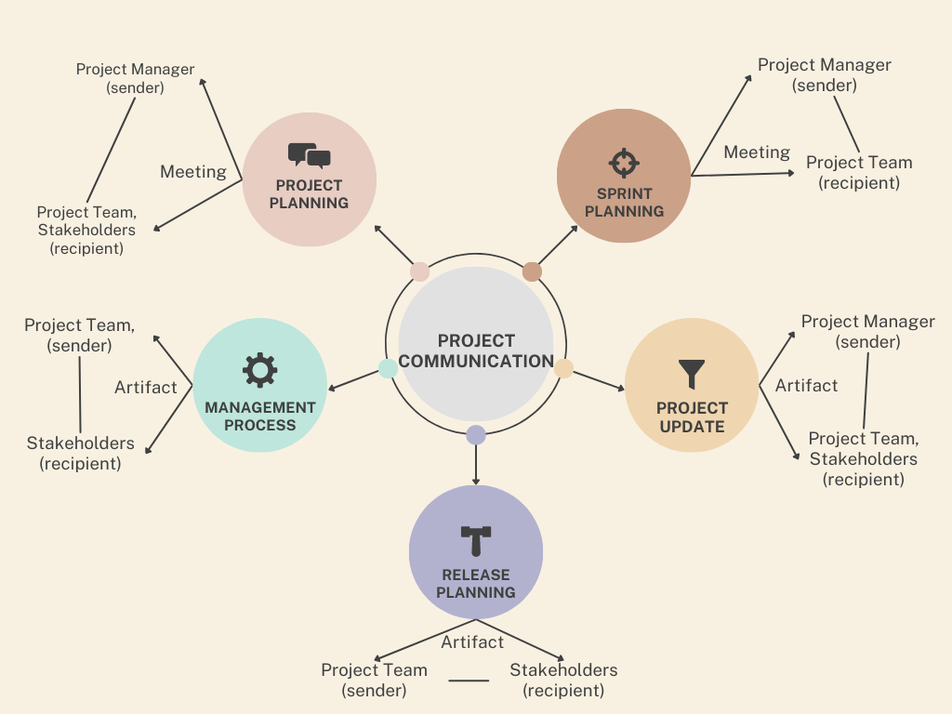

## Guidelines for Meetings

Listed below are the meeting guidelines for Barangay South Signal Village Web App:

1. **Agenda:** The meeting agenda should be discussed in advance, it should include the purpose of the meeting, the topics to be discussed, and what the team should resolve after the meeting is done. This will help the team members to prepare thoroughly for the session.
2. **Minutes:** The minutes should include all of what has taken place during the session. It should document all topics discussed, changes made, resolved resolutions, and decisions made by the team.
3. **Attendance:** attendance dictates that all team members must be present at the time of the meeting. If a member is unable to attend, they should inform the project manager in advance as well as provide a valid excuse for the absence.
4. **Schedule:** The schedule of the meeting should be scheduled in advance. The time should be agreed upon by all the team members to ensure that everyone will be able to attend.
5. **Communication:** All team members are required to voice their opinions and ideas which they think will contribute to the project. Having a smooth flow of communication will guarantee that there are no misunderstandings between the team members and that everyone has understood what has taken place in the meeting.

Having a set of well-defined guidelines will be beneficial for the team as it will help the team prepare for the meetings thoroughly. The guidelines will help each session of the team to be more organized and consistent, which will create a more collaborative environment for the team. Meetings will be more effective, efficient and productive by indicating the roles of each team member in the session and the agenda of the meeting that was established with the help of the meeting guidelines.

## Communication Standards

It is important to establish clear guidelines and protocols to ensure effective and efficient communication among team members and stakeholders. Encourage open communication channels, provide opportunities for team members to provide input, and ensure that the established communication standards are consistently followed throughout the web application development process.

1. **Active Listening:** The development team needs to encourage every team member to pay attention, seek clarification if needed, and demonstrate understanding by summarizing what others have communicated or talked about. When the team is actively listening, they will have a better understanding and it will reduce the chances of miscommunication.
2. **Clarity and Conciseness:** Team needs to emphasize the importance of clear and concise communication. Everyone in the team must express their thoughts and ideas in a straightforward manner, not just the team manager or team leader in the team. Also, avoid unnecessary jargon and technical terms that may hinder or cause comprehension.
3. **Timeliness:** Team needs to establish a standard for timely communication. Team members need to encourage everyone to respond or give feedback to messages, emails, and requests within a reasonable time limit. Set a deadline for how urgent the matters should be done or addressed. Having timely communication in the team helps maintain the project momentum that can prevent delays on the project.
4. **Professionalism and Respect:** In every communication exchange, the team should emphasize the importance of professionalism and respect to each other. Team members should be or must be respectful and courteous in every discussion, even when disagreements arise.
5. **Documentation:** Having clear documentation in the team helps maintain a record of essential information and serves as a point of reference for future use. The development team must encourage every team member to document decisions, discussions, email exchanges, agreements, and action items from meetings.
6. **Collaboration Tools:** The team should establish this in the first place where they would communicate and collaborate on their project. They need to determine the preferred collaboration tools and platforms for their communication. Standardize the use of these tools to facilitate efficient communication and ensure that all team members are familiar with their functionalities.
7. **Meeting Guidelines:** Provide guidelines for conducting effective meetings. This includes the setting of agendas, defining clear objectives for each meeting, and ensuring that the stakeholders are invited or involved when necessary. Team members must have active participation, time management, and efficient decision-making during team meetings. Always record or share meeting minutes or summaries afterward to ensure that information is accurately captured and shared.
8. **Regular Project Updates:** Team needs to have a standard for regular project updates and progress reporting. Ensure consistent and timely communication with the stakeholders. Having a regular update on the project keeps all parties informed of its progress.
9. **Feedback and Constructive Criticism:** Every team member must have an open mind and encourage a culture of feedback and constructive criticism within the team. Every team member must feel comfortable providing feedback and suggestions for improvement of the project. Emphasize the importance of delivering feedback respectfully and focusing on actionable suggestions rather than personal attacks.

## Communication Escalation Process

The communication escalation process for a web application development project outlines the steps to be taken when communication issues or conflicts arise and need to be escalated for resolution. Establishing a clear communication escalation process, you can address and resolve communication issues promptly, minimizing their impact on the web application development project.

1. **Define Communication Channels:** The development team needs to identify and establish the primary communication channels to be used for their project, like email, project management software, or designated communication tools. Every team member must be aware of and have access to these communication channels.

1. **Establish Communication Hierarchy:** The development team should define the communication hierarchy within the project team. They should identify the key project stakeholders, responsibilities, roles, this includes the project managers, project leader, and clients. The team must clearly communicate the chain of command and reporting structure to all team members.

1. **Escalation Points:** Escalating the issue to the higher-level team members or project managers who can help facilitate resolution. This is essential to address communication issues that cannot be resolved.

1. **Initial Resolution Attempts:** Whenever there is an issue in the team, team members should resolve communication issues informally and at the lowest level possible. When there are conflicts or misunderstandings, members should first attempt to address the issue directly with the involved parties through open and respectful communication.

1. **Escalation Process:** First the team needs to Identify the issue then notify immediately the supervisor or project manager. After that, Document and track the issue and facilitate a resolution. Communicate the resolution to the team for them to be aware of the resolution and move forward with a clear understanding of the resolution’s impact.

1. **Continuous Improvement:** Encourage Feedback and review the effectiveness of the communication escalation process periodically. Make necessary adjustments if needed to the process based on lessons learned.

# Procurement Plan

## Introduction

The Procurement Management Plan for the South Signal Village Barangay Web App project aims to establish an effective framework for managing the procurement activities associated with the development and deployment of the web application. This plan outlines the approach and strategies that will be employed to identify, analyze, monitor, and mitigate procurement risks, as well as determine costs, consider procurement constraints, and establish a contract approval process.

## Procurement Risks

The procurement risks for the "South Signal Village Barangay Web App" project include:

1. **Cost Estimation Risk**: Estimating procurement costs accurately can be challenging, leading to overestimation or underestimation. This can result in unnecessary expenses or budget constraints for the web application.
2. **Schedule Risk:** Delays in procurement activities can cause project schedule delays and impact subsequent tasks if the project team fails to submit or finish on time.
3. **Quality Risk:** There is a risk of procuring substandard services that do not meet the project's quality standards, leading to poor project outcomes.

## Procurement Risk Management

The South Signal Village Barangay Web App Project’s Procurement Risk Management Plan is outlined in this section. A particular risk management approach is essential given the special issues that procurement presents.

1. **Risk Identification:** We'll identify possible risks by conducting periodic risk evaluations with the project team, particularly those involved in procurement.
2. **Risk Analysis:** Each risk will be examined with consideration of how it can impact project cost, schedule, and quality. To precisely assess risk probability and potential impact, both qualitative and quantitative risk analysis methodologies will be used.
3. **Risk Monitoring:** Throughout the duration of the project, all risks will be continuously monitored, along with any related mitigation plans. With this strategy, any changes in the state of the risk are immediately detected and addressed.
4. **Risk Reporting:** Key stakeholders will receive regular reports on procurement risks, their status, and any notable changes, providing transparency and group decision-making.

## Cost Determination

Cost analysis is a crucial step in the procurement process for the Barangay South Signal Village Web Application project, ensuring the choice of reliable and affordable vendors. The project team will use a comprehensive cost determination process, which includes defining the purpose of cost determination, estimating costs, issuing a Request for Proposal (RFP), developing Cost Evaluation Criteria, executing cost analysis and negotiation, and documenting and reporting costs.

Cost Determination in the Procurement Management Plan for the Barangay South Signal Village Web App Project includes the following:

1. **Purpose** - This section describes the process and factors that should be considered when calculating costs for the Procurement Management Plan. It involves evaluating expenses for acquiring products and services from other vendors, particularly for the Barangay South Signal Village Web App Project.
2. **Cost Estimation** - The project team will work together to estimate the costs of obtaining the necessary goods and services for the web app project. Various cost estimation techniques will be used based on available information and project requirements. Accurate cost estimates will be developed incorporating previous information, industry benchmarks, and expert opinion.
3. **Request for Proposal (RFP)** - Vendors will be encouraged to submit requests in response to the RFP, which will contain full information about their goods or services along with cost breakdowns. The RFP will clearly define the cost components that must be included in vendor proposals, which will include hardware, software, licensing fees, development services, maintenance, and other relevant costs. Vendors will be obliged to submit thorough breakdowns to encourage transparency and effective evaluation.
4. **Cost Evaluation Criteria** - Costs, along with quality, experience, and delivery schedules, will be important consideration in the vendor selection process. The Procurement Team is going to create an evaluation procedure to emphasize cost in relation to other assessment factors. The cost evaluation will consider both the initial and ongoing costs associated with the goods or services.
5. **Cost Analysis and Negotiation** - The Procurement Team will examine the cost breakdowns provided after receiving vendor proposals. Any errors, shortcomings, or areas requiring clarification in the cost bids will be recognized and corrected through discussions with the suppliers. Cost analysis may be performed again to ensure accuracy, reasonableness, and alignment with the project's budget and objectives.
6. **Cost Reporting and Documentation** - Accurate cost reporting and documentation will be maintained throughout the procurement process. Cost reports will provide an overview of estimated costs, vendor proposals, cost analysis findings, negotiation outcomes, and final agreed-upon costs. These reports will serve as a reference for stakeholders, promoting transparency and accountability in the procurement process.

The Barangay South Signal Village Web App Project aims to procure goods and services at optimal costs while meeting project requirements and maintaining financial control by implementing effective cost-determination processes within the Procurement Management Plan.

## Procurement Constraints

The purpose of this section is to outline the constraints that must be considered during the procurement management process for the Barangay South Signal Village Web App project. These constraints may impact various aspects such as schedule, cost, scope, resources, technology, and buyer/seller relationships. It is essential to identify and address these constraints throughout the procurement activities to ensure project success. Identifying constraints early in the project lifecycle is crucial, as late identification may significantly impact the project's likelihood of success.

The following constraints have been identified for the Barangay South Signal Village Web App project:

1. **Budget Constraints:** The project has a predefined budget that must be adhered to during the procurement process. All procurement activities, including vendor selection, contract negotiation, and purchasing decisions, must be aligned with the approved budget.
2. **Timeline Constraints:** The project has specific timelines and milestones that must be met. Procurement activities should be planned and conducted in a way that aligns with the project schedule to avoid delays in the overall development and deployment of the web app.
3. **Scope Constraints:** The project has well-defined scope boundaries that should be considered during the procurement process. Procurement activities should focus on acquiring goods and services that align with the project's scope and requirements, avoiding unnecessary purchases or scope creep.
4. **Resource Constraints:** The availability of internal resources, such as procurement specialists or contract administrators, may be limited. This constraint should be considered when planning and executing procurement activities. External resources may need to be engaged to supplement the internal team if necessary.
5. **Technological Constraints:** The procurement of technology-related components, such as software licenses, hardware, or cloud services, may have specific constraints or compatibility requirements. The procurement team should ensure that the selected vendors and solutions align with the project's technological infrastructure and are compatible with the existing systems.
6. **Buyer/Seller Relationships:** The project may have established relationships with preferred vendors or suppliers that need to be considered during the procurement process. If there are existing contracts or agreements with specific suppliers, they should be reviewed to determine if they align with the project's requirements and if any amendments or renewals are necessary.

These constraints should be thoroughly considered and incorporated into the procurement management process for the Barangay South Signal Village Web App project. Careful planning, proactive risk management, and effective communication with stakeholders will help navigate these constraints and ensure successful procurement outcomes while meeting the project's objectives.

## Contract Approval Process

The contract approval process for a web application development project involves the steps and procedures to ensure that the contractual agreements between the client and the development team are carefully reviewed, approved, and executed. It is important to note that the contract approval process may vary depending on the organization's internal procedures, legal requirements, and project complexity. It is advisable to involve legal experts, project managers, and relevant stakeholders in each step of the contract approval process to ensure compliance, clarity, and effective risk management.

1. **Contract Drafting:** The contract is usually drafted by the client’s legal team or the development team’s legal representatives. The contract should clearly outline the scope of the work, deliverables, payment terms, project timelines, intellectual property rights, confidentiality clauses, dispute resolution mechanisms, and any other relevant terms and conditions.

1. **Internal Review:** The development team’s legal representative and relevant stakeholders, like the project managers and senior management, should conduct an internal review before presenting the contract to their client. The review is important because this ensures that the contract aligns with the project requirements, legal considerations, and company policies.

1. **Client Review:** Since the draft contract is shared with the client for their review, the client may involve their legal team or internal stakeholders to assess the terms and conditions. This will allow the client to review the proposed agreement, provide feedback, and request changes if there are any.
2. **Negotiation and Amendments:** A negotiation process takes place between the development team and the client when the client requests a change or raises a concern about the specific clauses. Both parties will work together and address their concerns, propose amendments, and reach a mutually acceptable agreement. Take note that this may involve multiple rounds of discussions and revisions until both parties are satisfied.

1. **Legal Approval:** Once the negotiations and amendments are finalized, the contract will be sent to the legal teams of both the client and the development team for final review and approval.

1. **Senior Management Approval:** Following legal approval, the finalized contract is presented to the senior management or executive of the client and the development team for final approval.

1. **Execution and Signatures:** The contract is prepared for execution once it obtains the required approvals. After that, the authorized representatives of both the client and the development team will sign the contract to make it legally binding. Signatures may be physical or electronic depending on the jurisdiction and organizational practices.

1. **Documentation and Filing:** It should be properly documented and filed for future reference once the contract is signed. The team should maintain copies of the executed contract in a secure and accessible location. This is important because the documentation serves as a reference point throughout the project lifecycle and can be used in case of any disputes or clarifications.

## Decision Criteria

The following are the decision criteria that the contract review board will use for the Barangay South Signal Web App:

1. **Cost**: The cost of the vendor’s proposed solution should be manageable and affordable. It should be based on existing resources and materials in the current market.
2. **Schedule:** The vendor must show they can complete the project by the deadline and deliverables, as well as significant checkpoints and due dates.
3. **Technical Skills:** The vendor must be able to exhibit the necessary skills and capabilities to ensure that the project will be successful.
4. **Experience:** The vendor must show that they have sufficient experience in handling the current project through past projects that involve developing similar or related systems.
5. **Risk Management:** The vendor must show that they have the necessary knowledge of risk mitigation techniques as well as methods in identifying potential risk that might impact the progress of the project.

The vendor that best fulfills the demands and goals of the project will be chosen by the contract review board after all proposals have been evaluated using these criteria.

## Performance Metrics for Procurement Activities

This section outlines the metrics to be used for measuring the performance of procurement activities associated with the Barangay South Signal Village Web App project. These metrics serve two primary purposes: to ensure that procurement activities stay on schedule and to compile data on vendor performance to assist with future procurement activities and vendor selection criteria.

The following performance metrics will be utilized for procurement activities:

1. **Procurement Schedule Adherence:** This metric measures the extent to which procurement activities adhere to the defined schedule. It tracks the timeliness of key milestones, such as vendor selection, contract negotiation, and purchase order issuance. Any deviations from the schedule will be identified and addressed promptly to prevent delays in the overall project timeline.
2. **Vendor Response Time:** This metric evaluates the time it takes for vendors to respond to requests for information (RFIs), requests for proposals (RFPs), and other inquiries. It ensures that vendors are responsive and provides insights into their efficiency and commitment to the procurement process.
3. **Vendor Performance Evaluation:** This metric assesses the performance of selected vendors based on predefined criteria, such as quality, adherence to contractual obligations, on-time delivery, and customer satisfaction. It provides data on vendor performance that can be used to evaluate their suitability for future procurement activities and assists in the development of vendor selection criteria.
4. **Cost Variance:** This metric measures the variance between the planned procurement costs and the actual costs incurred. It helps identify any deviations from the budget and enables the project team to take appropriate corrective actions if necessary.
5. **Quality of Procured Goods and Services:** This metric evaluates the quality of goods and services acquired through the procurement process. It assesses whether the procured items meet the defined quality standards and specifications.
6. **Contract Compliance:** This metric examines the extent to which vendors adhere to the terms and conditions specified in the contracts. It ensures that vendors fulfill their contractual obligations, including delivery timelines, payment terms, and performance requirements.

By using these performance metrics, the project team can monitor and evaluate the effectiveness of procurement activities. The data collected will provide valuable insights for improving future procurement processes, vendor selection, and contract management. Regular performance reviews and analysis of these metrics will help identify areas for improvement, ensure accountability, and optimize procurement practices for the Barangay South Signal Village Web App project.

# Implementation Plan

## Executive Summary

The Barangay South Signal Village Web App aims to deliver a robust and user-friendly platform that enhances communication and engagement within the community. The plan emphasizes efficient resource allocation, adherence to timelines, stakeholder engagement, quality assurance, and comprehensive training and support.

Throughout the implementation phase, the project team will continuously monitor progress, identify risks and issues, and take proactive measures to address any challenges that may arise. Regular evaluation and feedback mechanisms will ensure that the implementation aligns with the project's objectives and delivers the desired outcomes.

The successful implementation of the Barangay South Signal Village Web App will pave the way for improved community services, streamlined communication channels, and enhanced citizen participation in the affairs of the barangay.

## Transition Approach

Since there is a requirement for continuity and minimal disruption to existing activities, the Transition Out strategy for the Barangay South Signal Village Web App Project will take a phased transition approach. This strategy reduces the possibility of downtime and service disruption by transferring knowledge, assets, and responsibility to the client gradually and systematically.

The transition approach will include the following steps:

1. **Communication Plan:** A detailed communication plan will be prepared to ensure that all stakeholders are well-informed on the transition plans, schedules, and expectations. Regular updates, meetings, and documentation will support transparent and effective communication throughout the transition process.
2. **Transition Planning:** The transition plan, which outlines a thorough schedule of activities throughout the transition phase, will be created in collaboration with Barangay South Signal Village. Responsibilities, including data migration, system configuration, and verification, are included to guarantee a seamless handover.
3. **Knowledge Transfer:** To guarantee that the client has the skills and knowledge required to support the system, knowledge transfer will be supported via various techniques. User guides, technical details, and as-built documents will all be included in the comprehensive documentation. Formal training sessions and workshops will be held to further demonstrate to the client's team handling the system, maintenance, and troubleshooting.
4. **Resource Transfer:** Resources will be transferred from the project team to the client during the transition. This comprises the web app's source code, database, licensing, and other relevant assets needed to function and manage. The transfer will be carefully planned to guarantee that all relevant resources are transferred promptly.

By following this phased transition approach, the Barangay South Signal Village Web App Project aims to enable a seamless and successful transfer of the system to the client, allowing them to autonomously operate and maintain the web app in the long term.

## Transition Team Organization

## 

The transition team for the project consists of the following key roles:

1. **Project Manager**: The Project Manager is responsible for managing the project's scope and ensuring that it remains within the defined boundaries. This includes identifying and managing any changes to the scope, communicating scope changes to the team and stakeholders, and ensuring that the project's deliverables align with the scope. The Project Manager is also responsible for ensuring that the project is completed on time and meets the specified quality standards.
2. **Product Owner**: The Product Owner is responsible for defining and prioritizing the project requirements and ensuring that the final product meets the needs of the Project Sponsor. They work closely with the Project Manager and Scrum Team to ensure that the project deliverables align with the scope.
3. **Scrum Master**: The Scrum Master is responsible for facilitating the agile development process and ensuring that the team is following the Scrum framework. They work closely with the Project Manager and Product Owner to ensure that the project is progressing according to the defined scope. The Scrum Master is also responsible for identifying and managing any scope-related risks or issues.
4. **Scrum Team**: The Scrum Team is responsible for developing the project deliverables and working together with the rest of the team to ensure the success of the project. This includes understanding and adhering to the project's scope, identifying any scope-related risks or issues, and communicating these to the Project Manager and Scrum Master.
5. **Documentation Manager**: The Documentation Manager is responsible for managing the project documentation and ensuring it is complete and accurate. They work closely with the Project Manager and team to ensure that all project documentation aligns with the scope.
6. **Project Sponsor**: The Project Sponsor is responsible for providing input on the project's scope, including requirements and expectations. Also, responsible for accepting the project deliverables defined by the project's scope. It is important for the Project Manager to communicate regularly with Project Sponsor to ensure that the project remains aligned with their needs and expectations.

## Workforce Transition

A crucial part of our strategy for the "South Signal Village Barangay Web App" is staff members changes. Establishing and communicating the staff strategy for the duration is important for ensuring a smooth and successful transition.

The best course of action for employees, the Transition Project Manager will engage closely with the existing and new development teams as well as the barangay authorities and residents. The current team can potentially be retained, members could be transferred to the new contractor, or new team members could be brought on entirely.

In this process, effective communication will be crucial. Any changes should be promptly and respectfully communicated to the staff. To make sure all team members are fully informed of their options and receive the appropriate assistance throughout the transition process.

Furthermore, employees will receive the necessary training or retraining to ensure that they are well-equipped to continue providing high-quality services both during and after the transition phase. Understanding details of the web app, its features, and the security precautions it uses are part of this.

## Workforce Exec During Transition

Transitioning a workforce during a web application deployment or migration requires careful planning and execution to ensure a smooth and efficient process.

1. **User Training:** The team needs to identify the specific knowledge and skills users need to acquire. Also, set a clear objective aligned with the web application’s features and user roles. Lastly, facilitate a training session that will ensure active participation of the users and addressing their questions.
2. **Final Testing and QA with the stakeholders:** The project team, with the necessary stakeholders, needs to conduct final testing and quality assurance of their web application to ensure a fully functional and it meets all requirements. Migrate any relevant data or content from the legacy systems to the new web application and validate the accuracy and completeness of the data.
3. **Documenting Successes and Achievements:** Document all the successes and achievements of the implementation process of the team. Acknowledge the contributions of team members and stakeholders who played a vital role in the project's success. Lastly, Identify the areas where improvements can be made for future implementations and updates.
4. **Update Files/Records:** The team needs to identify the specific files and records that need to be updated. Collect all the updated data or information that needs to be incorporated into the files and records. Lastly, ensure the accuracy and integrity of the new data and verify the source and its relevancy.
5. **Gain Formal Acceptance:** Verify everything that all project tasks and activities have been successfully completed. After verifying everything, the development team needs to prepare a formal acceptance agreement or document that will outline the stakeholder’s acceptance of the project. Do not forget to obtain the necessary signatures or approvals from the relevant stakeholders to signify their formal acceptance.
6. **Archive Files/Documents:** The team needs to review all the files to determine which one is eligible for archiving. After that, sort the files into categories for efficient archiving.
7. **Project Close Out Meeting:** The development team needs to define the objectives of the close out meeting, including reviewing the project accomplishments, documenting lessons learned, and lastly, celebrating the project's success.

## Property Transition

### Intellectual Property

In the case of the Barangay South Signal Village Web App, the client has no prior system before the project has been done. All processes were conducted manually through a physical workforce and the storage are physical file cabinets. The system of the barangay before the project is all paper based so there will be no issues regarding the transition of all the intellectual properties. In terms of the election of the new barangay chairperson, all the legalities that are needed during the transition will be handled by the client.

### User Accounts and Passwords

For the South Signal Village Barangay Web App, the objective of this implementation plan is to outline the stages and procedures for implementing user accounts and passwords. The security and privacy of user data on the web app is greatly improved with user accounts and passwords. We hope to develop a reliable and intuitive authentication system by adhering to the guidelines and best practices described in this plan.

**Objectives**

The objectives of implementing user accounts and passwords are as follows:

1. Provide residents with a secure and personalized experience on the web app.
2. Protect sensitive user information by ensuring proper authentication and authorization.
3. Enable residents to access personalized services and features based on their roles.
4. Facilitate communication and interaction between residents and barangay officials.

**User Account Creation**

To create a user account, the following steps will be taken:

1. Registration: Users will be required to provide necessary information such as their full name, contact details, and government-issued identification.
2. Identity Verification: The system will verify the user's identity using the government-issued identification documents provided.
3. Account Creation: Upon successful verification, a unique user account will be created with a username and password.
4. Account Activation: An activation link will be sent to the user's registered email address for account activation.

**Password Management**

To ensure strong password security and management, the following measures will be implemented:

1. Password Complexity: When creating a password, users will be asked to use a combination of uppercase and lowercase letters, numbers, special characters with at least one character.
2. Password Encryption: User passwords will be stored in an encrypted format using industry-standard encryption algorithms to prevent unauthorized access.
3. Password Reset: A password reset mechanism will be provided, allowing users to reset their passwords through a secure email verification process.

**User Communication and Support**

To enhance user experience and provide necessary support, the following measures will be implemented:

1. User Notifications: Users will receive notifications for important announcements, updates, and account-related activities via email or in-app notifications.
2. Help and Support: A dedicated support system, such as a helpdesk or a frequently asked questions (FAQ) section, will be available to assist users with any issues or queries related to their accounts.

**Compliance and Data Protection**

To comply with data protection regulations and ensure user privacy, the following measures will be implemented:

1. Data Encryption: User data, including personal information, will be encrypted during transmission and storage to prevent unauthorized access.
2. Data Retention: User data will be retained for the necessary duration as per legal and regulatory requirements.
3. User Consent: Users will be required to provide explicit consent for the collection, processing, and storage of their personal information.

## Knowledge Transfer

1. The team will provide relevant documentation and manuals that provide step-by-step instructions on how to perform specific functions related to the system.
2. The team will conduct training for the barangay employees who will utilize the web application to ensure they fully understand the system and its processes.
3. The team needs to identify the individuals or teams who possess the critical knowledge and skills that need to be transferred.
4. Encourage every team member to create comprehensive documentation that will include processes, best practices, procedures, and their insights.
5. Determine the most effective methods for transferring knowledge and the learning preferences of the recipients.
6. Allocate or schedule sufficient time for both the knowledge holders to share their knowledge to the recipients for them to absorb and clarify the information.
7. The team needs to encourage an interactive discussion and Q&A sessions to address any questions.
8. The development team needs to implement knowledge sharing platforms to facilitate ongoing knowledge sharing and collaboration.
9. Always conduct a regular evaluation and feedback to assess everything about the effectiveness of the knowledge sharing.

This will enable the development team to retain expertise, enhance the capabilities of team members, and promote continuous learning and improvement.

## Schedule

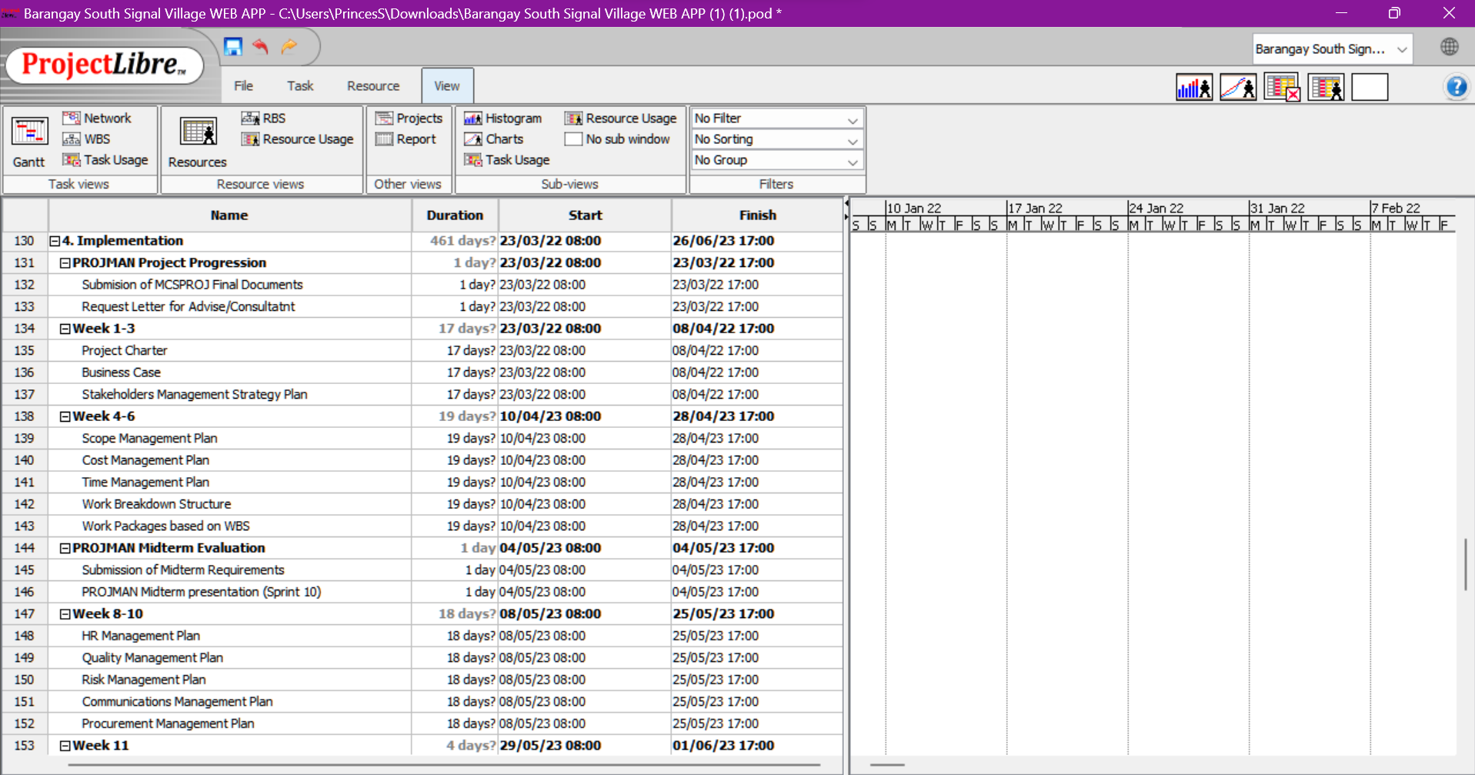

Figure 4 Schedule

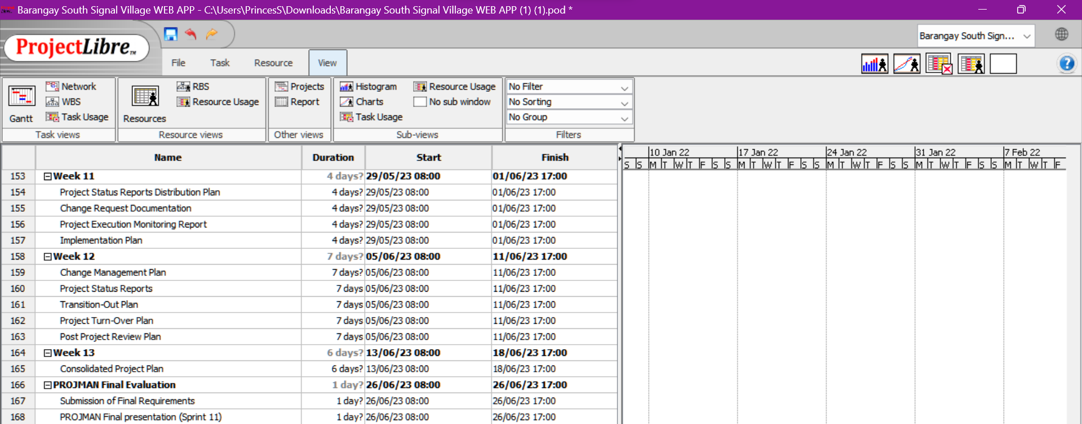

## Handover And Acceptance

The Handover and Acceptance phase marks the transition from the implementation phase to the operational phase of the Barangay South Signal Village Web App project. This section outlines the key activities and considerations involved in the handover process and the acceptance of the web app by the stakeholders.

### Handover Process

1. **Documentation Completion:** All relevant project documentation, including technical specifications, user manuals, training materials, and system documentation, will be finalized and compiled. These documents will provide essential guidance and information for future maintenance and operation of the web app.
2. **Training and Knowledge Transfer:** The project team will conduct training sessions to transfer knowledge and skills to the designated stakeholders responsible for the web app's operation and maintenance. This training will ensure that the stakeholders understand the app's functionalities, administration processes, and troubleshooting techniques.
3. **System Testing and Quality Assurance:** A comprehensive testing process will be conducted to ensure that the web app functions as intended and meets the defined quality standards. Any identified issues or bugs will be addressed and resolved before the handover.
4. **Source Code and Deployment Assistance:** The project team will provide the client with the web app's source code as part of the handover process. They will also provide assistance and guidance for the web app's deployment, guaranteeing a seamless transition and effective implementation.
5. **Transition Planning:** A detailed transition plan will be developed to outline the activities, responsibilities, and timelines for the handover process. It will include the identification of key contacts and escalation procedures in case of any issues during the transition.

### Acceptance Process

1. **Acceptance Criteria:** The acceptance criteria for the Barangay South Signal Village Web App will be established in collaboration with the stakeholders. These criteria will define the specific requirements and performance benchmarks that must be met for the app to be accepted.
2. **Acceptance Testing:** The stakeholders will conduct acceptance testing to verify that the web app fulfills the agreed-upon requirements and meets the acceptance criteria. This testing may include functional testing, usability testing, and performance testing.
3. **Issue Resolution:** Any identified issues or discrepancies during the acceptance testing will be documented and resolved by the project team. The stakeholders will review the resolution process and provide feedback on the effectiveness and completeness of the resolutions.
4. **Acceptance Sign-Off:** Once the stakeholders are satisfied with the performance and functionality of the web app and all identified issues have been resolved, an official acceptance sign-off will be obtained. This sign-off indicates that the stakeholders accept the web app as meeting their requirements and are ready to assume responsibility for its operation and maintenance.

The Handover and Acceptance phase ensures a smooth transition from the project team to the stakeholders, enabling the Barangay South Signal Village Web App to enter the operational phase effectively. Clear documentation, thorough training, comprehensive testing, and collaborative acceptance processes are essential to ensure a successful handover and acceptance.

# Change Management Plan

## Introduction

Change Management is a very important part or step of a successful project. The change management process defines the steps used to identify and make changes to a project including the scope of it. This ensures that the appropriate things are in place like the development, design of the web app, execution, and what the barangay’s still need. A comprehensive and structured approach to change management is very important to the success of the project that will bring about significant changes/s. An effective change management will enhance the performance and ensure the continuous improvement of the team’s project web application.

## Change Management Approach

In this section, the team outlines the web application's approach to managing changes throughout the project lifecycle. The goal is to ensure consistency and repeatability process in managing the changes, which would guarantee the effectiveness of our change management approach.

1. The team would look through the web application's errors, notably spelling mistakes, grammar, word usage, and consistency in the use of words. The team will take note of these changes for further review if the change is sufficient.
2. Communication between the client about the web application if any additional changes are needed. This will also help the team inquire about the web application if there are unsure/needed revisions.
3. The team will document the changes to ensure the changes are consistent as well as in line with our scope.
4. For large/significant changes to be implemented, we ensure that the clients are involved in the plan so that the team is still on track and consistent.

## Definitions of Change

There are several types of changes that may be requested and considered for the Webapp Project. Depending on their extent and type, changes to project documentation and communication will be required to include approved changes in the project plan and notify the client.

Scope Changes refer to modifications that are necessary and impact on the project's scope, possibly as a result of unforeseen requirements not initially planned for. These changes may also require revisions to the ERD, state machine, project scope statement, and other project documentation.

The team must ensure that any approved changes are communicated to the client and captured in the project documentation as necessary. These updated documents must then be shared with the project team, advisor, and client.

## Change Control Board

The Change Control Board (CCB) is the approval authority for all proposed change requests pertaining to the Barangay South Signal Village web-app. The purpose of the CCB is to review all change requests, determine their impacts on the project risk, scope, and schedule, and to approve or deny each change request. The following chart provides a list of the CCB members for the web-application project:

Table 24 Change Control Board

|  |  |  |
| --- | --- | --- |
| **Name** | **Position** | **CCB Role** |
| Hon. Michelle Odevilas | Project Sponsor | CCB Chair |
| Mikedale B. Dellera | Project Manager | CCB Member |
| Wilkins V. Caducio | Product Owner | CCB Member |
| Jakerson B. Bermudo | Scrum Master | CCB Member |

As change requests are submitted to the Project Manager by the project team/stakeholders, the Project Manager will log the requests in the change log and the CCB will convene every other Friday to review all change requests. For a change request to be approved, all CCB members must vote in favor. In the event more information is needed for a particular change request, the request will be deferred and sent back to the requestor for more information or clarification. If a change is deemed critical, an ad hoc CCB meeting can be called in order to review the change prior to the next scheduled bi-weekly CCB meeting.

## Roles and Responsibilities

The following are the roles and responsibilities for all change management efforts related to the Barangay South Signal Village Web App:

**Project Sponsor:**

* Approve all major changes to the web application.
* Approve all changes to schedule baseline.
* Approve any changes in project scope.
* Chair the CCB

**Project Manager:**

* Receive and log all change requests from project team.
* Conduct preliminary risk, schedule, and scope analysis of change prior to CCB.
* Seek clarification from change requestors on any open issues or concerns.
* Make documentation revisions/edits as necessary for all approved changes.
* Participate on CCB

**Project Team:**

* Submit all change requests on standard organizational change request forms.
* Provide all applicable information and details on change request forms.
* Be prepared to address questions regarding any submitted change requests.
* Provide feedback as necessary on the impact of proposed changes.

## Change Control Process

The change control process for the Team Developmentality of the South Signal Village Web Application will be guided by the standard change process for this project. The product owner and the scrum master are responsible for executing the change management procedure for every change request with the support of the project secretary and the rest of the team.

1. **Change Request** - A change request may be created by any team member, client, subject adviser, project adviser, or panellists. It must be documented on a formal change request form and submitted to the project secretary.
2. **Logging the Request** - The project secretary will log all change requests and provide them to the product owner and scrum master.
3. **Evaluation** - The product owner, in conjunction with the scrum master and the project adviser, will evaluate the change request through a meeting. They will assess the impact on the project's scope, timeline, and resource allocation and determine if the request is within the project plan's scope.
4. **Change Request Decision** - The change request will be approved or rejected by the product owner, scrum master, project adviser, and subject adviser. If approved, the project plan will be updated to incorporate the change.
5. **Implementation** - The approved change will then be carried out by the team based on its level of complexity. If the change involves updating documentation, the product owner will lead the team, and if it involves code updates or testing, the scrum master will be responsible for implementation. The team will ensure that the change meets the requirements specifications.
6. **Documentation** - The change will be documented properly by the project secretary, and it should be communicated to all project team members and their clients.
7. **Review** - The team will review the change to ensure it has been implemented as intended and the project still aligns with the project objectives.

The South Signal Village Web Application project's change control process gives Team Developmentality a framework for successfully implementing approved changes, communicating these updates, and maintaining project documentation. They may make sure the project is successful with the help of the scrum master and the product owner, who will serve as the team's leader.

# Sponsor Acceptance

This project acceptance document establishes formal acceptance of all the deliverables for the Barangay South Signal Village Web App project. The project has met all the acceptance criteria as defined in the requirements document and project scope statement.

Approved by the Project Sponsor:

Date:

Hon. Michelle Ann Odevilas

Barangay Captain

# Appendices

## Appendix A: Methodology

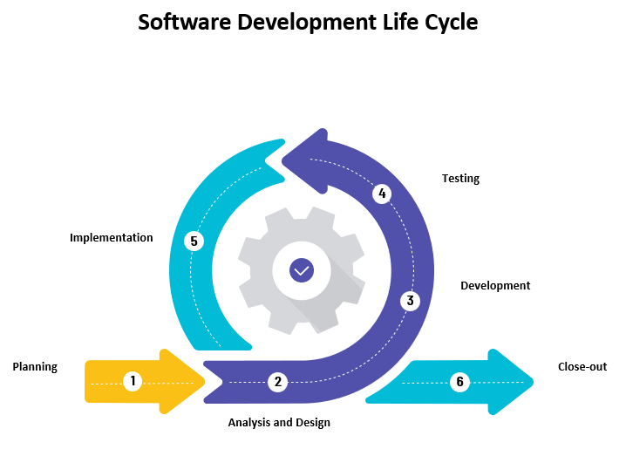

Figure 5 Methodology

Throughout this project, the team utilized an SDLC or Software Development Cycle to guide them, explicitly using the Agile Method. Software Development Cycle is one of the fundamental methods in developing software step-by-step. Using the Agile Method in the Software Development Cycle focuses attention on the team to respond to the changes that the clients demand throughout the development process. This method emphasizes the efficient and effective collaboration between the team and the client. SDLC Agile Methodology shows the model which the team used throughout the software development.

1. **Planning Phase:** The team starts by collecting information and requests from the client through interviews, talks, and meetings. They examine the main problem and come up with good ideas for how to fix it based on the information they've gathered. There are brainstorming meetings to figure out what technologies and software should be used. The client is told about the suggested solution and technologies and asked to agree with them.
2. **Analysis and Design:** This is where the team makes wireframes and mockups to show how the software will look, how it will work, and how it will be set up. They use the right UI and UX design concepts to meet the requirements and expectations of the client.
3. **Development Phase:** The team begins to put the proposed answer into action using the technologies and software they have chosen. They create the front end, back end, and database parts of the program and make sure they work well together.
4. **Testing Phase:** the team evaluates the software's features, speed, security, and the system as a whole as a whole. They use iterative development methods to take feedback into account and improve the software as needed.
5. **Implementation Phase:** The software is put into the production system, and the team turns over responsibility and ownership of the software to the client, according to the terms that were agreed upon.
6. **Close Out Phase:** The team gives the software a final look over and evaluates it. Any problems or bugs that are still there are fixed. The client is given all the necessary documentation and training tools for future use and maintenance. The project is finally finished, which means that the client now owns and runs the software without any problems.

## Appendix B: Release Plan

**RELEASE 1**

* Residents can visit the website and view the home page, contact page, safety section page, and about us page.
* Residents can register on the web app.
* Residents can access their resident profile by logging-in using email and password.
* Residents can edit on the resident dashboard on his/her address, email, mobile number, and password.
* Administrators can add, view, and edit Barangay Employee accounts (Barangay Secretary, Barangay Request Manager, Barangay Concern Manager, and Barangay Captain).
* Barangay Employee (Barangay Secretary, Barangay Request Manager, Barangay Concern Manager, Administrator and Barangay Captain) can access their dashboard by logging-in using email and password.

**RELEASE 2**

* Residents can request documents on their resident profile.
* Residents can receive tracking key through email or text.
* Residents can track the status of their requests.
* The Barangay Secretary and Barangay Request Manager can receive document request.
* The Barangay Secretary and Barangay Request Manager can view document request.
* The Barangay Secretary and Barangay Request Manager can change the status (approved or denied) of document request
* The Barangay Secretary can input the information into the database on their dashboard of all requested barangay documents done manually.

**RELEASE 3**

* Residents can submit concerns on their resident profile.
* Residents can receive notification about the submitted concerns.
* Residents can track the status of their submitted concerns.
* Barangay Secretary and Barangay Concern Manager can receive submitted concerns from the residents.
* The Barangay Secretary and Barangay Concern Manager can view, and process submitted concerns from the residents.
* The Barangay Secretary and Barangay Concern Manager can change the status of submitted concerns from the residents.
* Barangay Captain can view the report.
* Administrator can manage the web application.
* Security measures are created.

## Appendix C: Consolidated Gantt Chart

Access the file here: [01 CONSOLIDATED GANTT CHART - TEAM DEVELOPMENTALITY.pdf](https://asiapacificcollege-my.sharepoint.com/:b:/g/personal/jlquesada_apc_edu_ph/EdPufrqqlrdEgvcnTEZYuh8B89y8LuYNsg44AwlOKmAK_g?e=VbYlTt)

*Note: Clicking on the link will direct you to the Consolidated Gantt Chart file.*

## Appendix D: Budget and Project Costs

Access the file here: [02 Budget and Project Costs - TEAM DEVELOPMENTALITY.pdf](https://asiapacificcollege-my.sharepoint.com/:b:/g/personal/jlquesada_apc_edu_ph/ERsBCEYS9IBGrJkCAOGnxuEB1_y1Wr23eEd_9YqM3zSrUA?e=y94Fjh)

Note: Clicking on the link will direct you to the Budget and Project Costs file.

## Appendix E: Budget and Cost View Work Packages

Access the file here: [03 BUDGET AND COST VIEW WORK PACKAGES - TEAM DEVELOPMENTALITY.pdf](https://asiapacificcollege-my.sharepoint.com/:b:/g/personal/jlquesada_apc_edu_ph/EZiLN5T6XbRBp-qPKnnKpMQB30uPWXK-BnL7RN4ETtUbPg?e=TFIrbq)

Note: Clicking on the link will direct you to the Budget and Cost View Work Packages file.

## Appendix F: Prototype

### Resident Prototype:

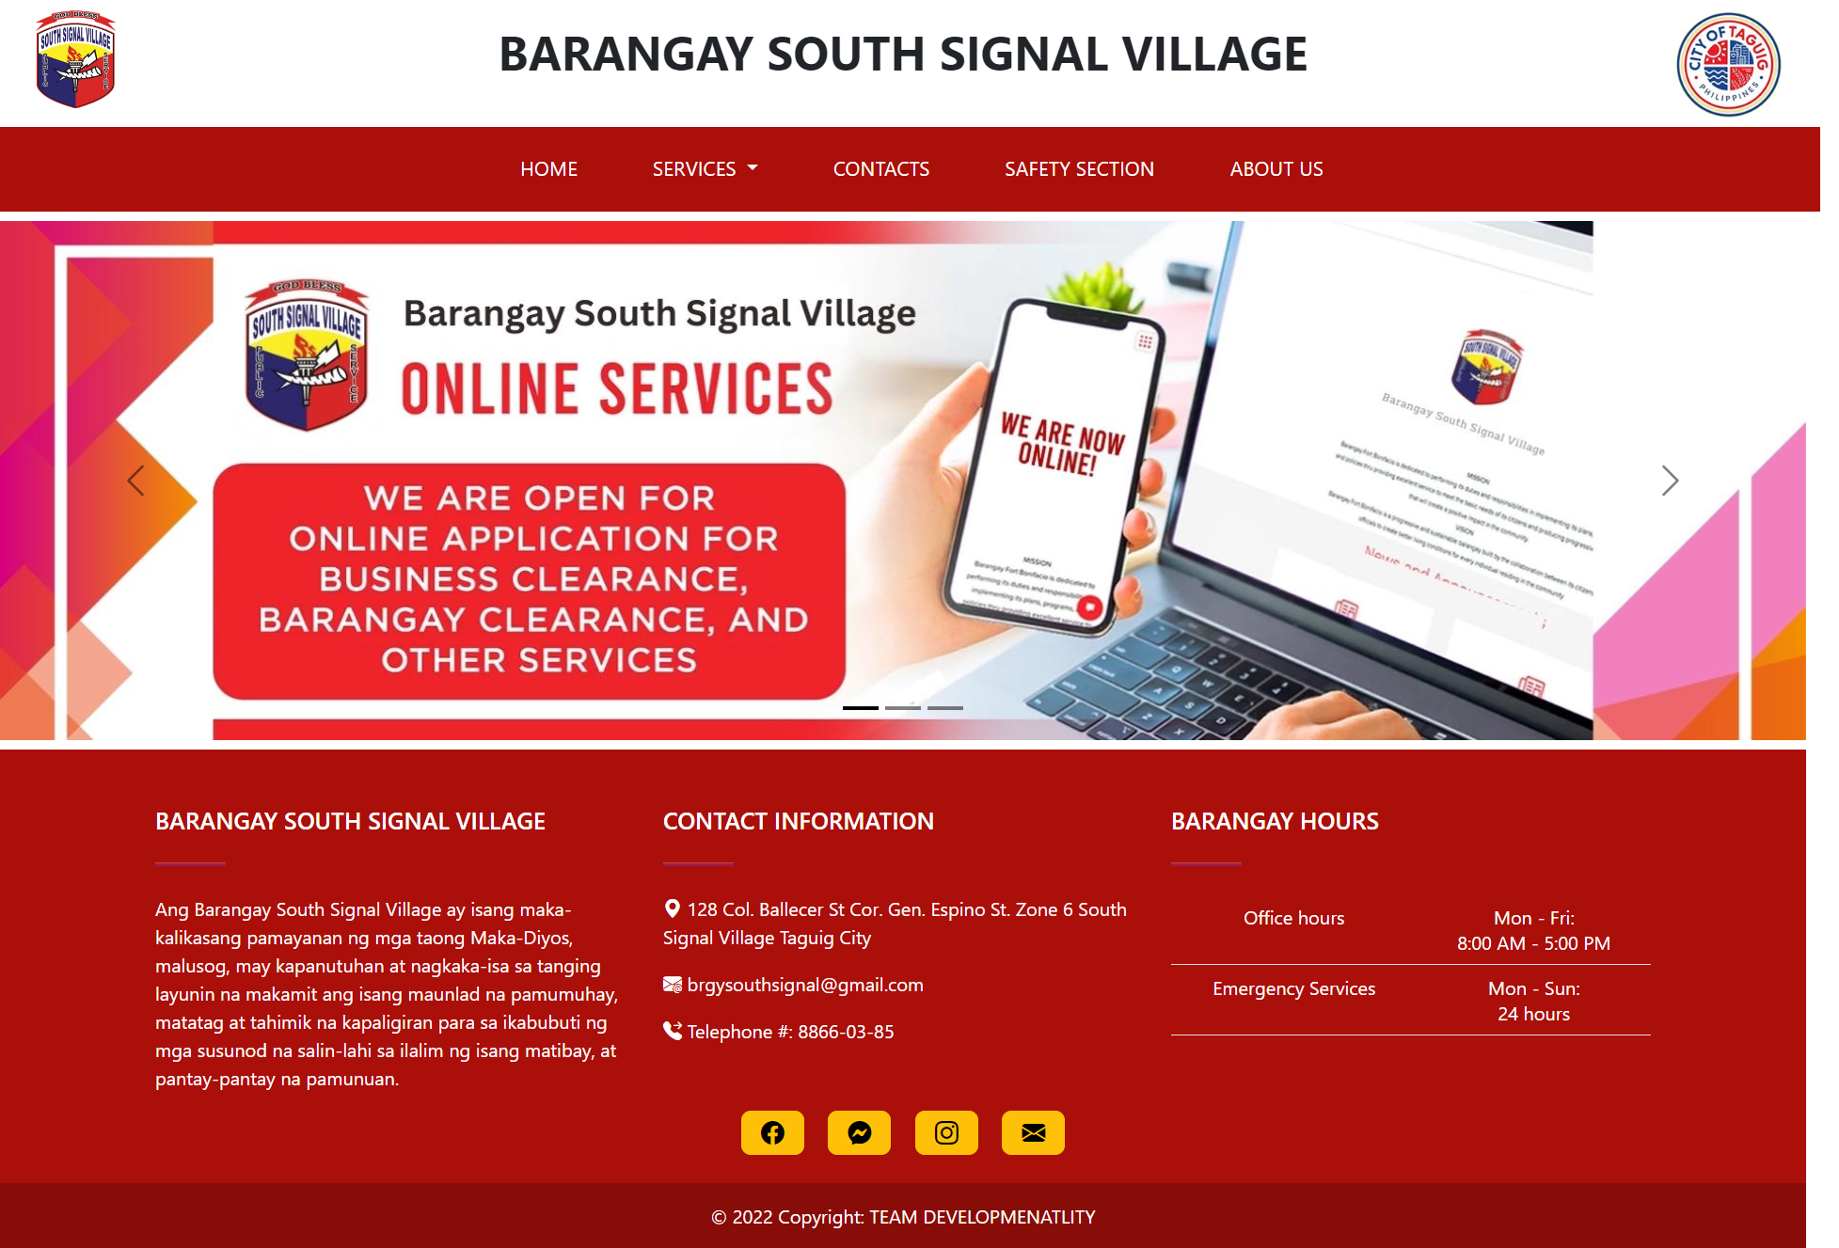

Figure 6 Home Page

This is the homepage featuring a carousel, a slideshow component that cycles through images of announcements made by the barangay.

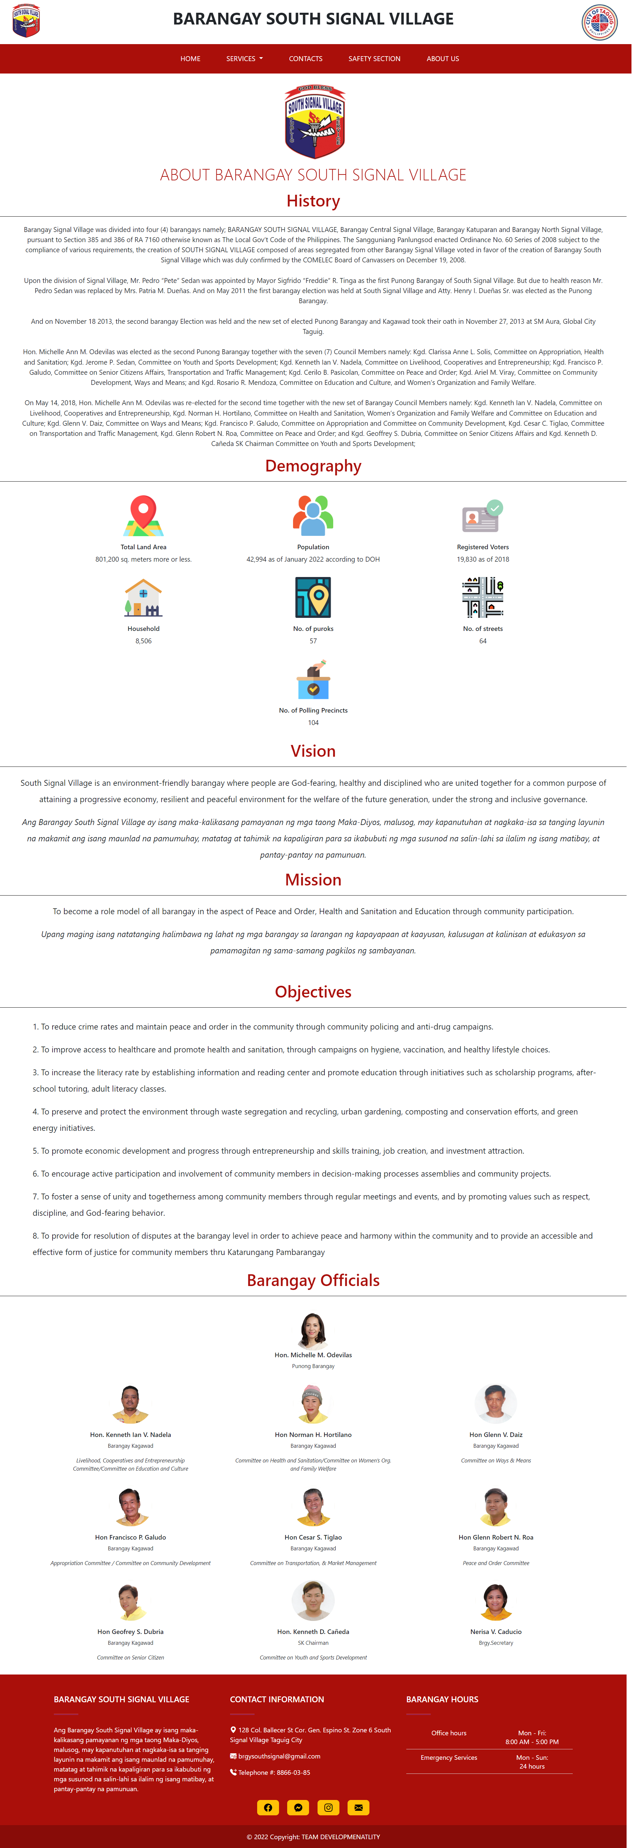

Figure 7 About Us Page

The 'About Us' page contains the barangay profile, including its history, demographic information, vision, mission, objectives, and a list of the current barangay officials.

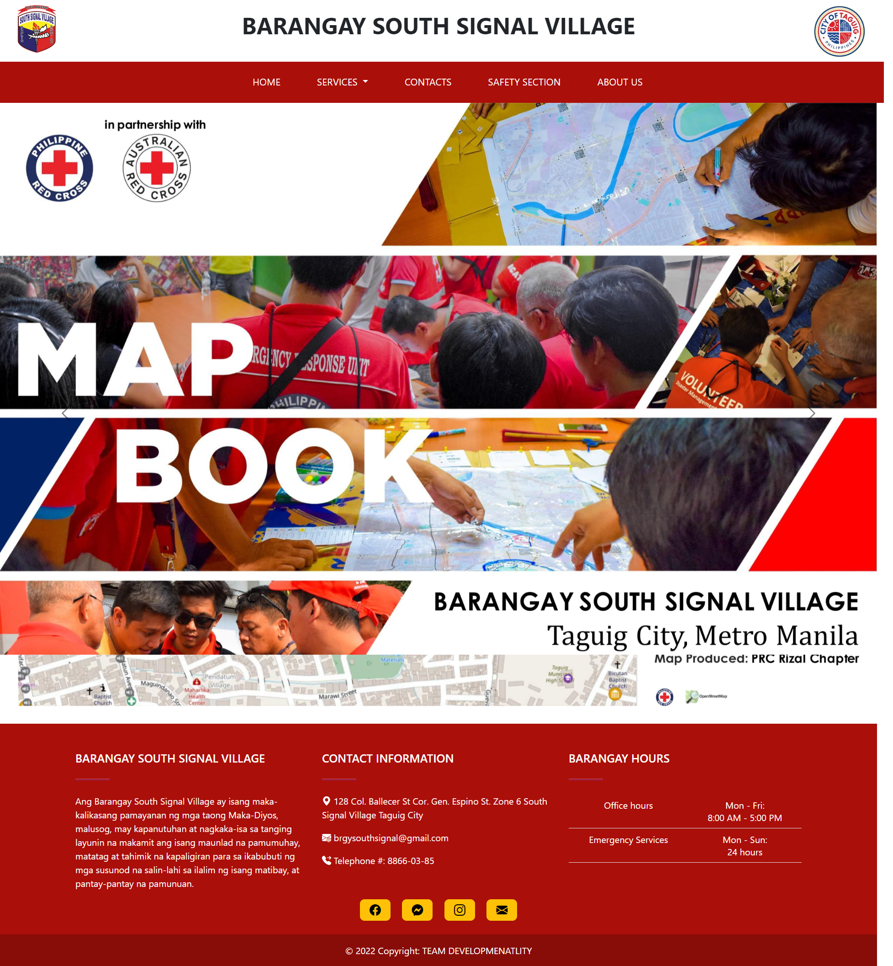

Figure 8 Safety Section

The 'Safety Section' page presents a Red Cross Philippines base map with a legend of barangay infrastructure, a population density map, a vulnerability map, a land use map, a historical hazard map, and a flood hazard map with risk levels.

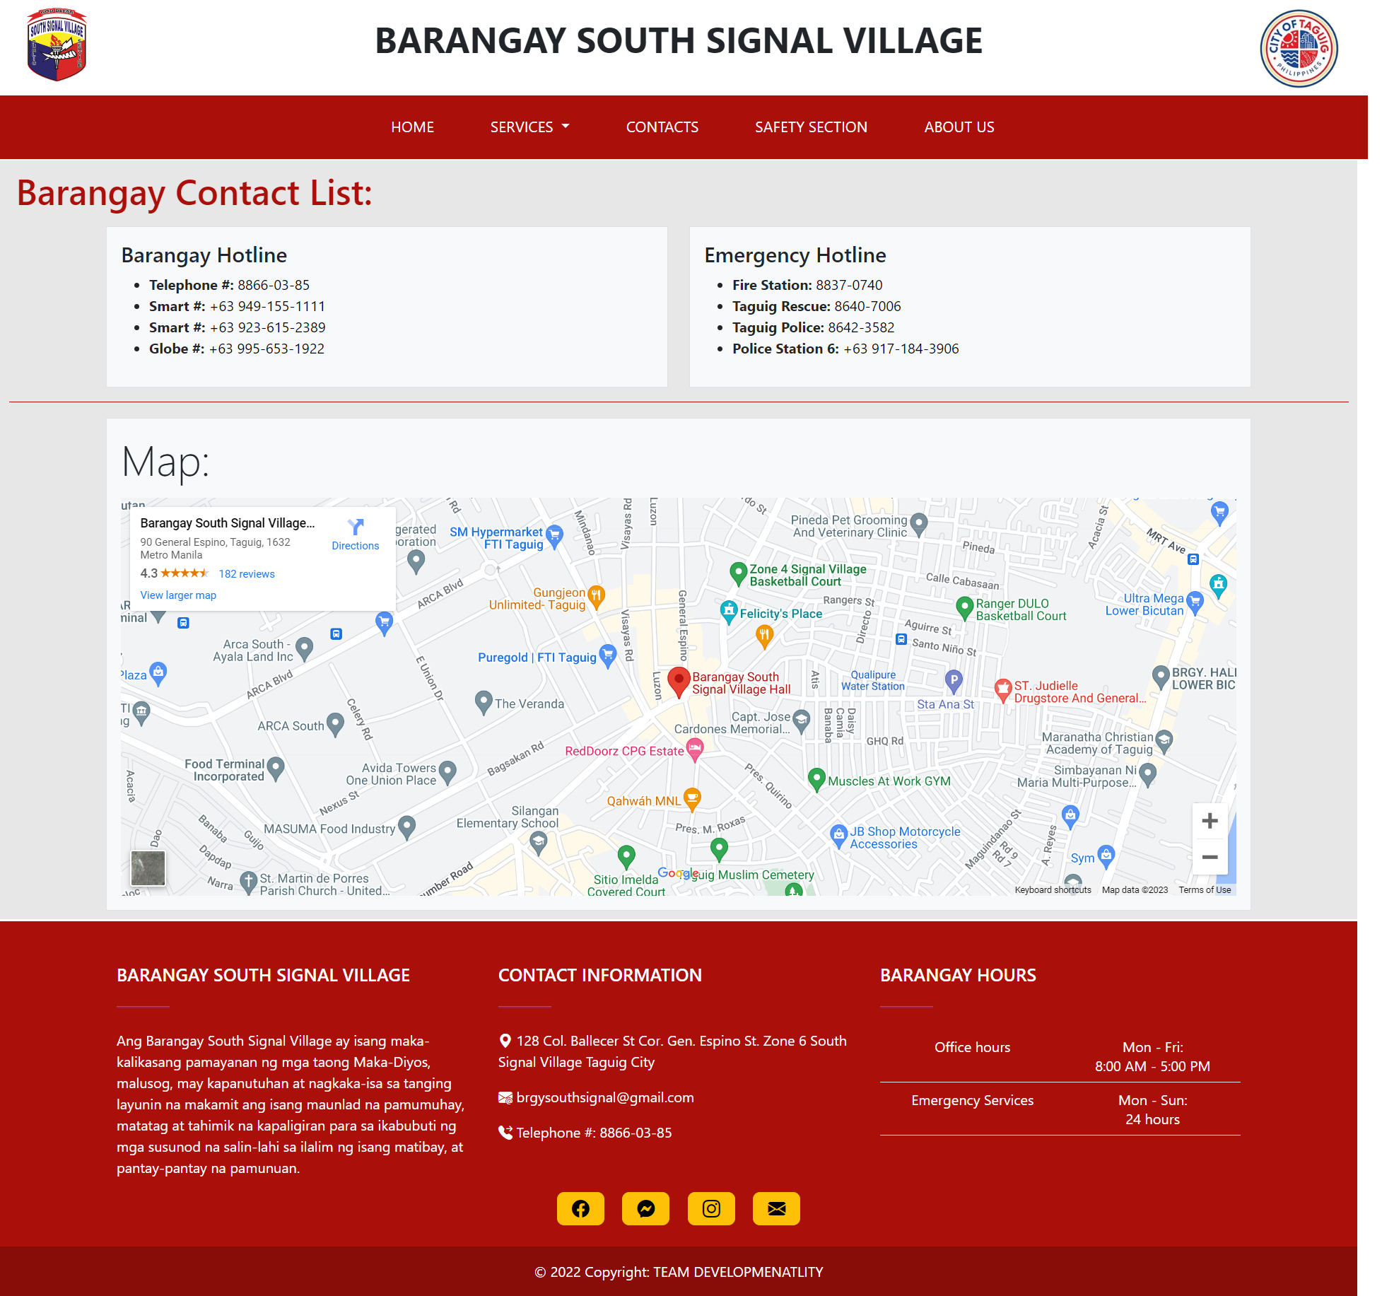

Figure 9 Contacts

The 'Contact' page lists various contact information and hotlines for residents to use and includes an embedded map of the barangay main office.

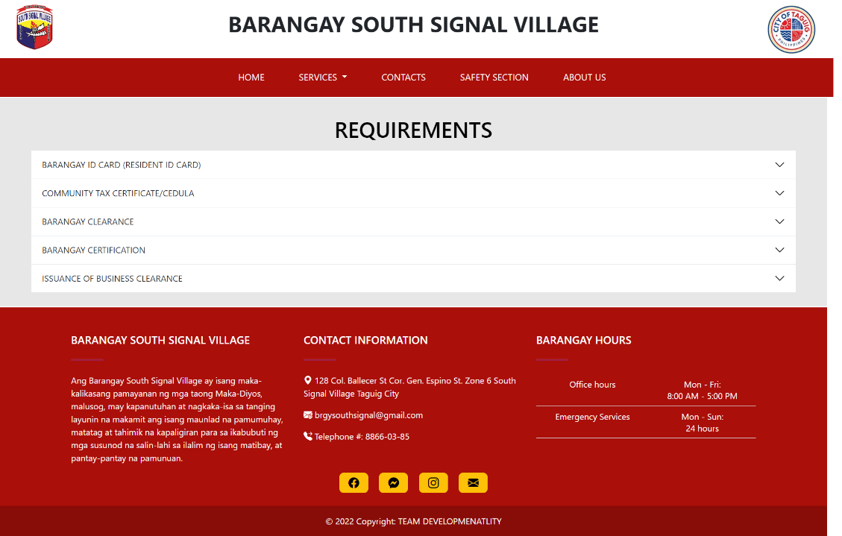

Figure 10 Requirements

The 'Requirements' page displays the various documents available from the barangay, along with information on the fees, the process for obtaining the requirements, and the necessary supporting documents for each requirement.

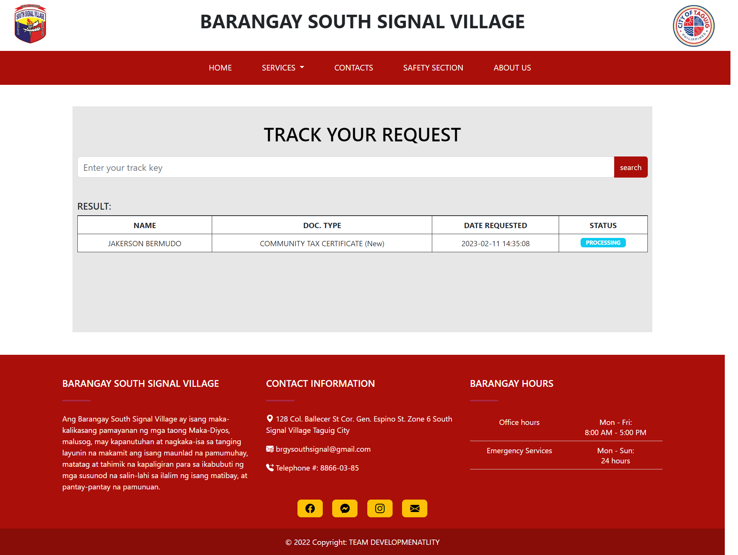

Figure 11 Track Request

The 'Request Tracking' page lets residents track document requests using a tracking key, which displays document type, date, and status (Pending, Processing, Ready for Payment, Done, or Denied).

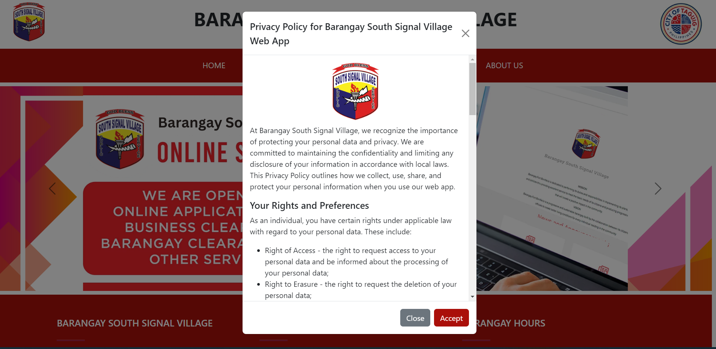

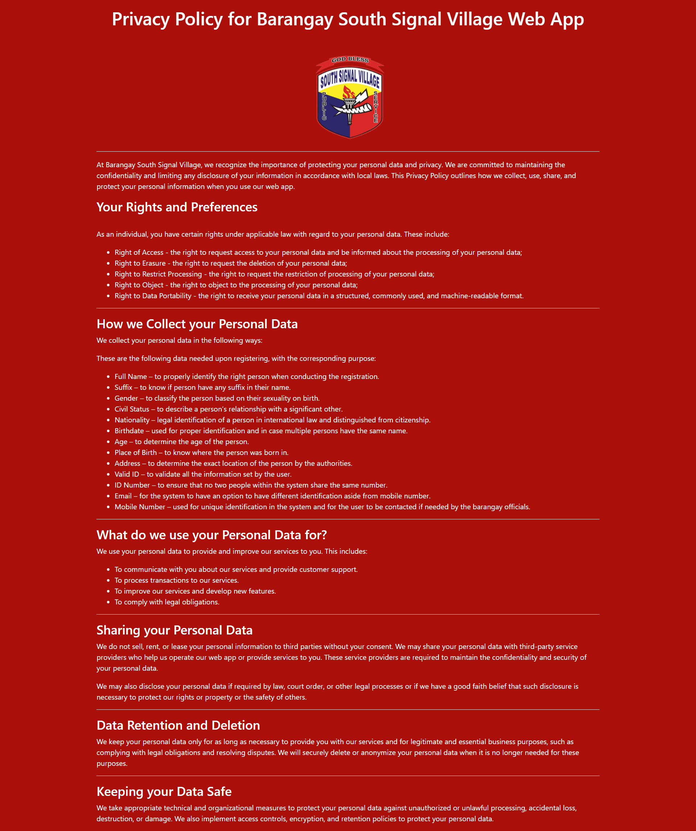

Figure 12 Data Privacy Notice

When a user tries to register for the web app, a pop-up window appears that displays the barangay's data privacy policy for resident information collected during the registration process.

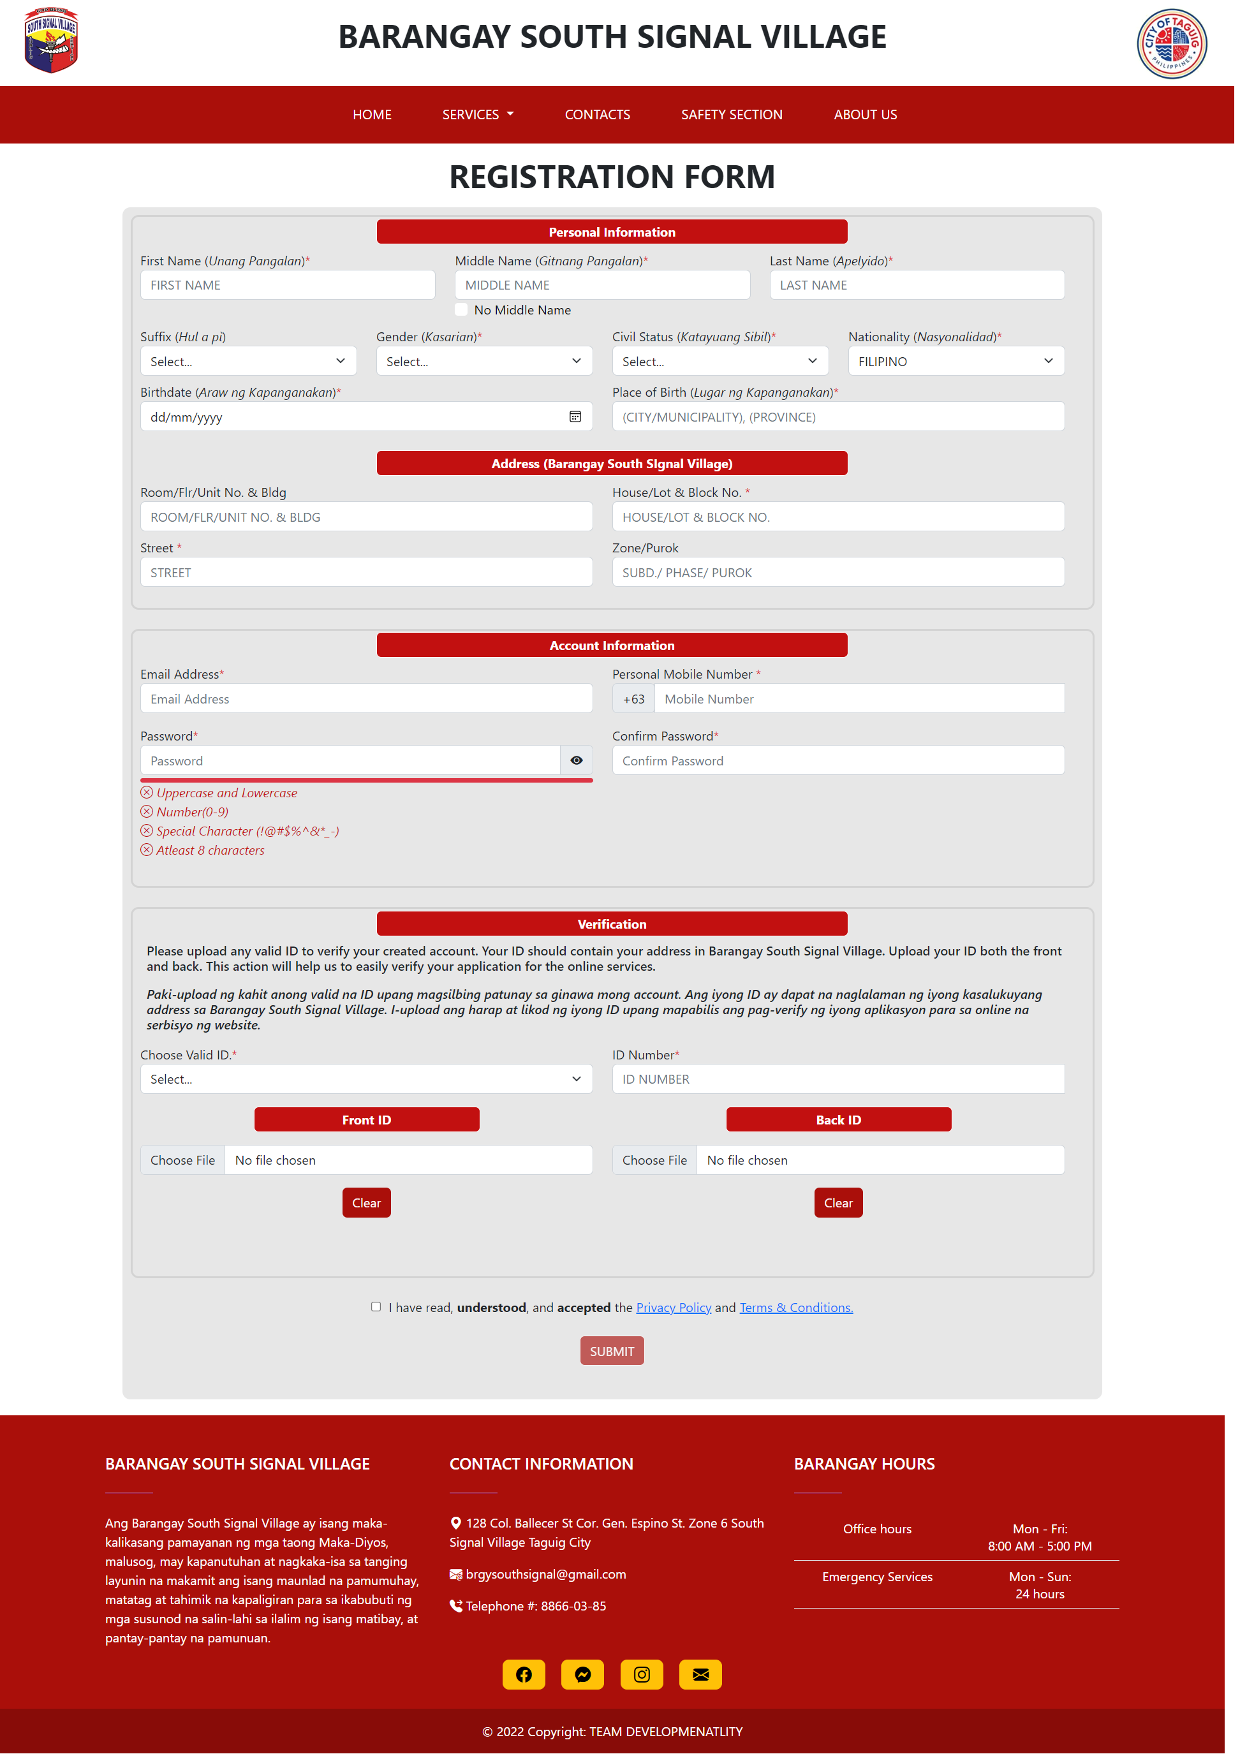

Figure 13 Registration Page

The 'Registration' page is a form for residents to create a resident account on the web app. Residents provide personal information, address, account details, and upload valid identification for verification.

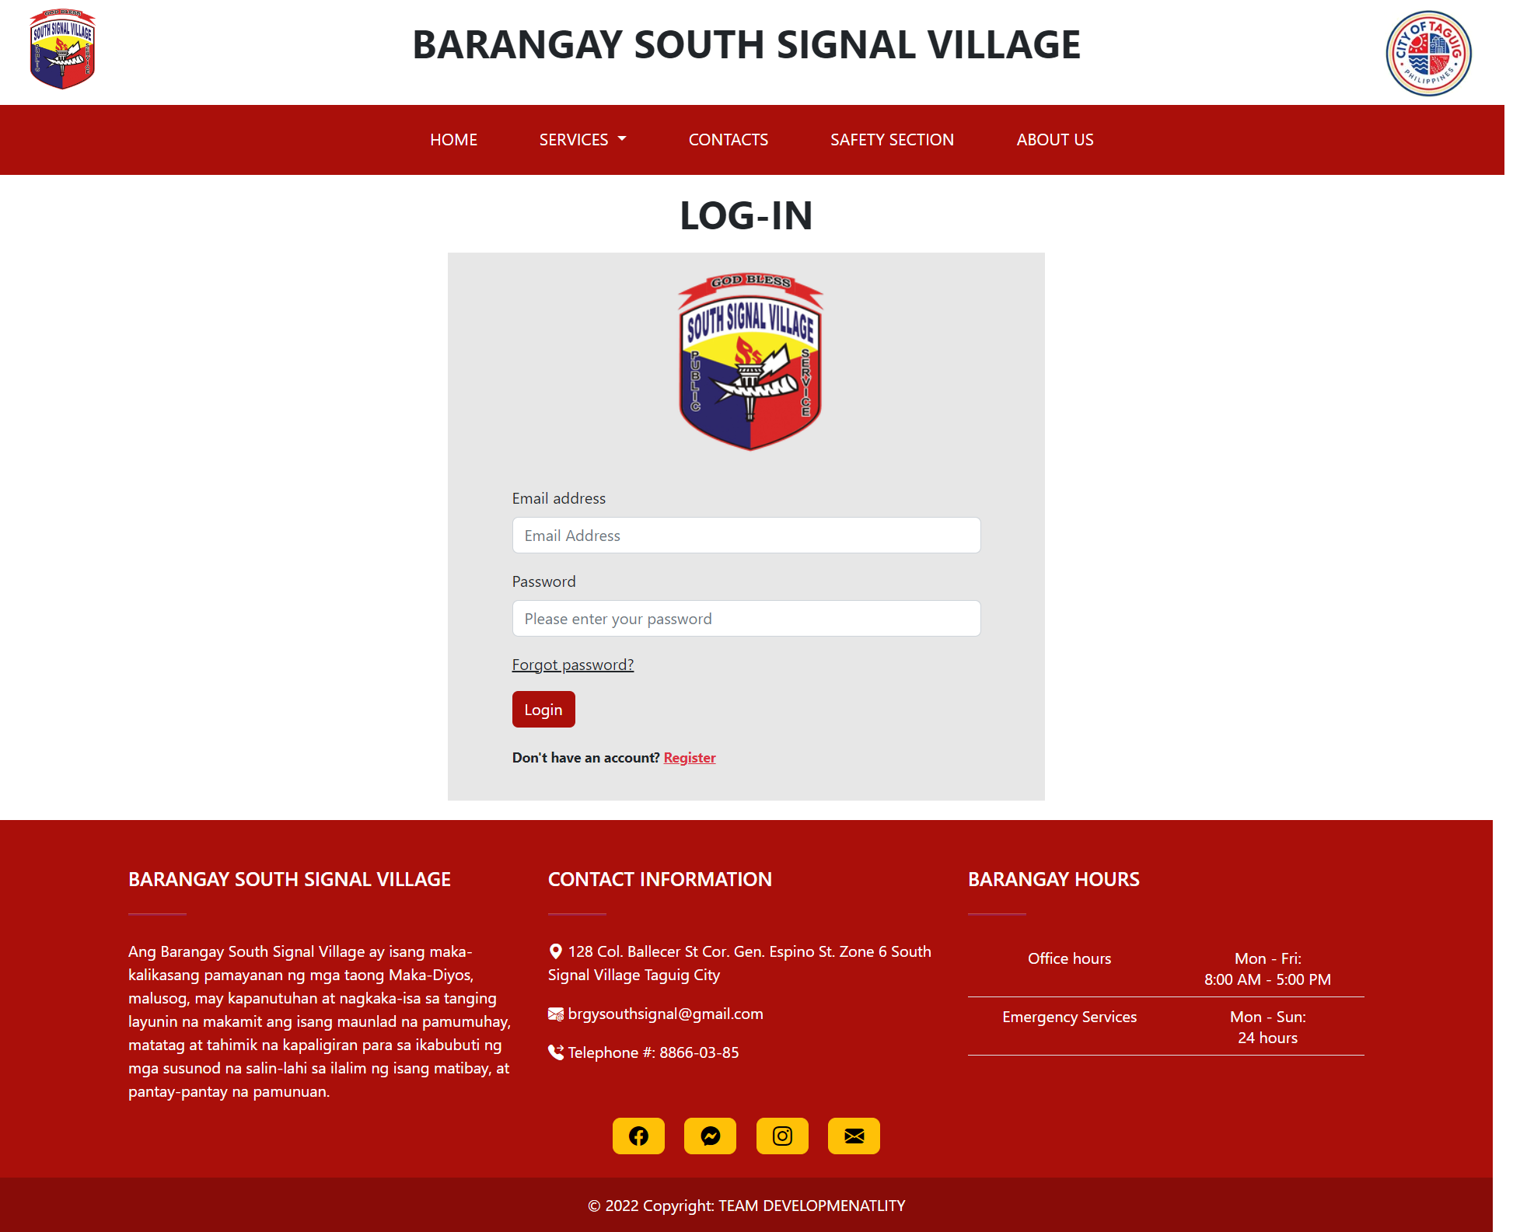

Figure 14 Log in page

The 'Login' page allows residents with a resident account to securely access their account on the web app by entering their registered email and password.

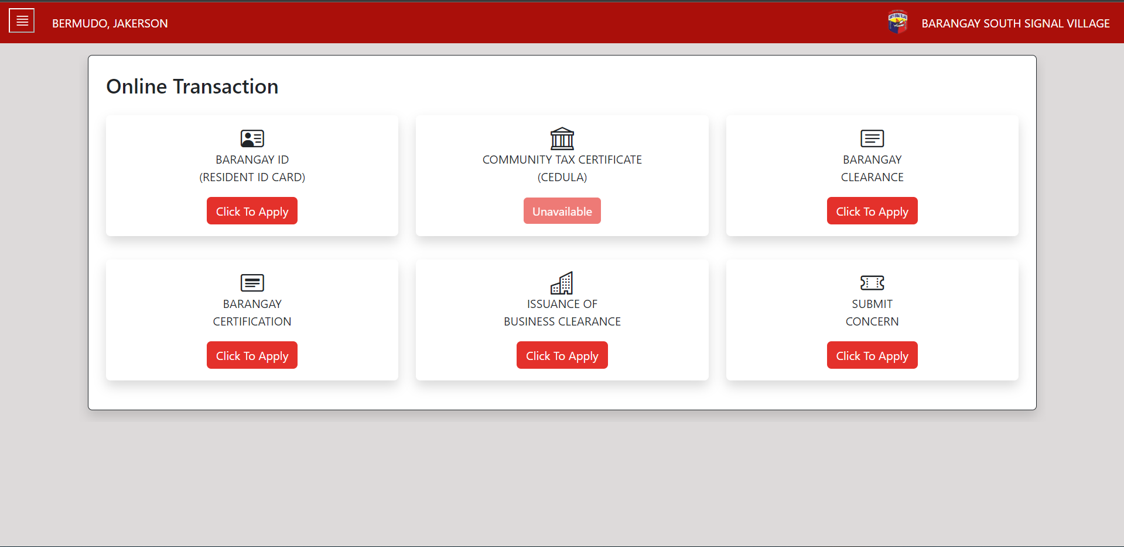

Figure 15 Resident Dashboard

Upon successful login, the resident is taken to their 'Resident Dashboard' page. This page displays the various online transactions that are available on the web app for the resident to access.

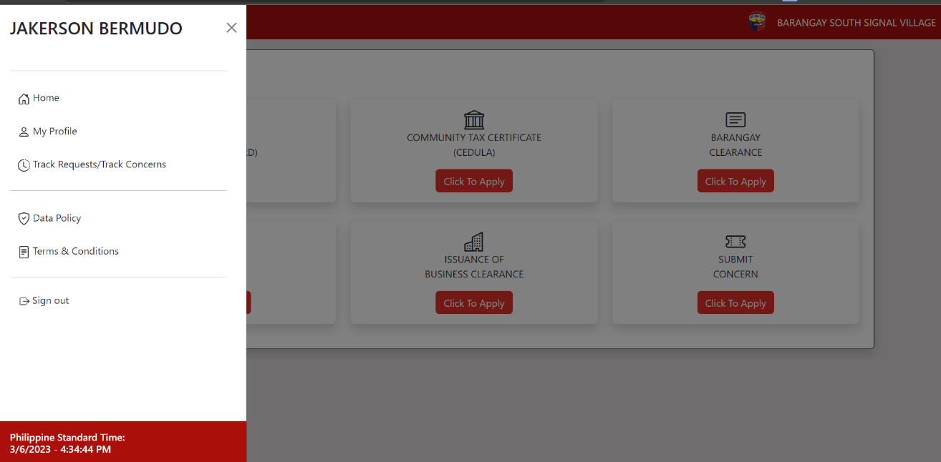

Figure 16 Resident Dashboard Side Bar

The side bar of the resident dashboard features six tabs: Home, Profile, Transaction History, Data Policy, Terms and Conditions, and Sign-out.

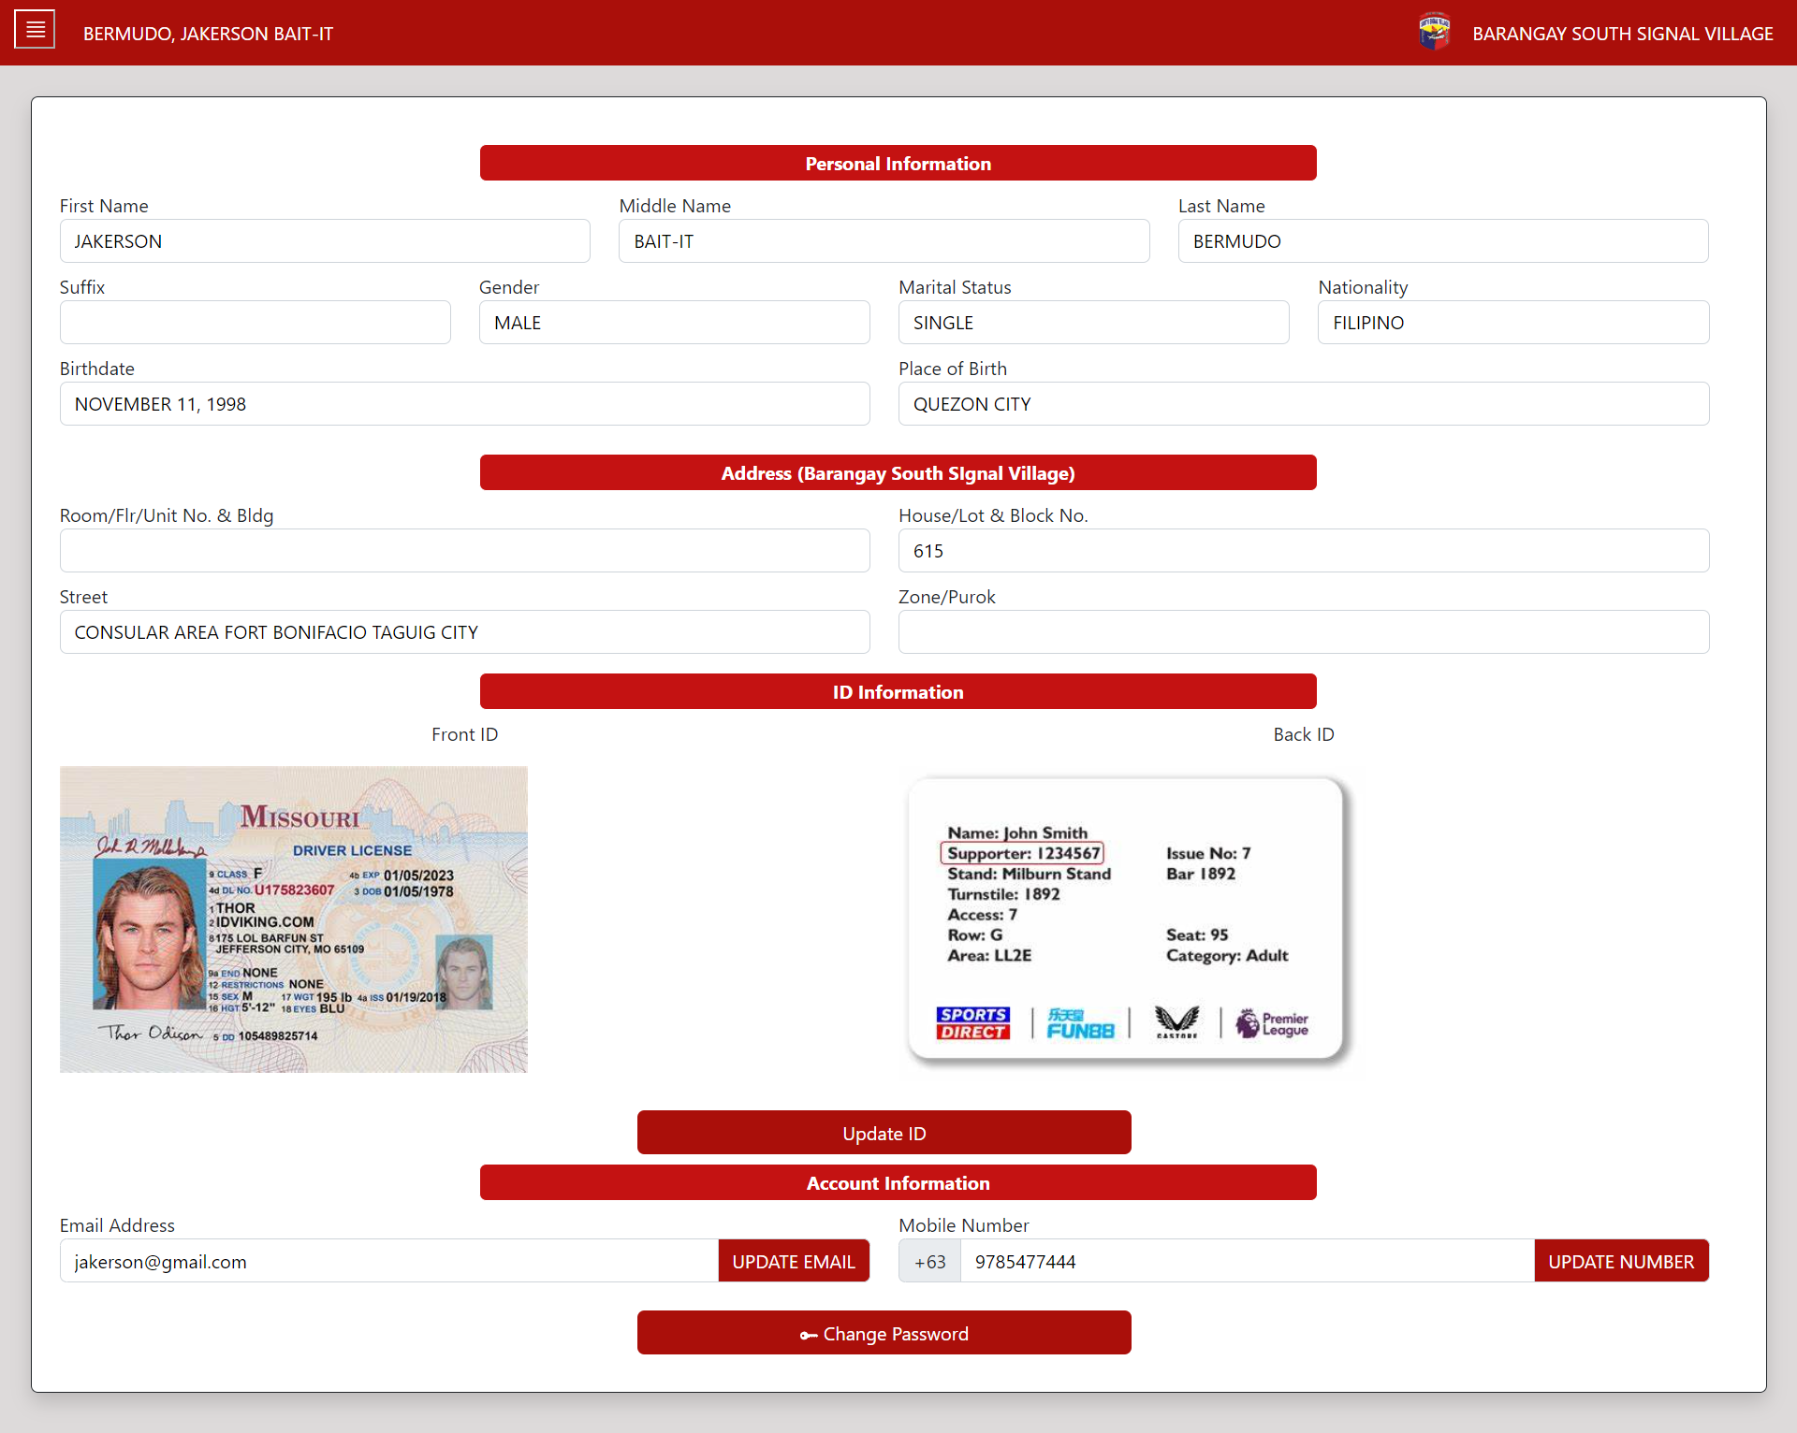

Figure 17 Resident Dashboard - My Profile

The 'My Profile' tab on the resident dashboard displays the resident's personal information. The resident can update their valid IDs, email, mobile number, and password.

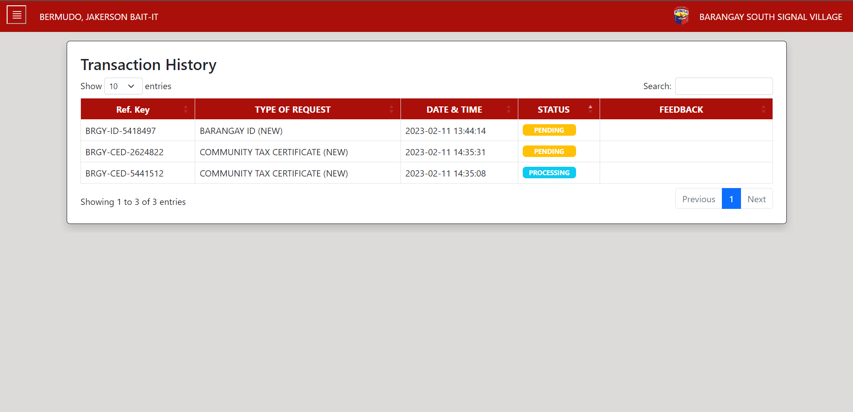

Figure 18 Transaction History

The 'Transaction History' tab on the resident dashboard displays a list of all the transactions that the resident has completed through the web app, including the date, type of transaction, and status.

### Barangay Employee Prototype

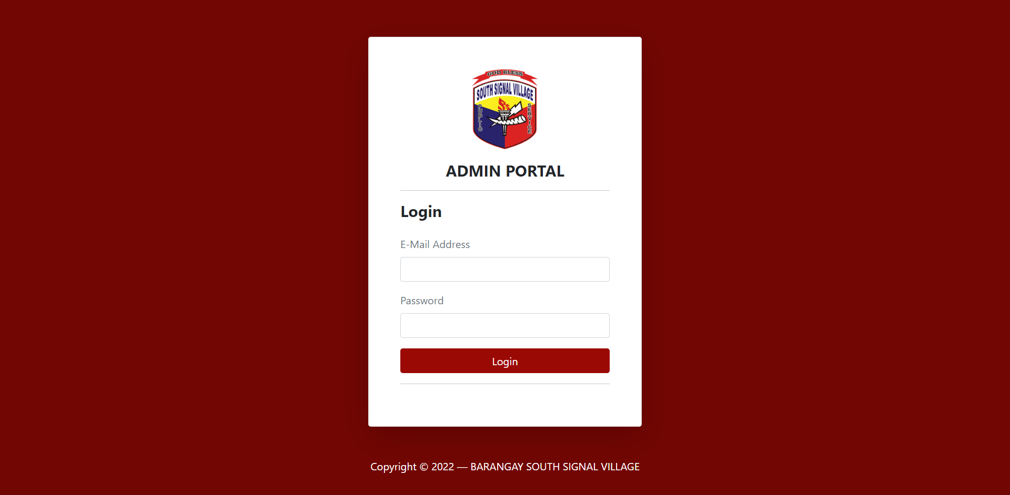

Figure 19 Admin portal login

The admin portal is a separate login page specifically for Barangay Employee of the web app, allowing them to access and manage different functions and information within the web app.

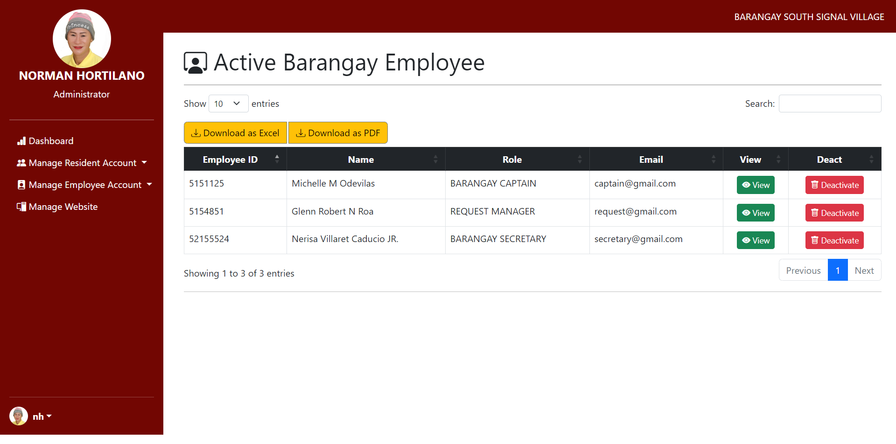

Figure 20 Administrator Dashboard

The Administrator Dashboard page is where the administrator can manage the barangay employees by adding, deactivating, and assigning roles to them. Additionally, the administrator can also manage the web-app, including editing the carousel announcements on the home page, updating the information about the barangay officials in the 'About Us' page, and updating the barangay's demography.

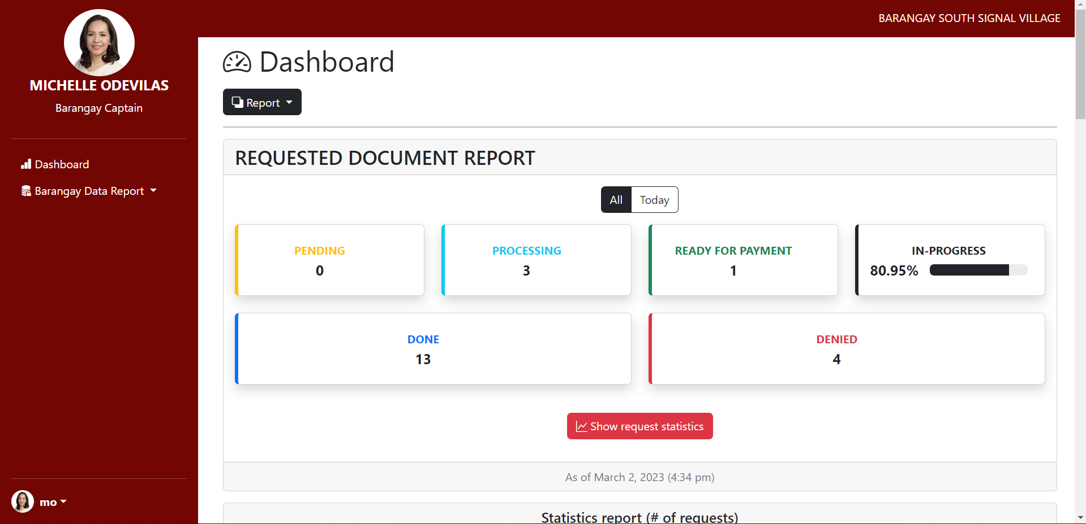

Figure 21 Barangay Captain Dashboard

The Barangay Captain Dashboard provides a comprehensive view of the web-app's report, lists of residents, employees, and requests, allowing the Barangay Captain to oversee all transactions within the web-app.

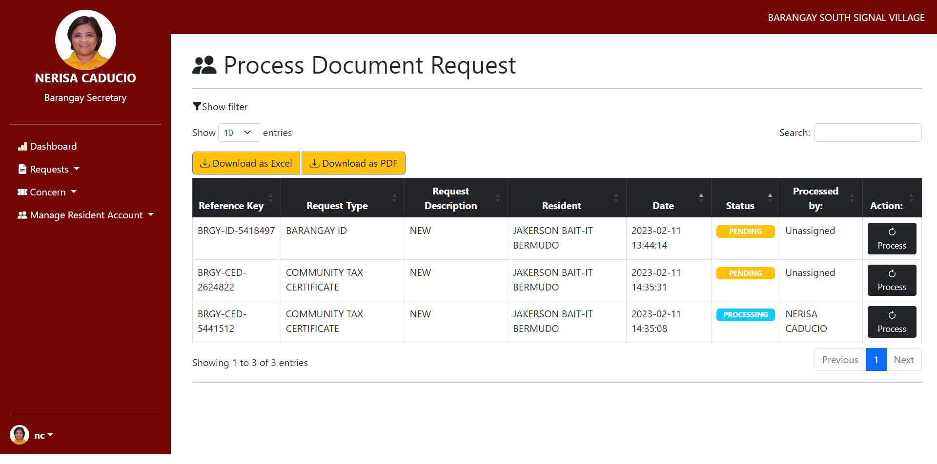

Figure 22 Barangay Secretary Dashboard

The Barangay Secretary Dashboard allows the Barangay Secretary to handle and process requests and concerns from residents in the web app, as well as have a comprehensive overview of all residents’ accounts.

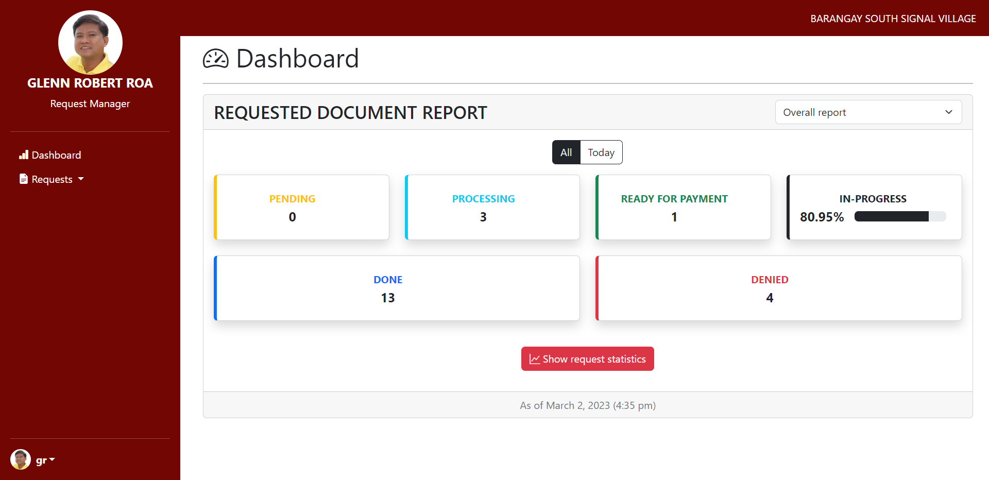

Figure 23 Request Manager Dashboard

The Request Manager Dashboard allows the Barangay Request Manager to handle and process requests from residents in the web app.

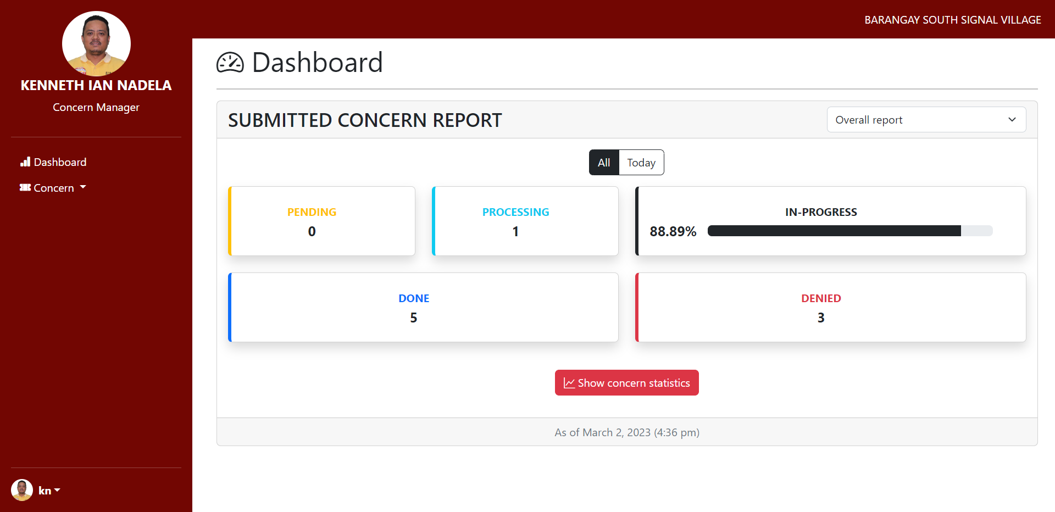

Figure 24 Concern Manager Dashboard

The Concern Manager Dashboard allows the Barangay Concern Manager to handle and process concerns from residents in the web app.

## Appendix G: Links

Table 25 List of Links

|  |  |
| --- | --- |
| OpenProject | <https://openproject.apc.edu.ph/> |
| Wiki | <https://github.com/apcjlquesada/APC_2022_2023_3rd_Term_PROJMAN/wiki/Group-02-Team-Developmentality---BARANGAY-SOUTH-SIGNAL-VILLAGE-WEB-APP>  <https://github.com/apcjlquesada/APC_2022_2023_3rd_Term_PROJMAN/wiki/Group-02-Team-Developmentality-Barangay-South-Signal-Village-Documentation-Part-2> |
| GitHub Repository | [apcjlquesada/APC_2022_2023_T3_PROJMAN_MI201_MI203_G02_Team_Developmentality: APC_2022_2023_T3_PROJMAN_MI201_MI203_G02_Team_Developmentality Project Management Repository (github.com)](https://github.com/apcjlquesada/APC_2022_2023_T3_PROJMAN_MI201_MI203_G02_Team_Developmentality) |
| Sample Hosting | [BARANGAY SOUTH SIGNAL VILLAGE (apc.edu.ph)](https://projects.apc.edu.ph/barangay/home) |